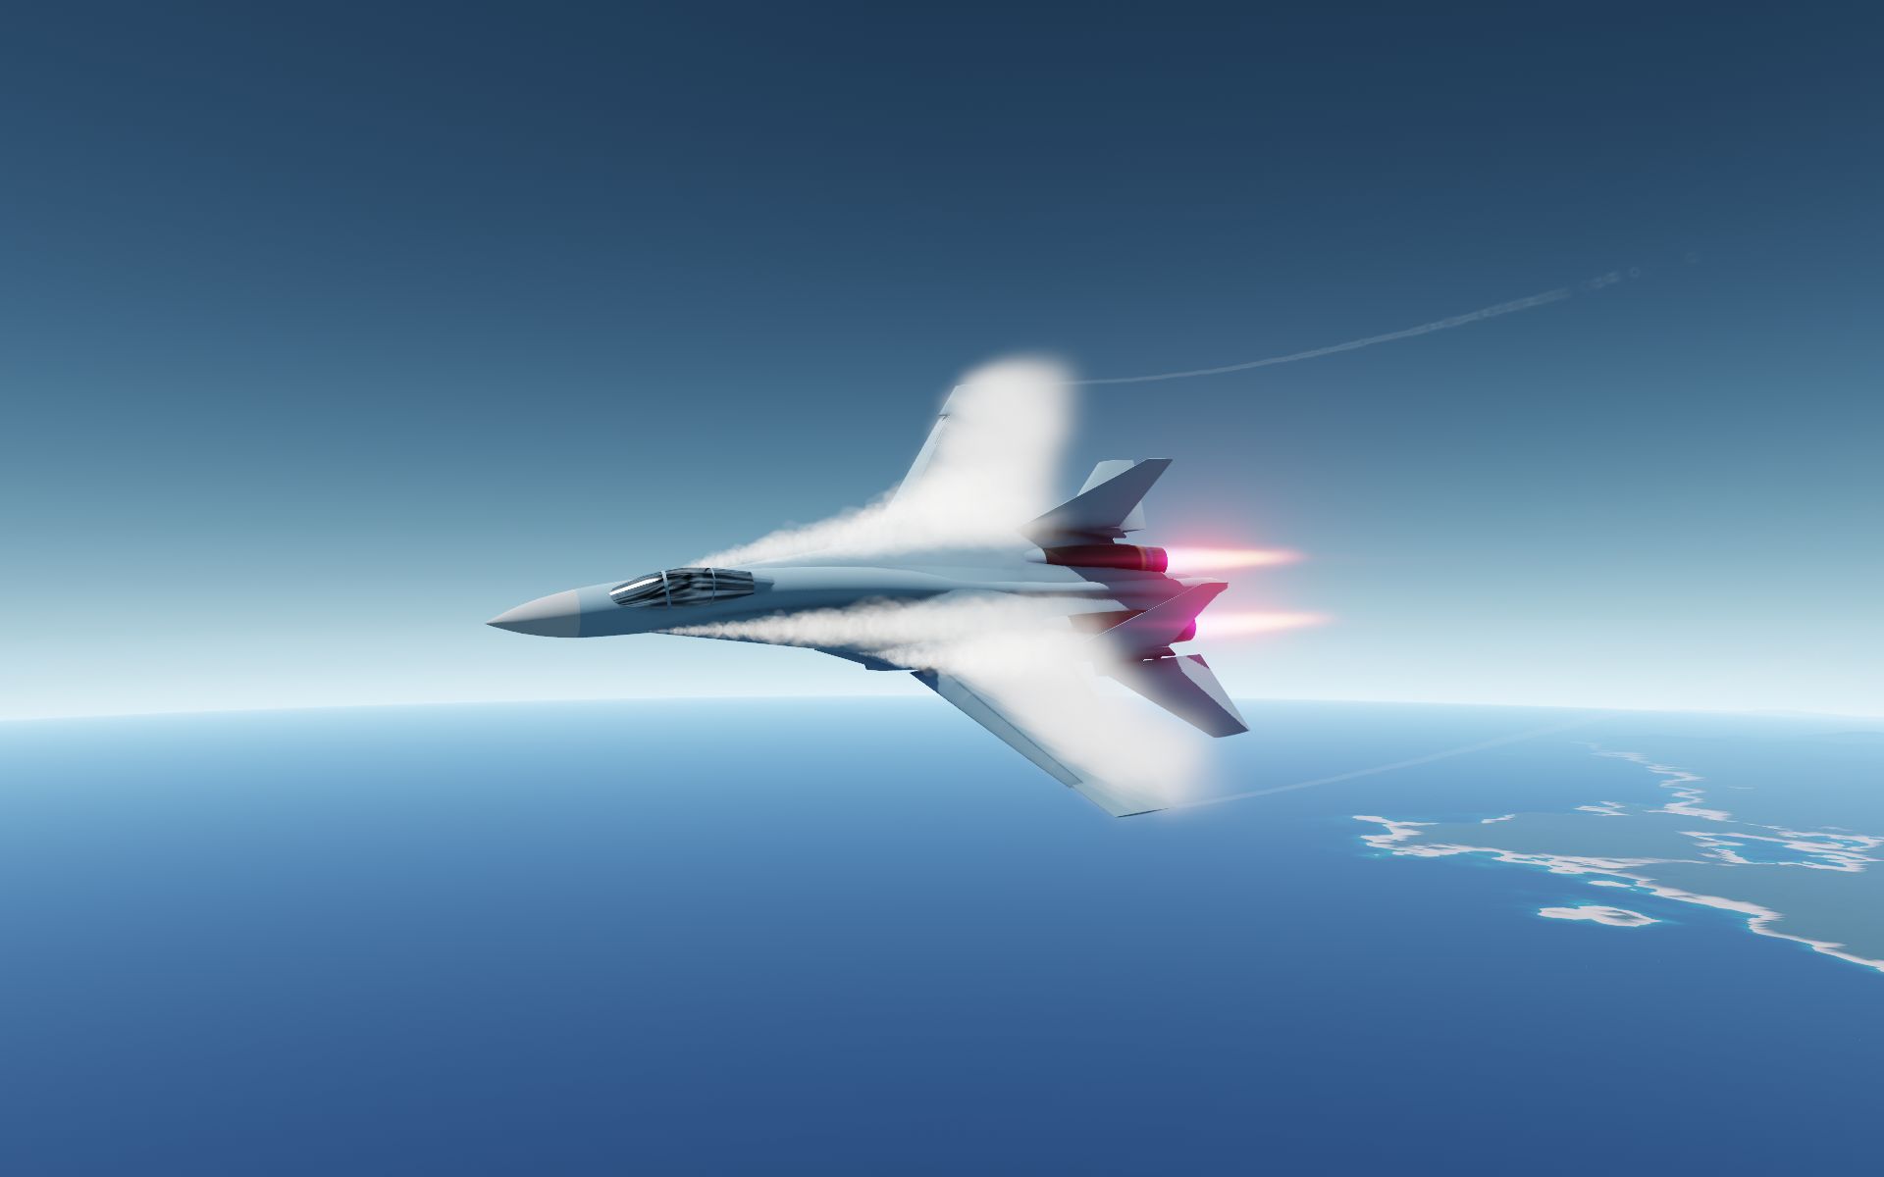SimpleWings2

User Manual

**Mod version: 1.0**

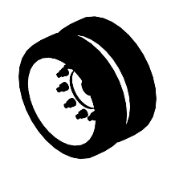**Date: June 13, 2025**

Table of contents

1. What is SimpleWings2? 4

2. Comparison with stock wing, advantages and disadvantages 15

3. Installing the mod 16

4. SimpleWing part location 18

5. Using different text colors in the manual 19

6. Terminology 20

7. How SimpleWing works 21

7.1. Lift force 22

7.2. Drag force 23

7.3. Wave drag force 24

7.4. Additional torque of the control surface 25

8. Basic aerodynamic characteristics of airfoils 27

8.1. Aerodynamic characteristics of the airfoil for calculation of lift force 27

8.2. Aerodynamic characteristics of the airfoil for calculation drag force 29

8.3. Aerodynamic airfoil characteristics for calculation LERX efficiency 30

9. SimpleWing curves calculation 31

9.1. Calculation of the lift curve 32

9.1.1. Influence of the control surface to the lift curve 35

9.1.2. Effect of deflected leading edge to the lift curve 39

9.1.3. Effect of LERX to the lift curve 41

9.2. Calculation of the drag force curve 43

9.2.1. Influence of the control surface to the drag force curve 49

9.2.2. Effect of deflected leading edge to the drag force curve 55

9.2.3. Effect of LERX to the drag force curve 57

10. LERX mechanics 59

11. Effect of sweep to lift and drag forces 65

12. Movement of the aerodynamic forces center (AFC) 66

13. SimpleWingData 67

13.1. Main Page 69

13.1.1. Lift data 70

13.1.2. Drag data 71

13.1.3. Wing data 72

13.1.4. Lerx influence 73

13.2. Lift & Drag page 74

13.3. α & Thickness 75

13.4. Polar page 76

14. Mod settings 77

15. Building recommendations 79

16. Table of aerodynamic characteristics of different airfoils 80

17. SimpleWing properties description 81

17.1. Geometry section 81

17.2. Airfoil section 82

17.3. Control Surface section 83

17.4. Leading Edge section 84

17.5. Washout section 85

17.6. Airfoil Rounding Section 86

17.7. Particle System section, Trail vortex 87

17.8. Particle System section, LERX vortex 89

17.9. Particle System section, Wing vortex 91

17.10. Flex section 93

17.11. Designer deflect section 94

17.12. Hidden section Additional Offsets 95

17.13. Decorations section, Actuator 97

17.14. Fuel section 99

17.15. Other hidden properties 100

18. Known errors 101

19. Source code 102

20. Conclusion 103

# What is SimpleWings2?

**SimpleWings2** is a mod for the game Juno: New Origins, which is only available on PC.

The mod adds a new part to the game - **SimpleWing**.

**SimpleWing** have deep customization and includes both a leading edge and control surface:

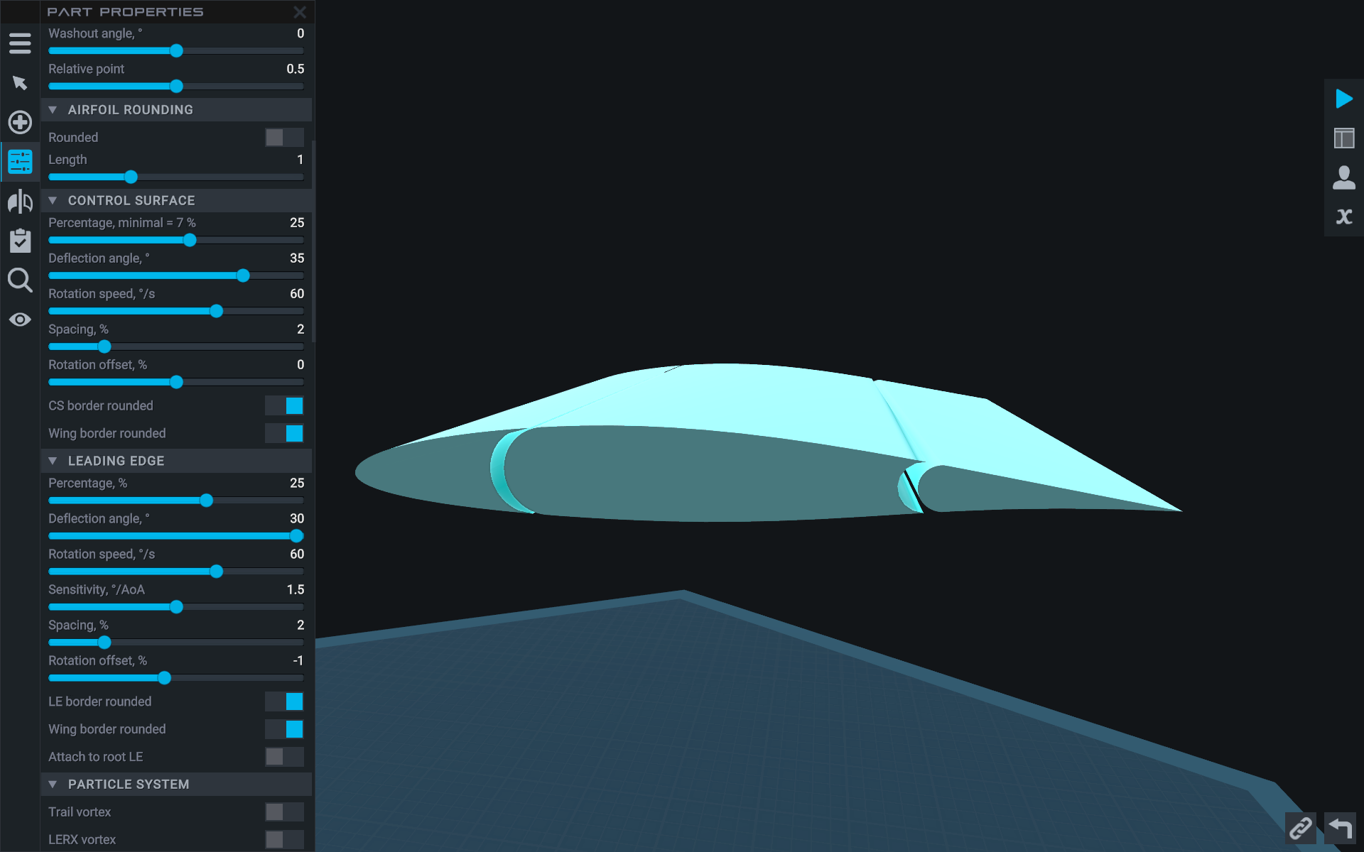

This allows you to create a realistic looking wing using minimal count of parts:

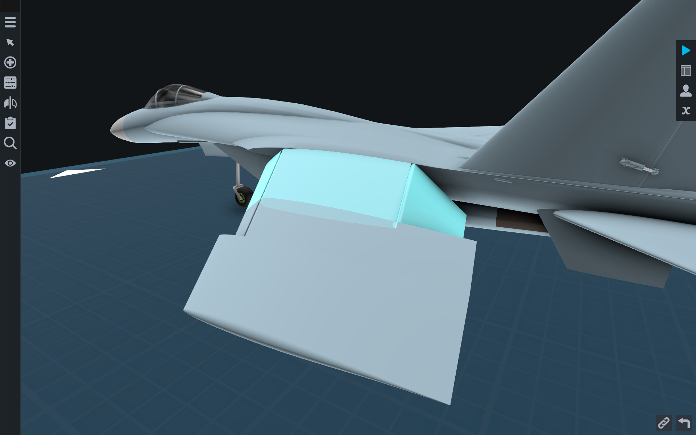

**SimpleWing** has an advanced flight model. Neither the deflectable leading edge nor the control surface generate their own forces. They change the wing lift curve $C_{y}$ and drag curve $C_{x}$ directly during flight:

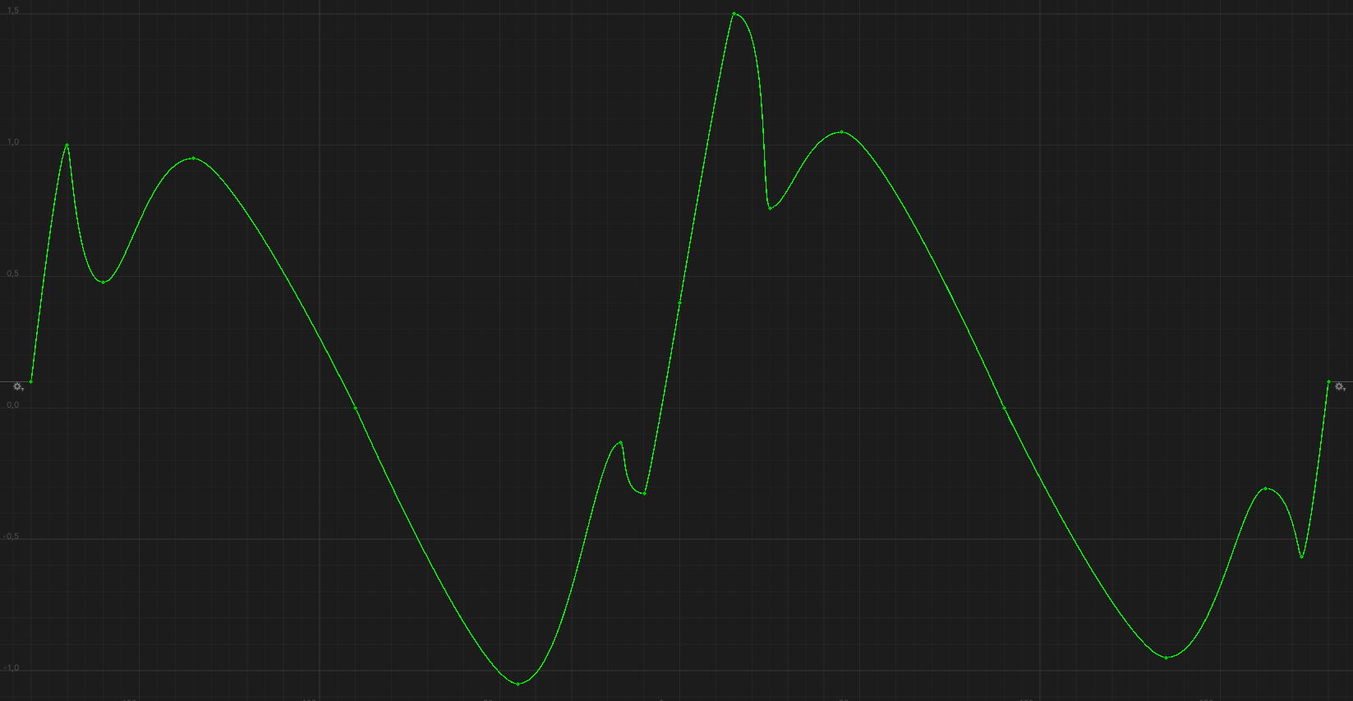

*Lift curve of the wing without mechanization in the range -180° ... +180° angles of attack*

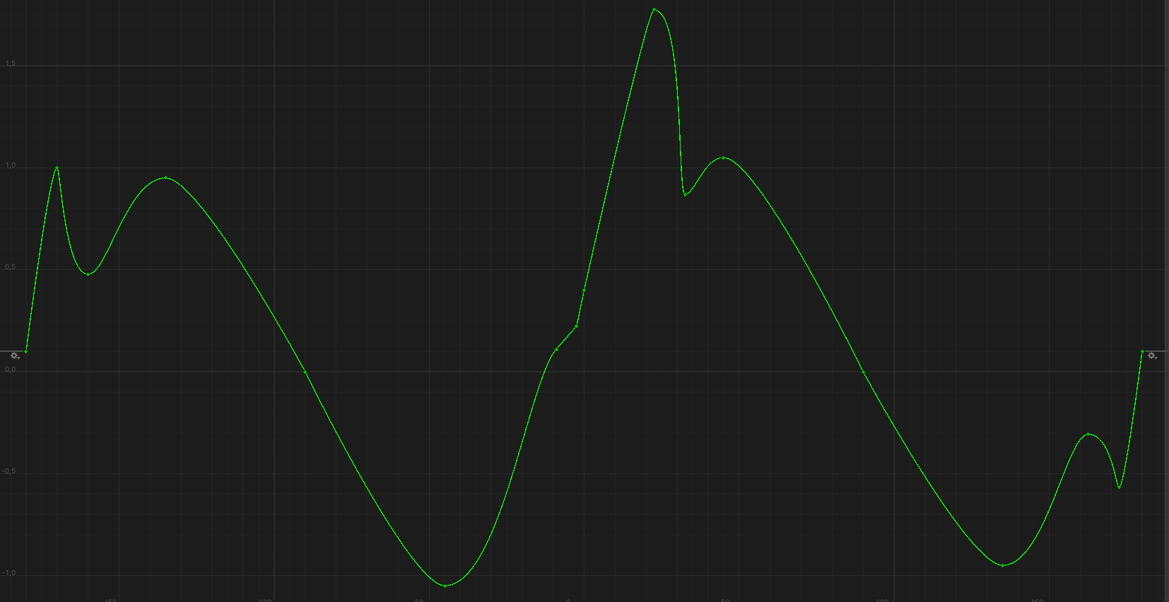

*Lift curve of the wing with deflected leading edge in the range -180° ... +180° angles of attack*

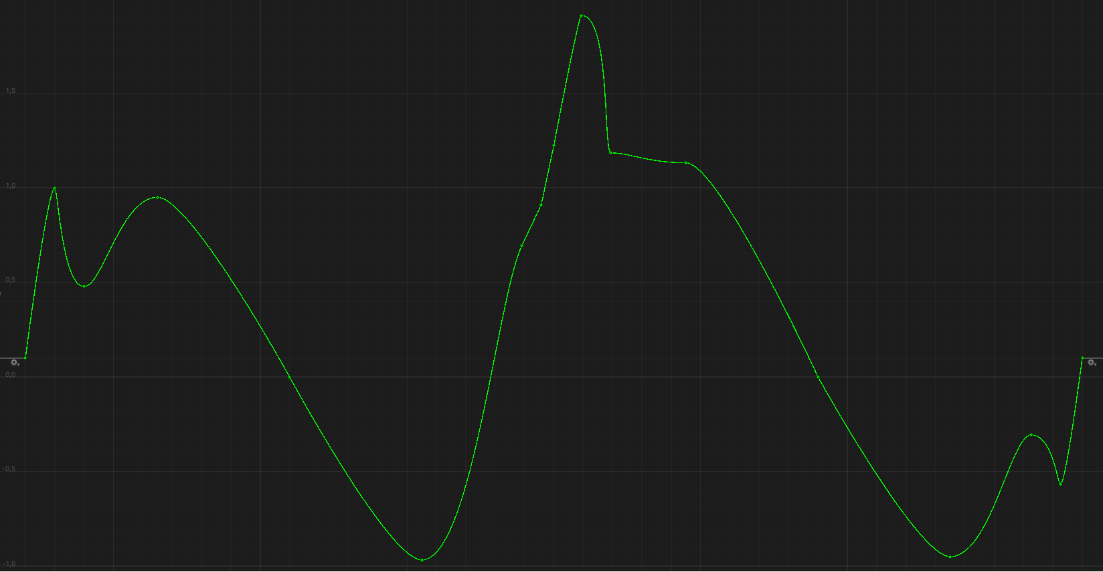

*Lift curve of the wing with deflected control surface in the range -180° ... +180° angles of attack*

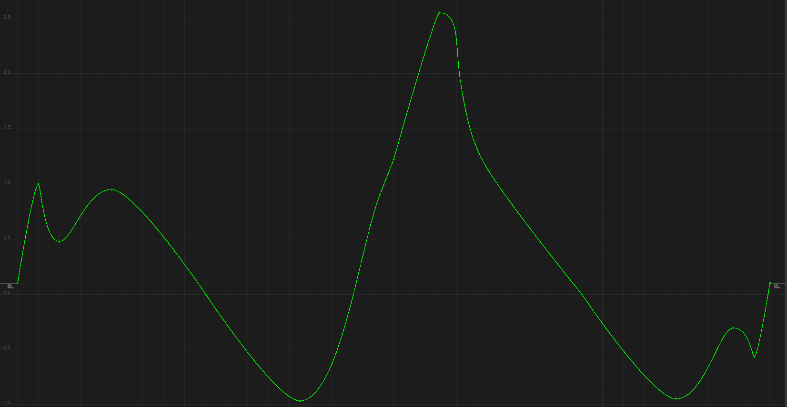

*Lift curve of the wing with deflected leading edge, deflected control surface and with maximum influence of LERX in the range -180° ... +180° angles of attack*

**SimpleWing** offers you 5 airfoils with different characteristics:

* **NACA 0012**, symmetrical subsonic airfoil:  
  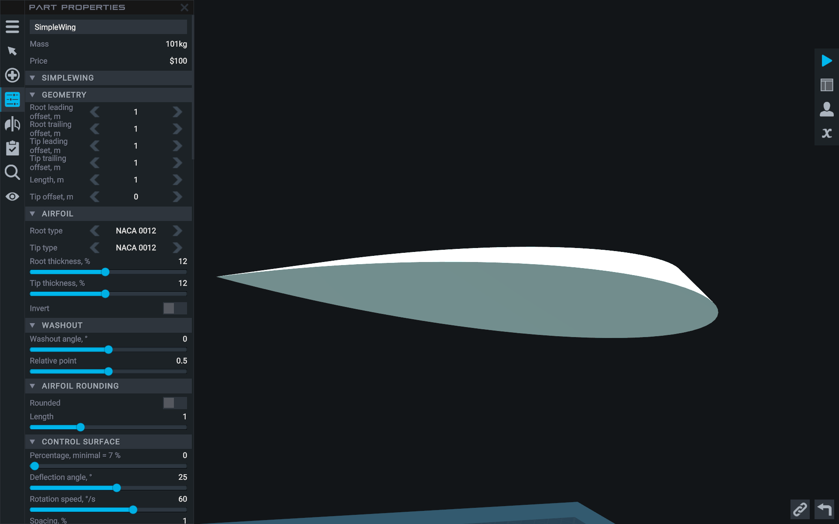
* **Clark Y**, asymmetric subsonic airfoil with high lift coefficient at zero angle of attack:  
  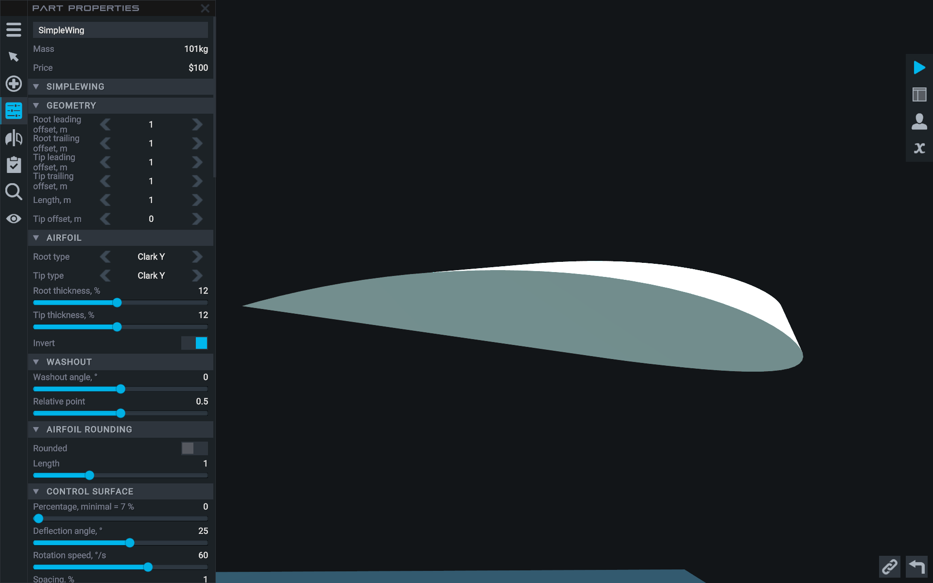
* **T-10 root**, an asymmetrical supersonic airfoil with a sharp leading edge, is well suited for creating a root leading edge extension (LERX):  
  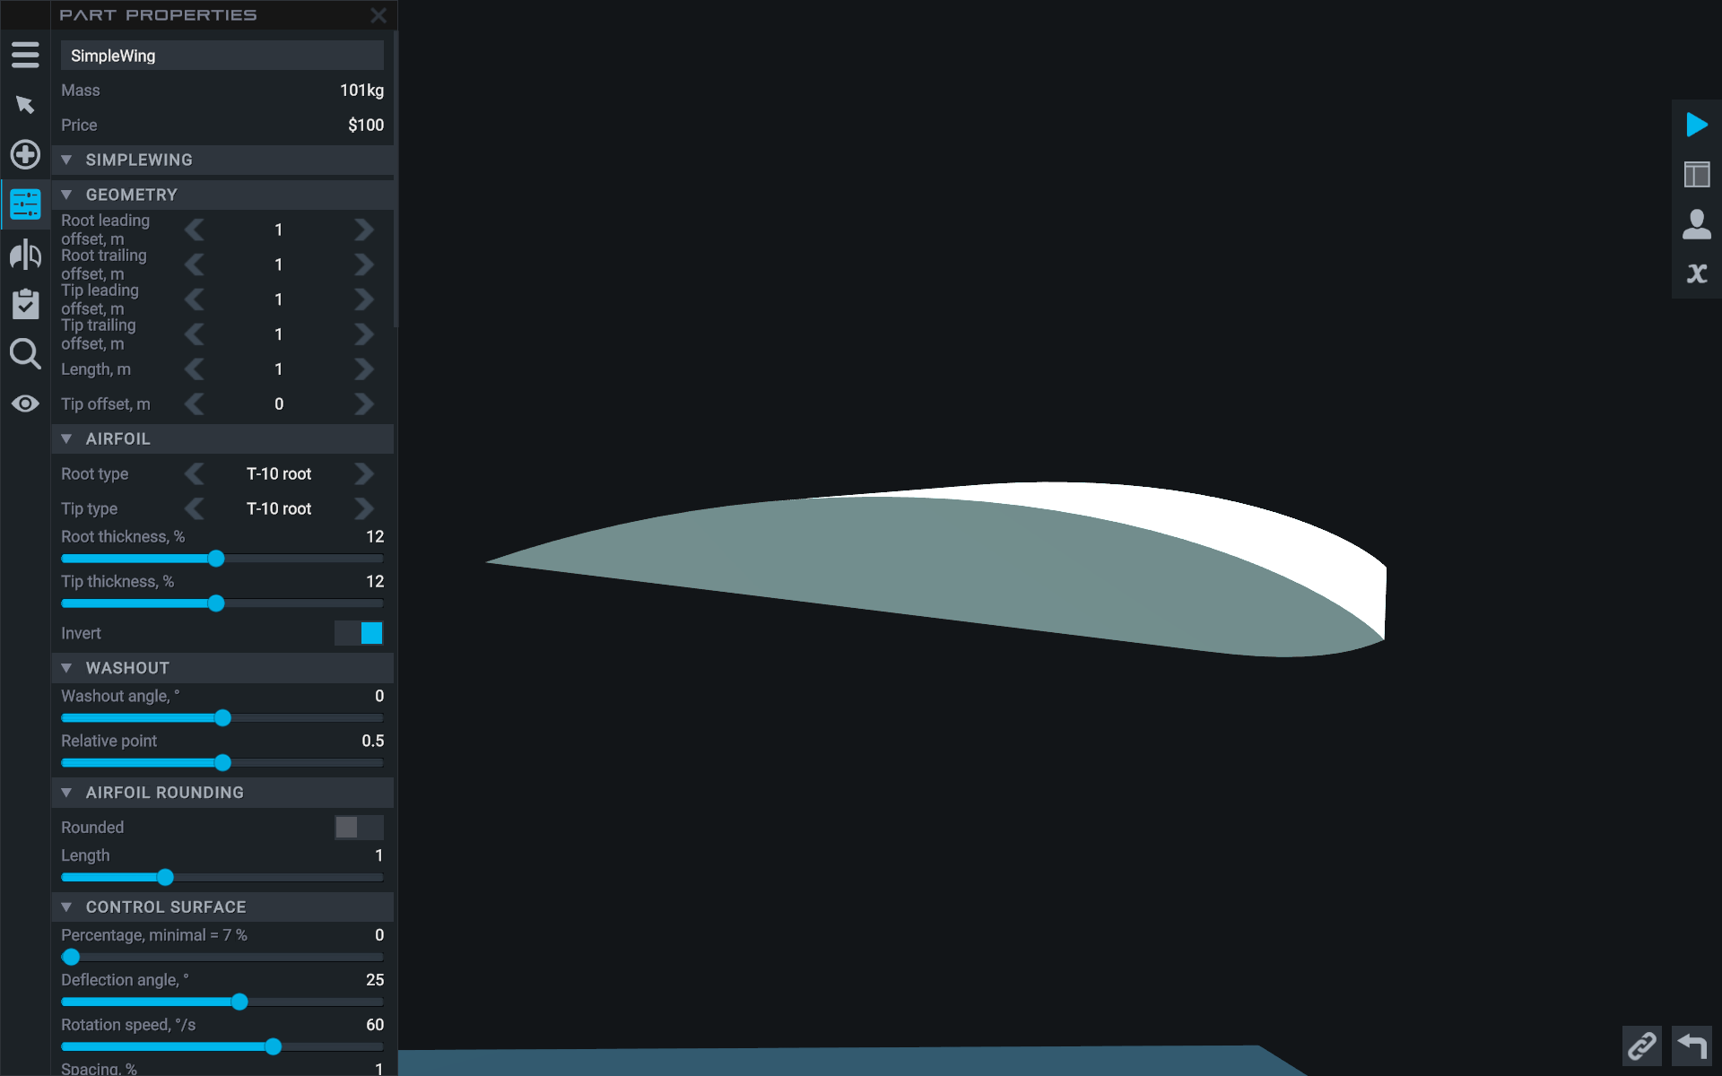
* **T-10 wing**, an asymmetric supersonic airfoil with a sharp leading edge, with poor performance at post-critical angles of attack and a high post-critical aerodynamic shake coefficient, suitable for LERX creation:  
  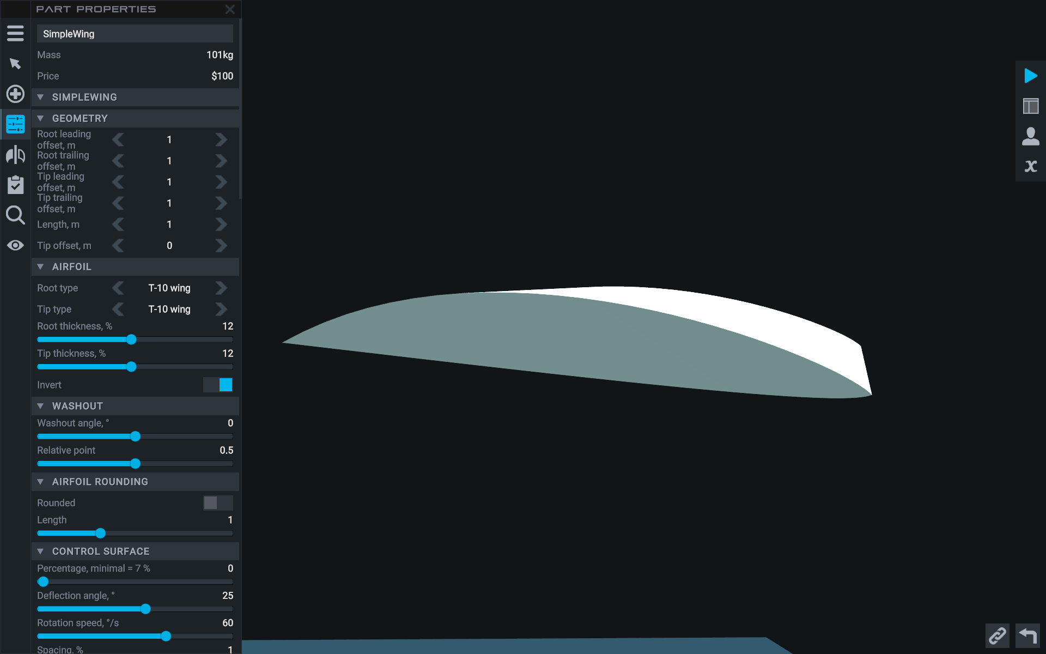
* **NACA 64-208**, asymmetrical subsonic airfoil, has medium lift at zero angle of attack. Well suited for fighter aircraft:

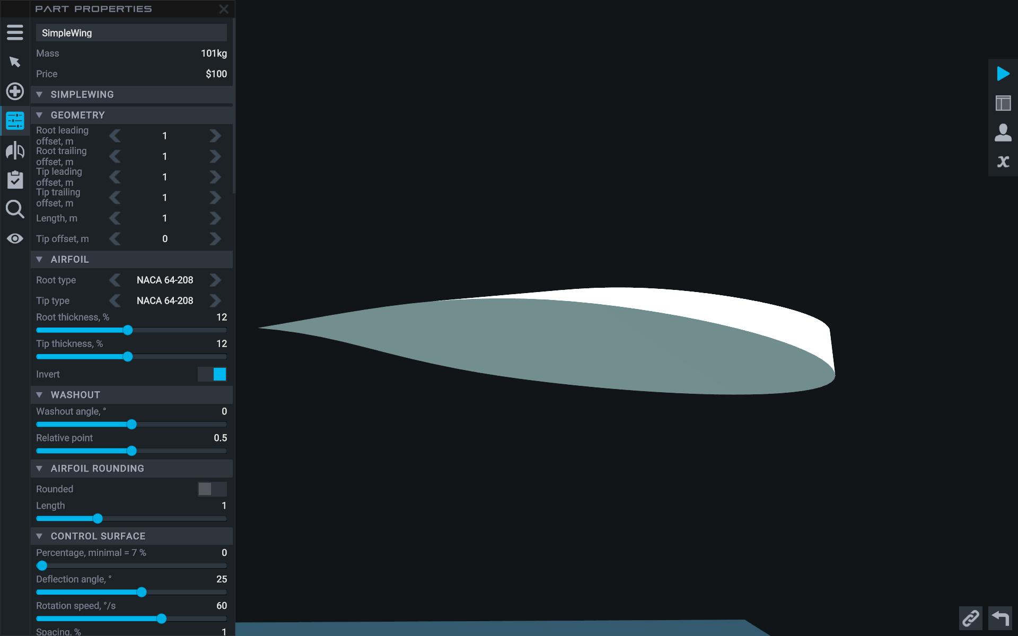

You can choose different airfoils for the wing root and wing tip, resulting in an average aerodynamic performance:

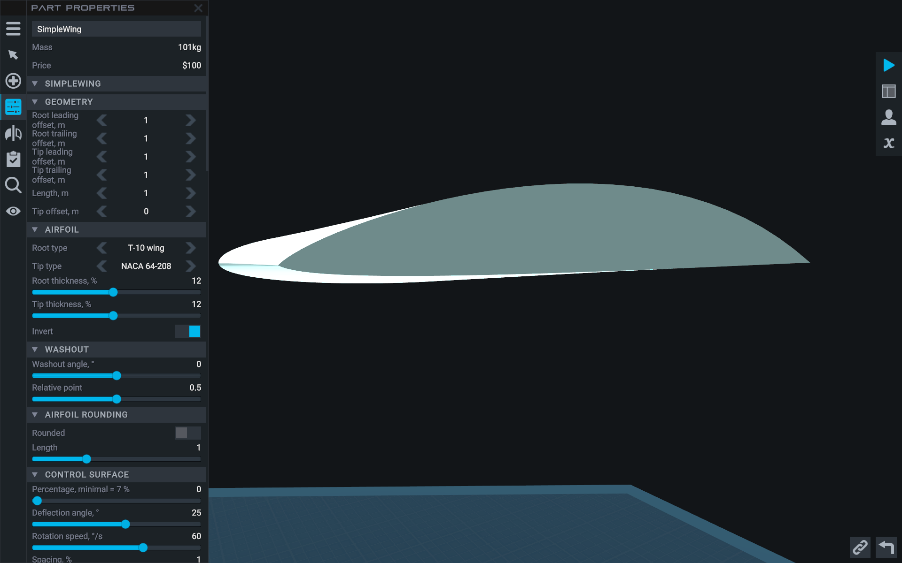

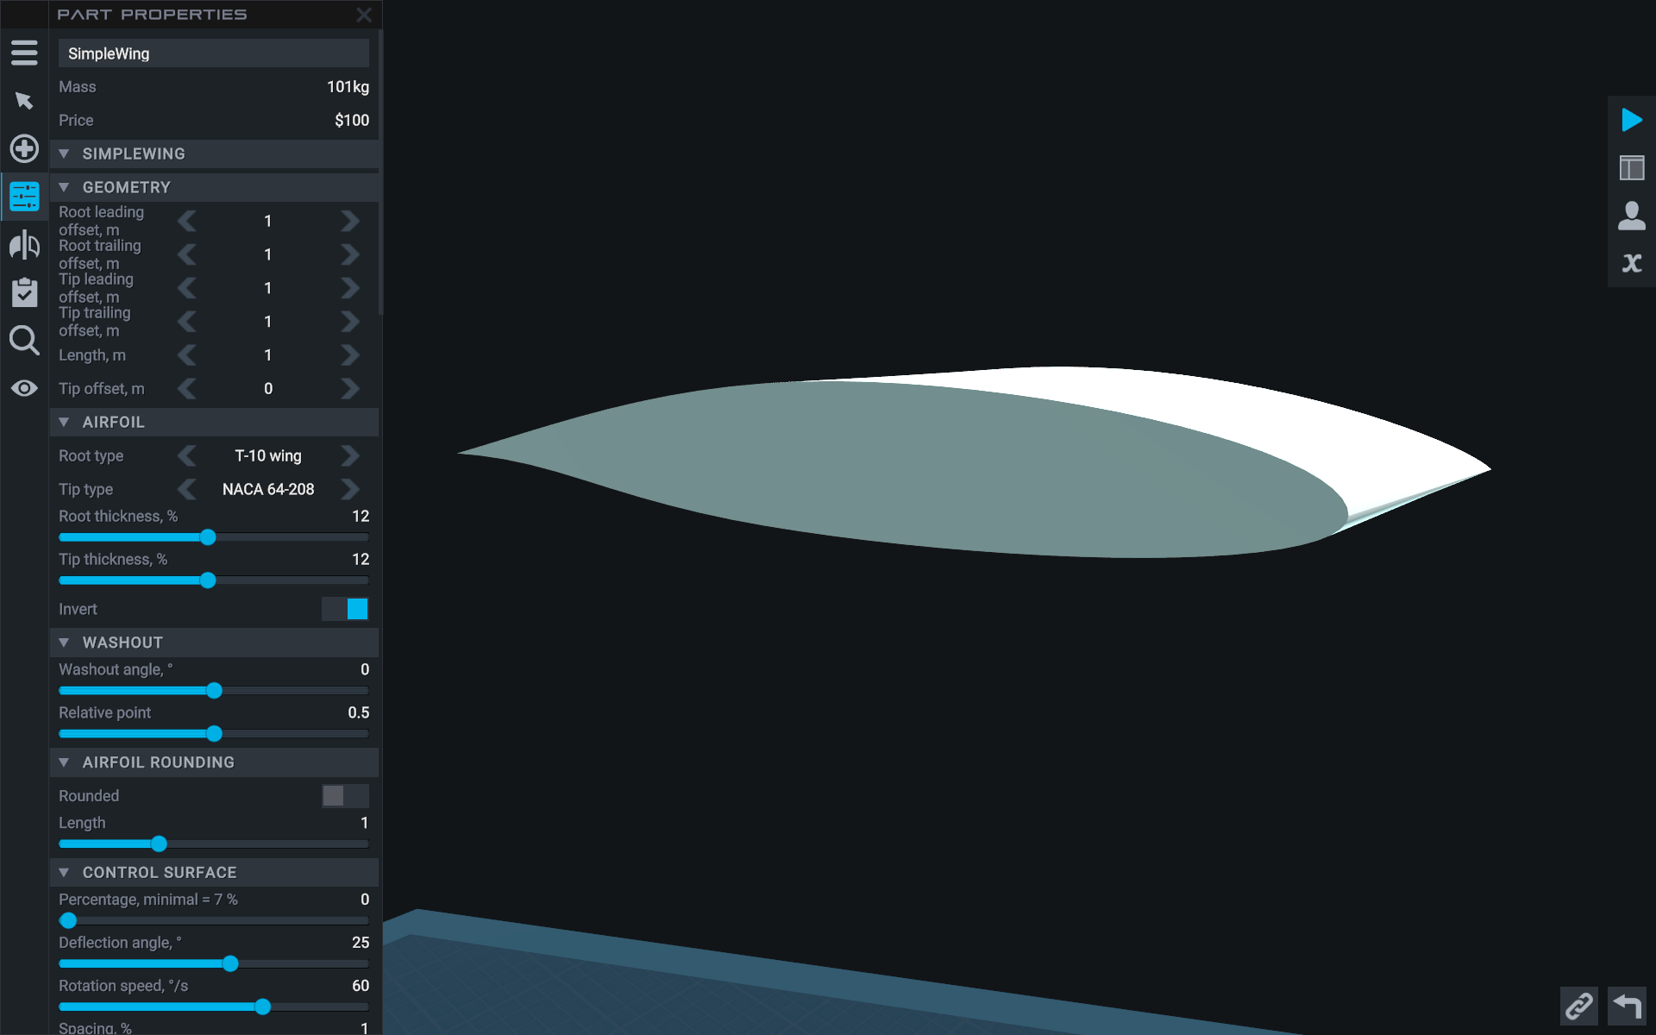

**SimpleWing** has its own customizable visual effects. Trail vortex effect:

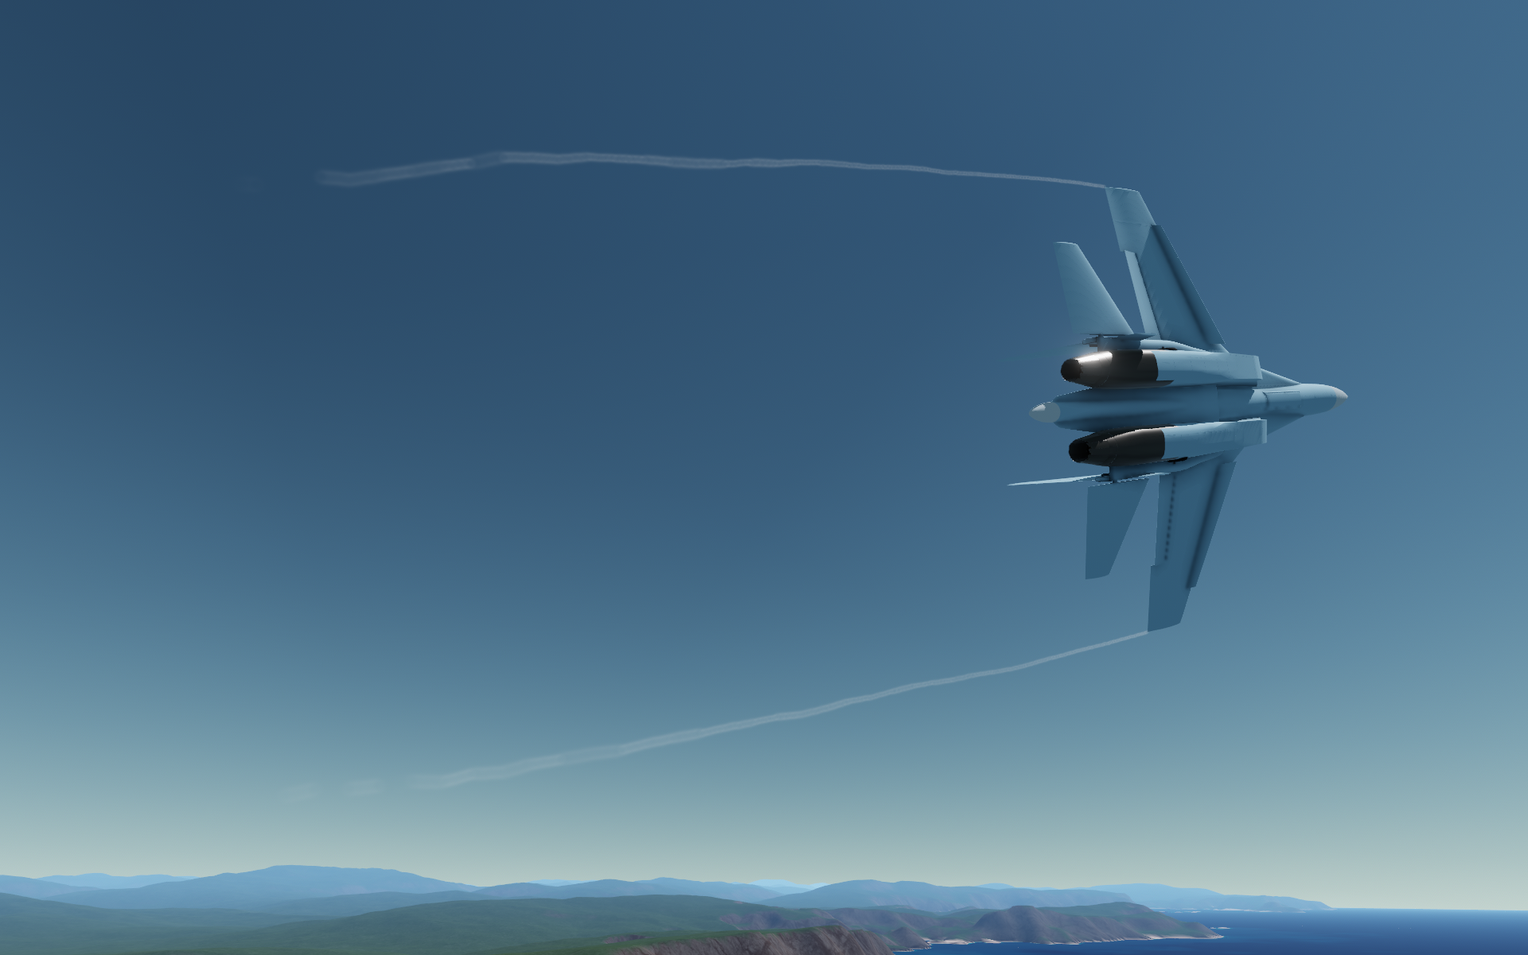

The LERX vortex effect:  
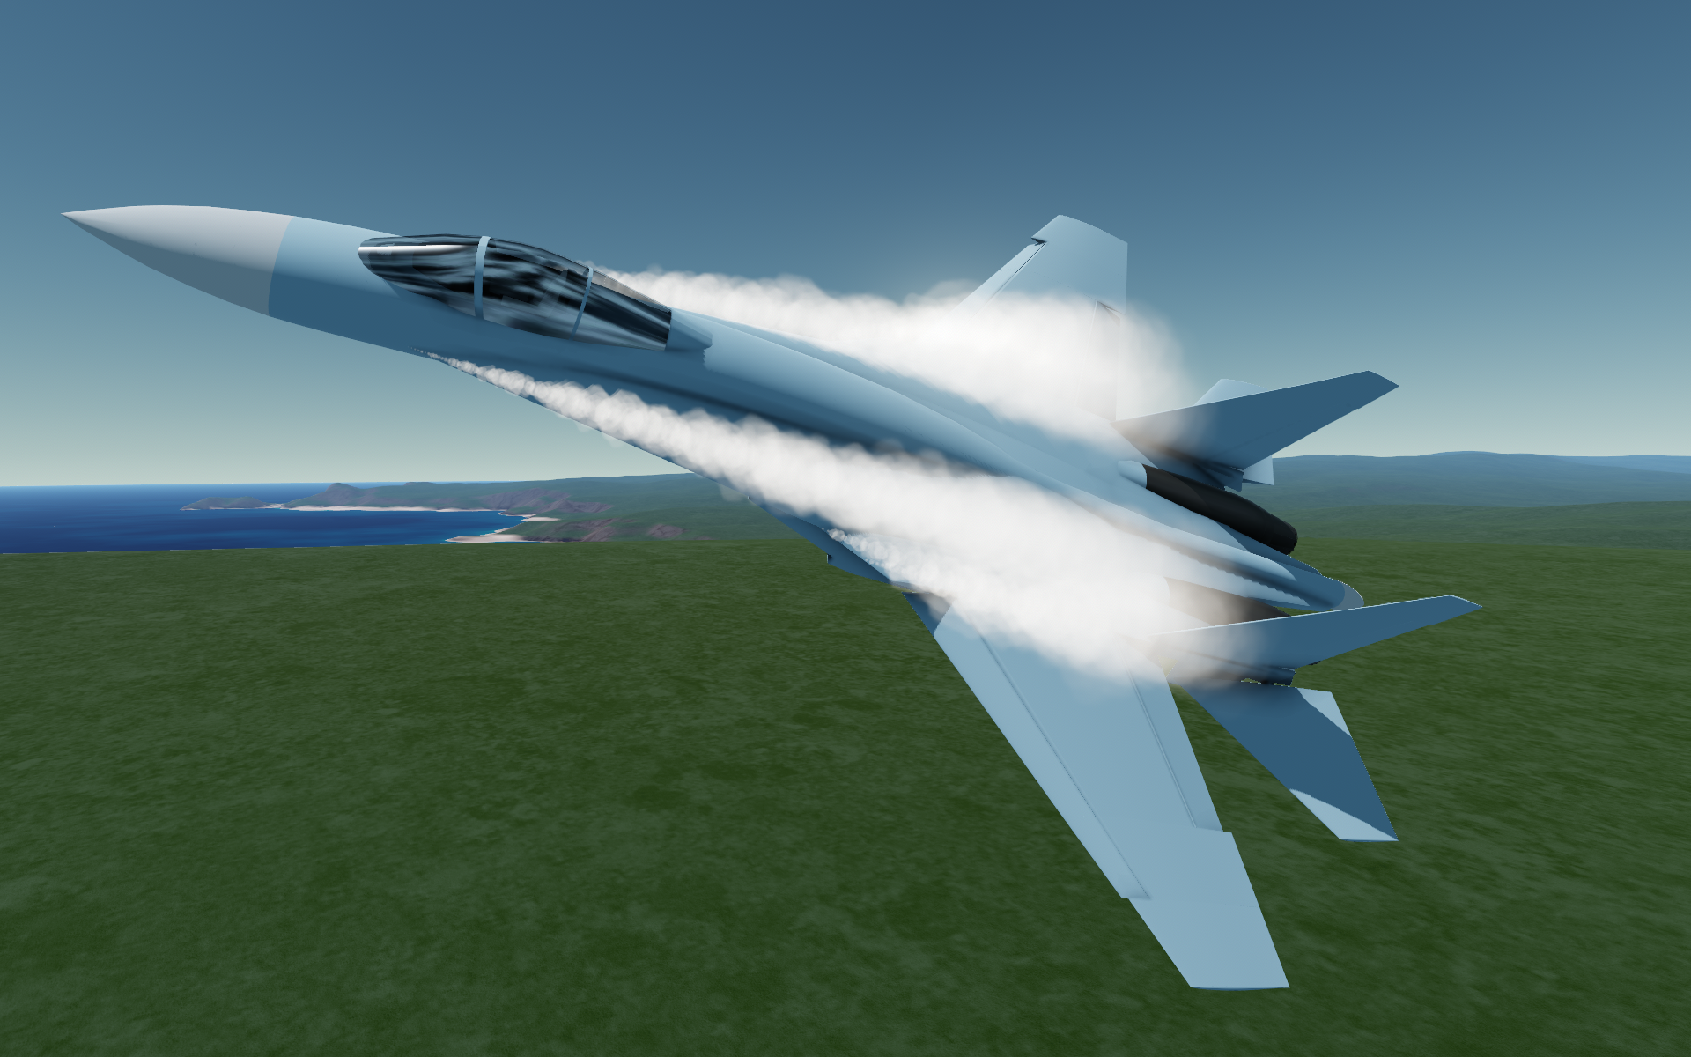

The wing vortex effect:

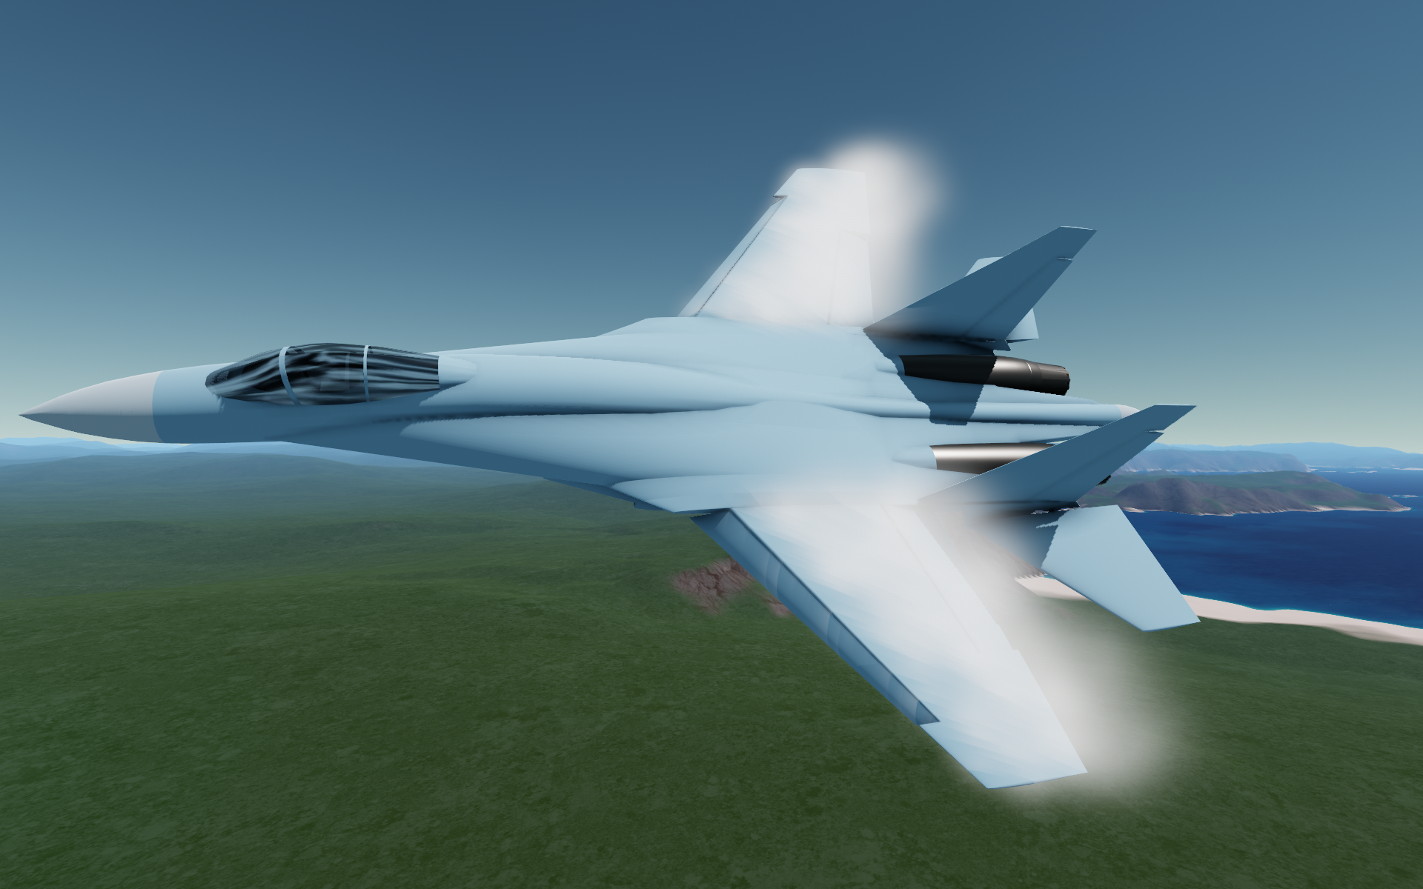

The visual effect of the wing bending:  
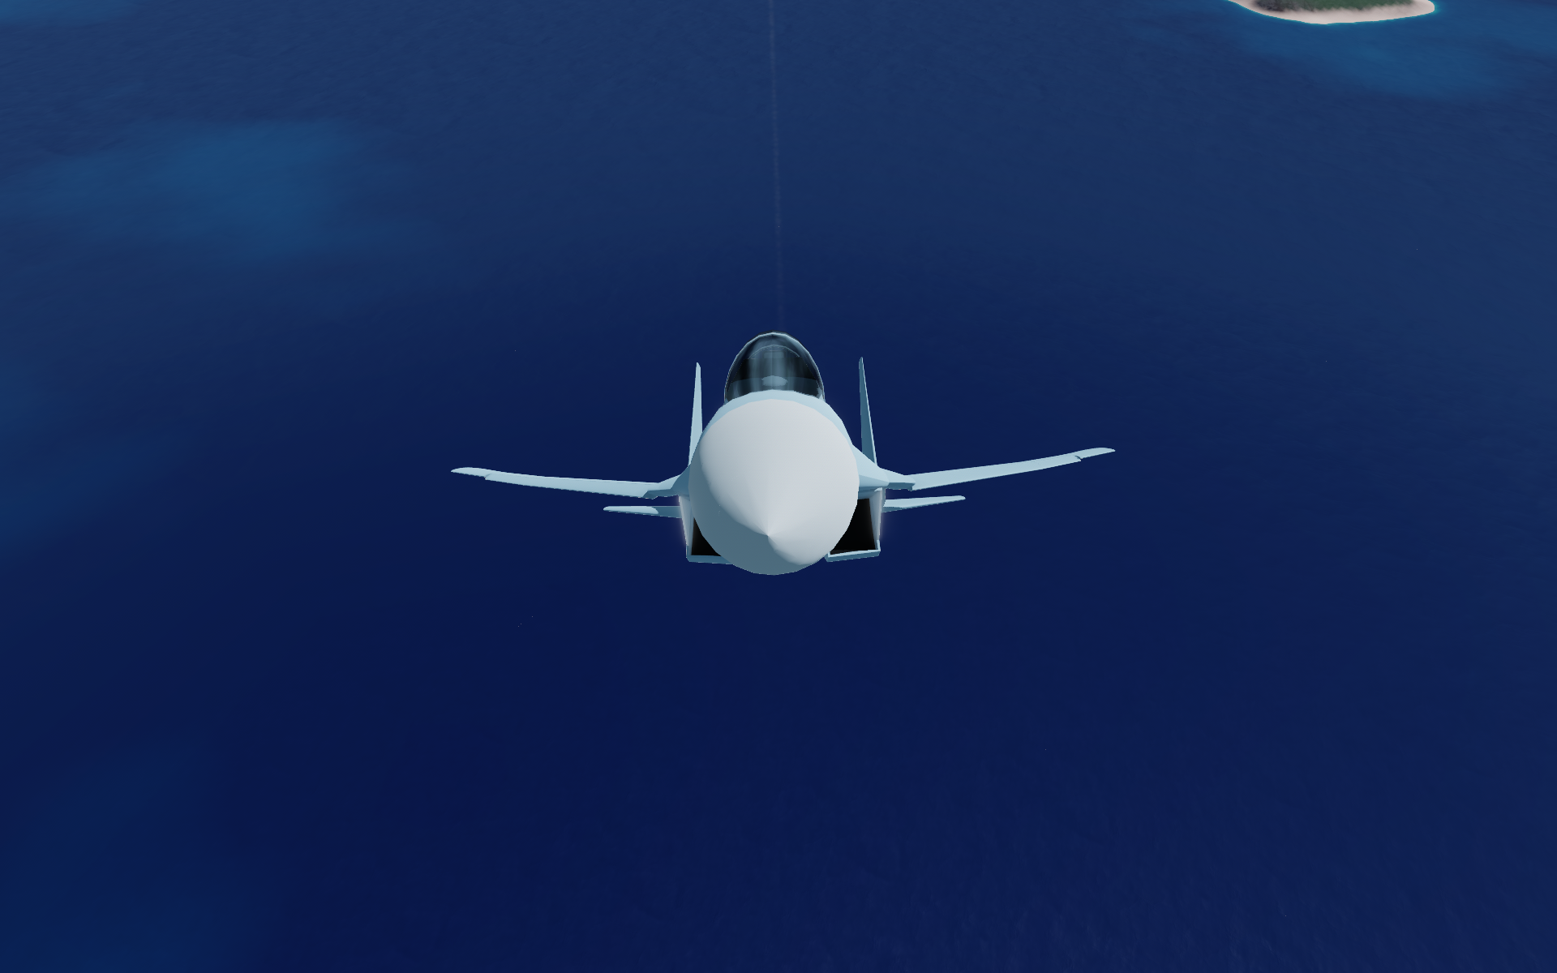

**SimpleWing** have a visually customizable actuator:  
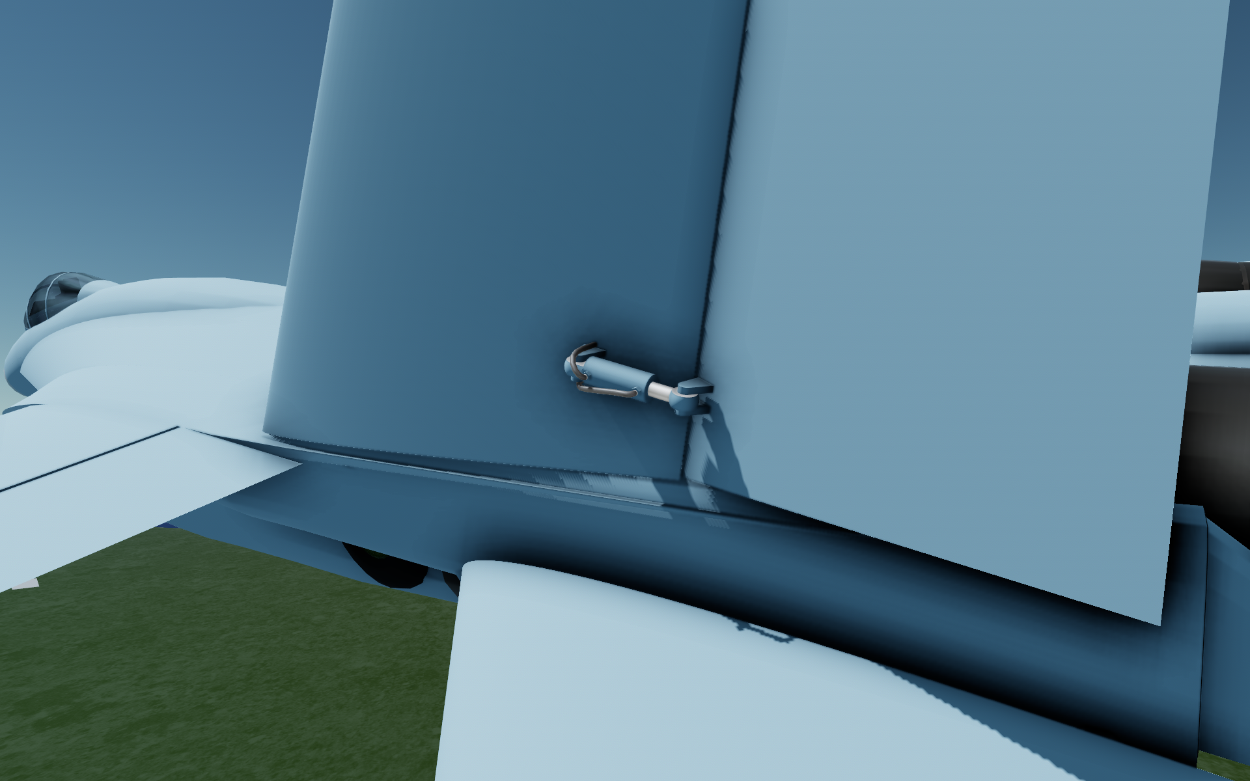

Also, in the mod settings you can enable Debug mode, which will render force vectors during flight:  
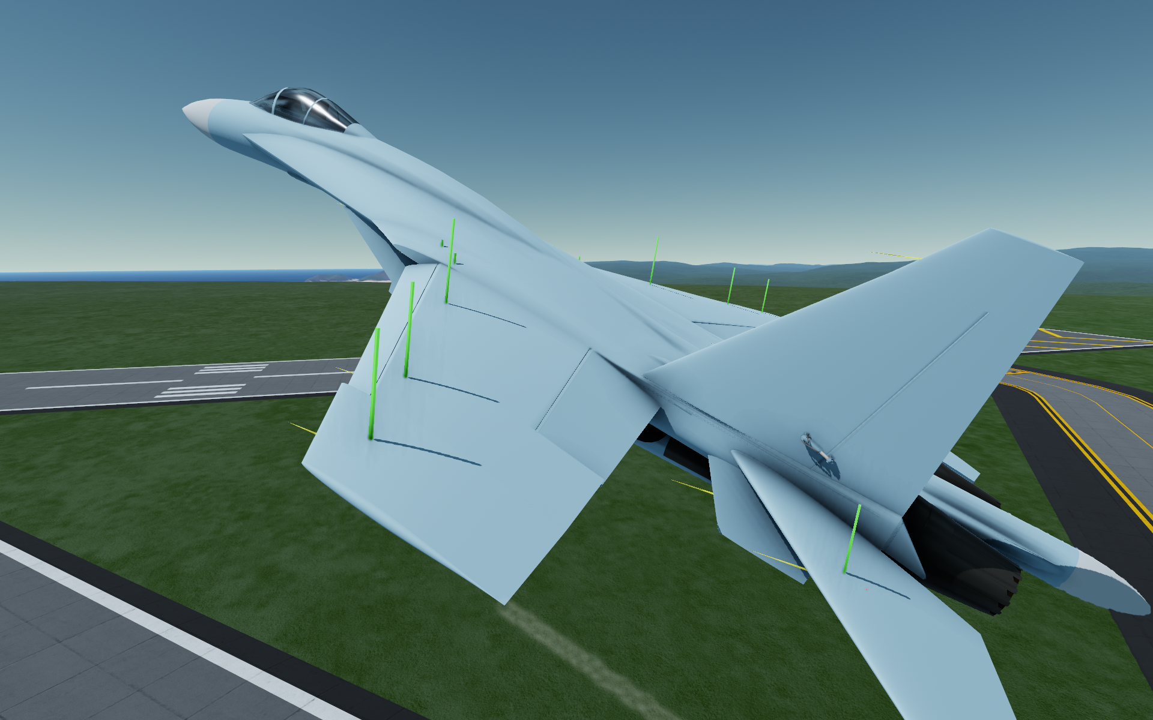

Among other mechanics, **SimpleWing** have the LERX mechanics. If the SimpleWing is a LERX (its sweep angle is greater than 61°), it affects the lift curve $C_{y}$ and drag curve $C_{x}$ of the attached SimpleWing parts:

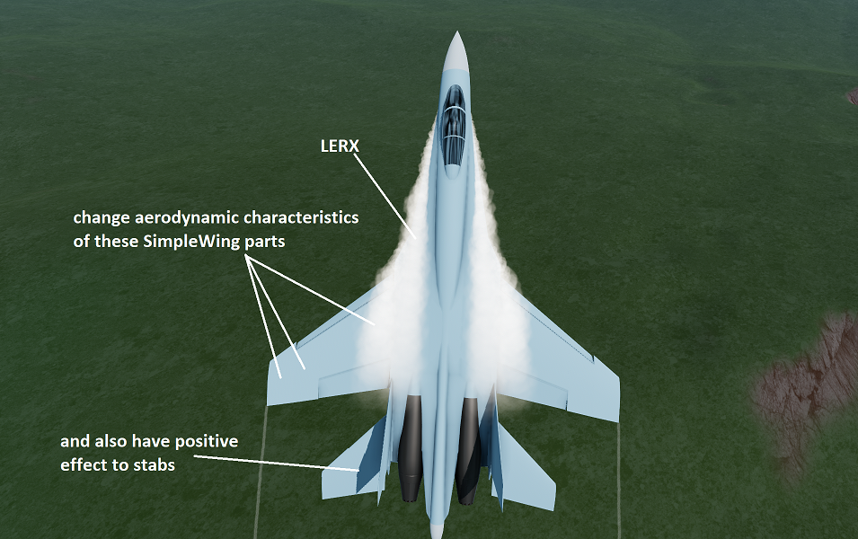

In the Designer in the special SimpleWingData window you can view various characteristics of the wing:  
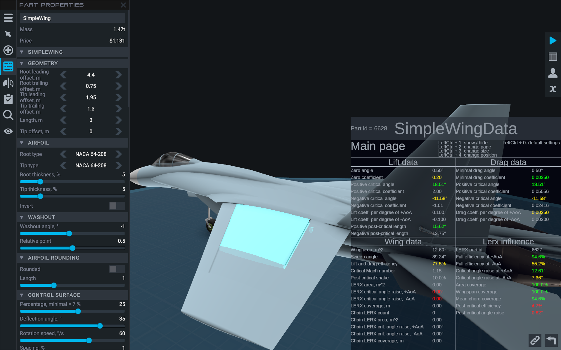

So, the new **SimpleWing** part allows you not only to design a wing that looks like the real wing, but also create an airplane with a flight model like the real airplane!

# Comparison with stock wing, advantages and disadvantages

Advantages:

* Leading edge is a part of the wing.
* $C_{y}$ and $C_{x}$ change during the flight.
* 5 different aerodynamic airfoils with different characteristics.
* Own visual effects.
* Visual bending effect.

Disadvantages:

* Unable to directly set the $C_{y}$ and $C_{x}$, like the stock wing.
* Adjusting the wing geometry is done manually through the wing properties in the Geometry section, not by using the handy arrows like the stock wing.
* Lower performance, with a lot of SimpleWing parts the frame rate of the game can drop.
* The visual effect of the bend has no affect the stock parts attached to the wing.

# Installing the mod

By clicking on the "Download" button on the mod page, you will download the **SimpleWings2.sr2-mod** file. After double-clicking on the file, automatic installation of the mod should start and the game Juno: New Origins should launch. If not, install the mod manually:

Place this file in the folder

*C:\Users\[USER NAME]\AppData\LocalLow\Jundroo\SimpleRockets 2\Mods.*

On my computer, the path looks like this

*C:\Users\Ivan\AppData\LocalLow\Jundroo\SimpleRockets 2\Mods.*

Note that the *AppData* folder may be hidden. Check the *Hidden Items* checkbox to display it:

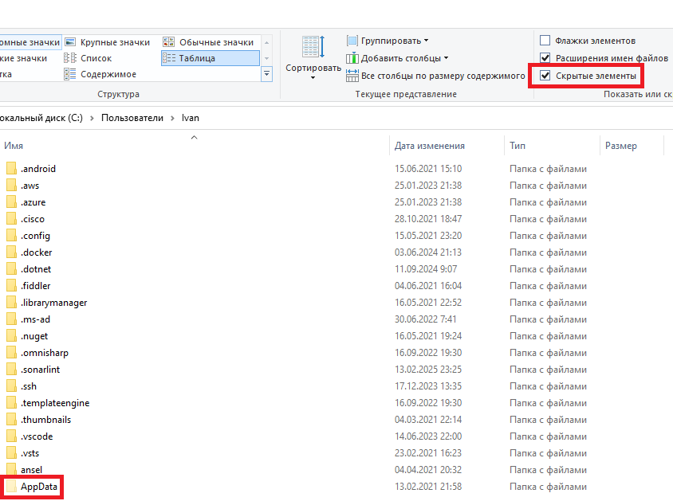

As a result, you should have this:

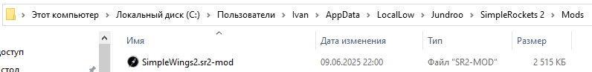

The size of the **SimpleWings2.sr2-mod** file you downloaded may differ from the 2515 KB in the image, as this manual is writing during the development of the mod, i.e. before its release.

Once you have launched Juno: New Origins, go to the Mod Manager tab:

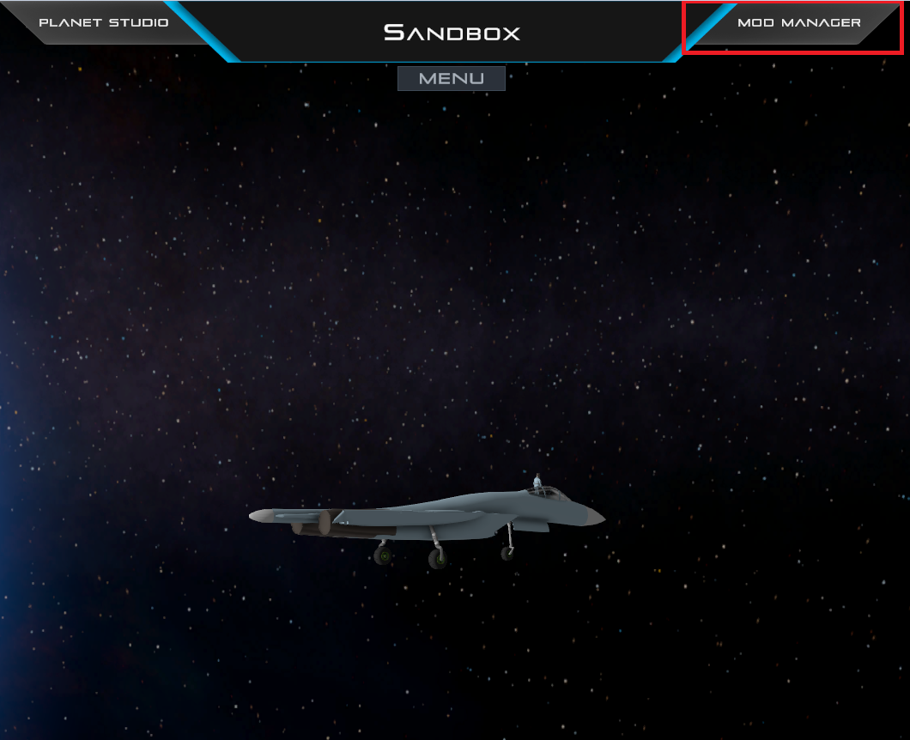

And enable the SimpleWings2 mod by clicking on "Enable":

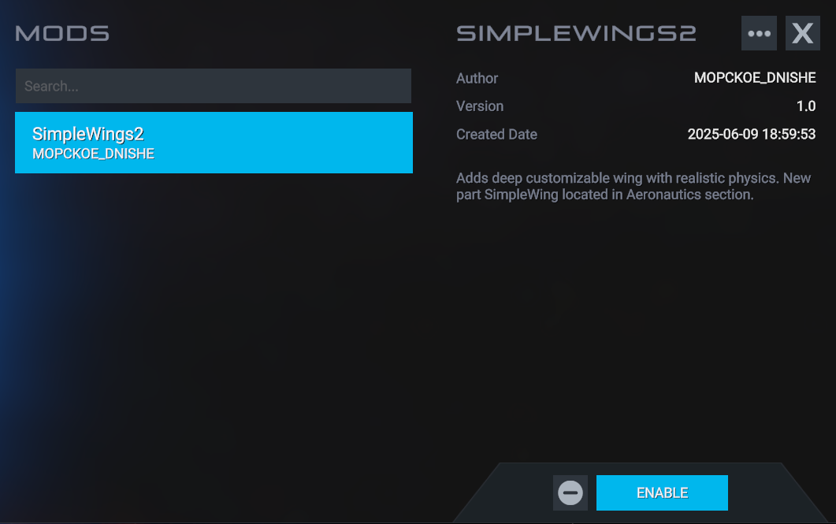

Note that your "Created Date" will be different and contain a later date - the release date of the mod.

# SimpleWing part location

In the designer, by going to the **Aeronautics** tab, you will find a new part, SimpleWing:

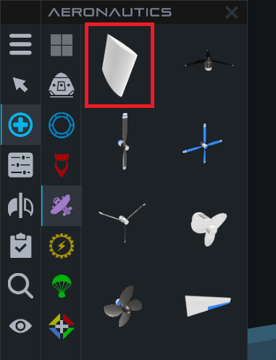

Once placed in the designer, it looks as follows:

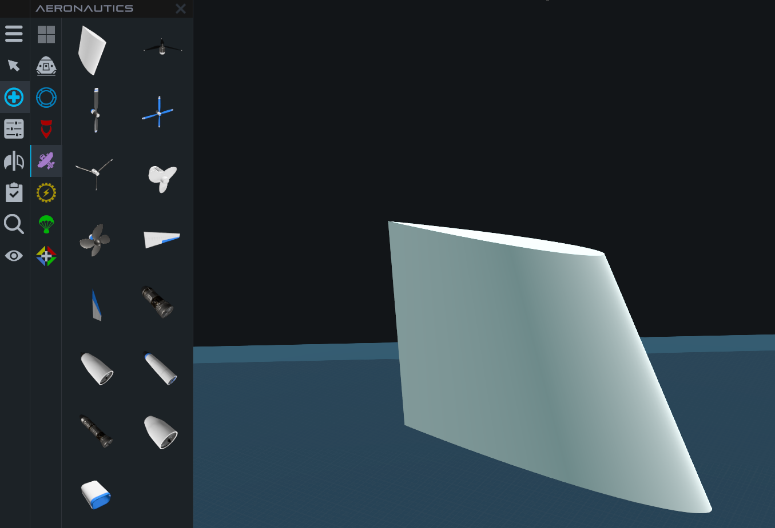

# Using different text colors in the manual

The various abbreviations are highlighted **in bold type like this**. The abbreviations can be found in the Terminology section.

The property names you see when going in Tinkel Panel are highlighted by this blue color.

# Terminology

**MAC** – mean aerodynamic chord.

**AoA** - angle of attack.

**AFC** - aerodynamic forces center.

# How SimpleWing works

SimpleWing creates 3 types of forces and 1 torque:

1. Lift force
2. Drag force
3. Wave drag force
4. Additional torque of the control surface

All three forces are applied at the aerodynamic forces center (**AFC**) of the wing. This center is located at 25% of the mean aerodynamic chord (**MAC)** at post-critical angles of attack. Once the critical angle of attack is overcome, the **AFC** moving to 50% of the **MAC** at 90° angle of attack (**AoA)**. A more detailed description of the logic for moving the **AFC** will be in the relevant sections.

## Lift force

The SimpleWing lift force is calculated by the formula

$$Y=C_{y}\frac{ρV^{2}}{2}S$$

where:

- lift force in Newtons;

- lift coefficient, depending on the angle of attack, wing sweep, angle of slip, airfoil characteristics, influence of the control surface, influence of the leading edge, influence of the LERX;

- the density of the environment (e.g., air) in ${ kg/m}^{3}$. At sea level in Droo, the air density is approximately 1.20;

- velocity of the SimpleWing relative to the planet's surface;

S - wing area in $m^{2}$.

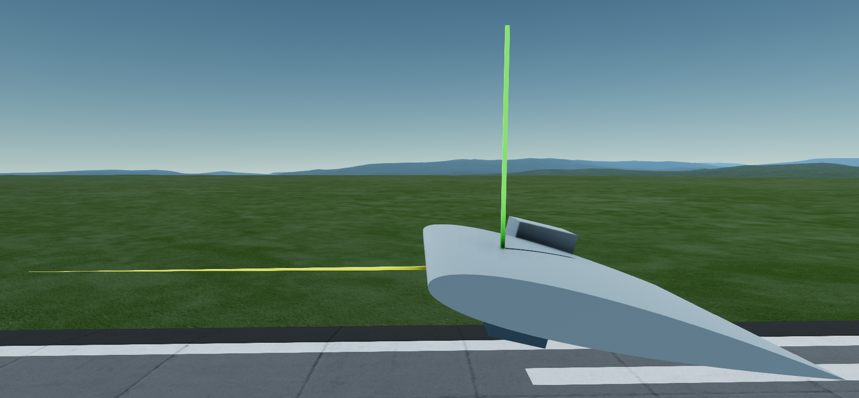

In the figure, the velocity vector is yellow. The lift vector is green. The lift vector is always perpendicular to the velocity vector.

## Drag force

The drag force is calculated using a formula very similar to the wing lift formula:

$$X=C_{x}\frac{ρV^{2}}{2}S$$

Where:

- drag force in Newtons;

- drag force coefficient, depending on the angle of attack, wing sweep, angle of slip, airfoil characteristics, influence of the control surface, influence of the leading edge, influence of the LERX;

- the density of the environment in ;

- the velocity of the wing relative to the surface of the planet;

S - wing area in $m^{2}$.

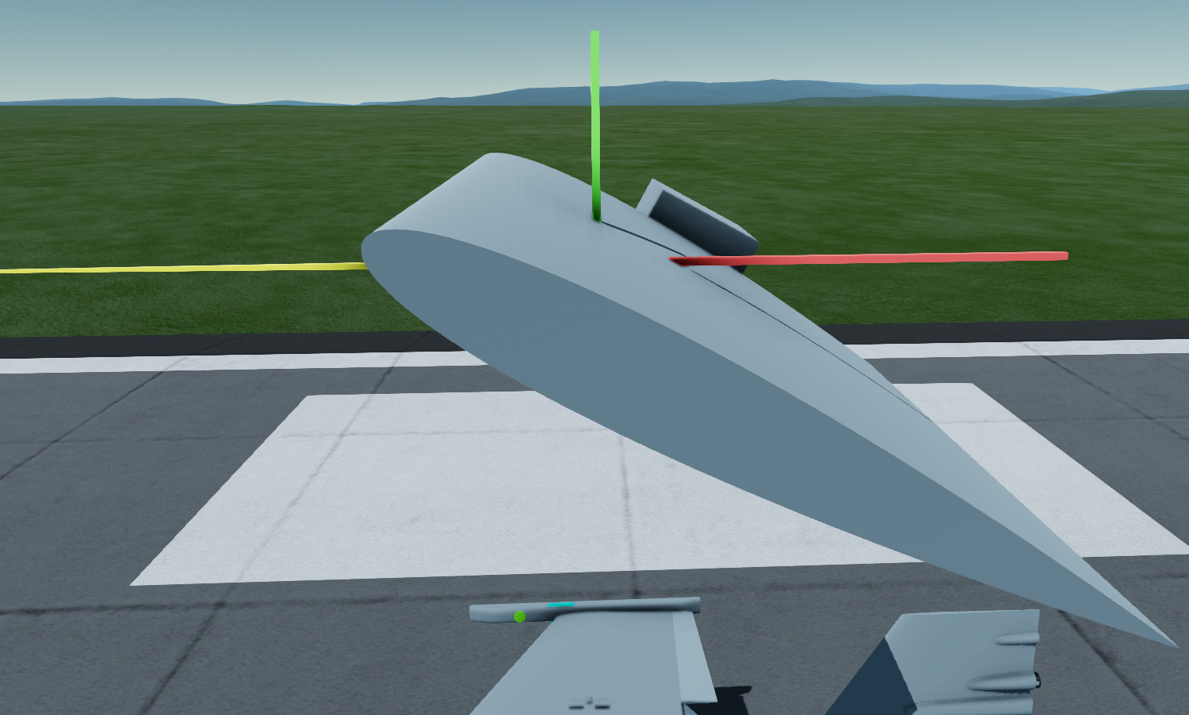

In the figure, the drag force vector is red. It is always directed against the velocity vector.

## Wave drag force

Wave drag occurs at speeds greater than the critical Mach number of the wing. For example, for a symmetrical airfoil *NACA 0012* with a 1% airfoil thickness and a straight wing without sweep, the critical Mach number is **1**, i.e. 340 m/s or 1250 km/h at sea level.

The wave drag coefficient is calculated by the formula:

$$C_{x wave}=0.002(1+2.5\frac{∆М}{0.06+∆М})^{3}-0.002$$

Where:

- wave drag coefficient;

- the difference between the wing speed in Mach and the critical Mach number of the wing.

The wave drag force is calculated by the formula:

$$Х_{wave}=C_{x wave}\frac{ρV^{2}}{2}S$$

Where:

- the wave drag force in Newtons;

- wave drag coefficient;

- environment density in ;

- the velocity of the wing relative to the surface of the planet;

S - wing area in $m^{2}$.

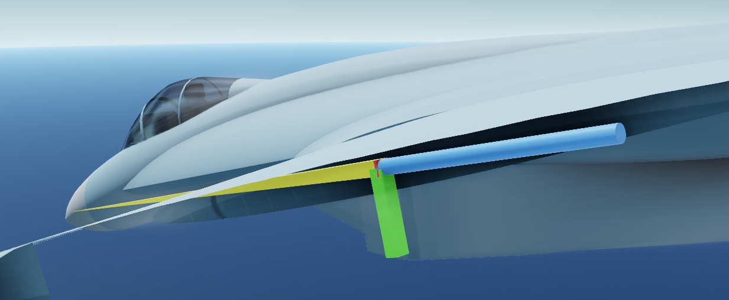

In the figure, the wave drag vector is blue. It is always directed against the velocity vector.

The formula for calculating the wave drag coefficient (11) is taken from [https://studfile.net/preview/9955111/page:4/.](https://studfile.net/preview/9955111/page:4/)

## Additional torque of the control surface

Additional control surface torque has been added so that you can build and control aircraft with a delta wing like the Mirage-2000.

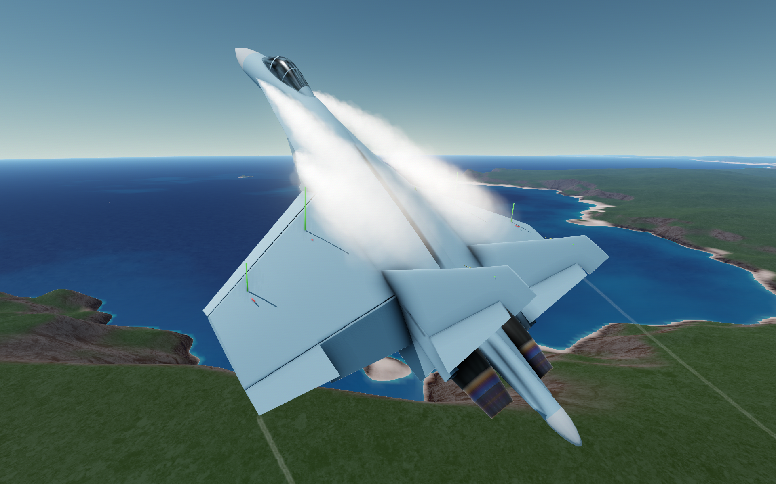

To understand why this is necessary, imagine you built an airplane that has the **AFC** of thewing at the center of mass of the airplane. Such a wing would generate lift, but would not generate any moment, since the moment of force relative to the aircraft's center of mass would be zero. An airplane with a delta wing would be uncontrollable in pitch.

In the other case, if the **AFC** ofyour delta wing were located far from the center of mass, the deflection of the control surface would create enough moment to control pitch.

So, in the first case the additional torque of the control surface will be maximal. In the second case it will be zero.

The calculation of the additional control surface torque depends on the position of the **AFC** relative to the aircraft's center of mass and the length of the **MAC.**

If the distance from the **AFC** to the center of mass is 0% of the **MAC**, i.e., the **AFC** is at the center of mass, the additional moment will be 100%.

If the distance from the **AFC** to the center of mass is 100% of the **MAC** length or greater, the additional moment will be zero.

Thus, as the distance from the **AFC** ofthe aircraft wing to its center of mass increases, the own moment of the wing will increase and the additional moment of the control surface will decrease.

# Basic aerodynamic characteristics of airfoils

The aerodynamic airfoil of the SimpleWing has a several aerodynamic characteristics that determine the lift force curve $C_{y}$ and drag force curve $C_{x}$.

## Aerodynamic characteristics of the airfoil for calculation of lift force

* Lift coefficient at zero angle of attack. Varies from **0** for *NACA 0012* airfoil to **0.4** for *Clark Y* airfoil.
* Critical angle of attack. Depends on the type of airfoil and its thickness. You can see it in the SimpleWingData window in the game on the **α & Thickness** page or in section 13.3. α & Thickness. If the critical angle of attack is exceeded, the lift force of the wing decreases a lot.
* Lift increment factor. Determines the increase of the lift coefficient per one degree of angle of attack. For the *NACA 0012* airfoil, this coefficient is **0.1**. This means that at an angle of attack of **10°**, the coefficient $C_{y}$ will be **1**.
* Post-critical length in degrees of angle of attack. Determines the stability at post-critical angles of attack. For *NACA 0012* airfoil it is **10°**:

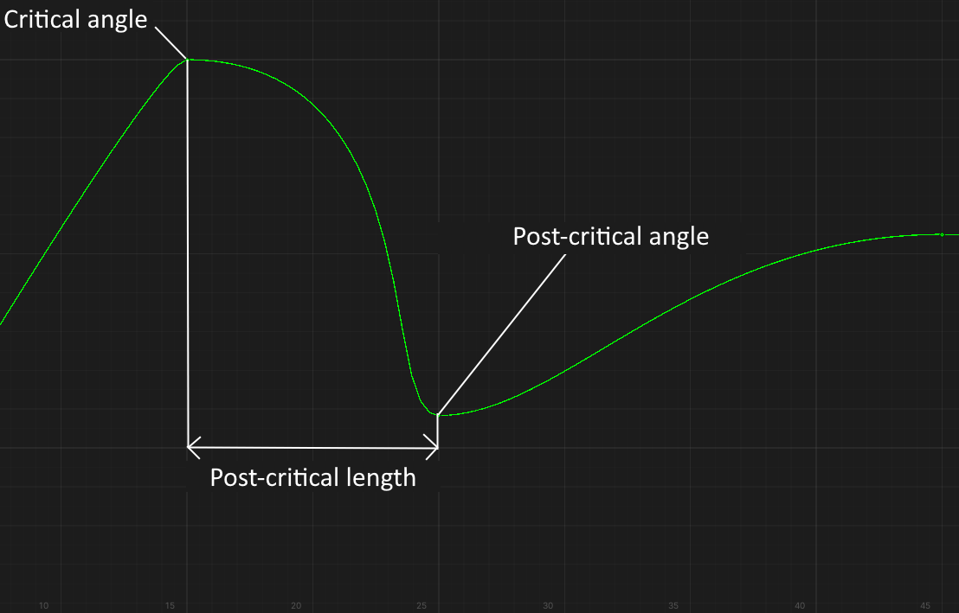

* Asymmetry coefficient for asymmetric airfoils. It determines how much the modulus of the negative angle of attack is less than the positive angle of attack and how much the negative post-critical length is less than the positive one. For the *Clark Y* airfoil, this coefficient **0.66**.
* Aerodynamic shake coefficient at post-critical angles of attack. For *NACA 0012* this coefficient is **10%**. This means that the value of lift force will vary from **90%** to **110%** when overcoming the critical angle of attack, creating aerodynamic shake. The drag force will vary from **100%** to **110%**.
* Critical coefficients that determine the nonlinearity of the lift curve in the region of subcritical angles of attack and the shape of the curve in the region of post-critical angles of attack. For *NACA 0012*, these coefficients are: **0.1, 1.0, 0.25**

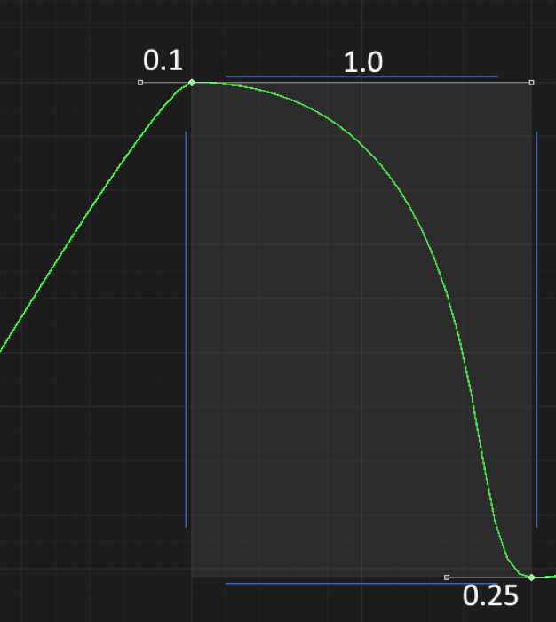

The first coefficient of **0.1** indicates that the lift force curve in the region of subcritical angles of attack is almost linear. The second coefficient of **1.0** and the third coefficient of **0.25** determine the smooth shape of the curve in the region of post-critical angles of attack.

## Aerodynamic characteristics of the airfoil for calculation drag force

* The coefficient of minimum drag force. For *NACA 0012* airfoil with 12% thickness is **0.006**. For *NACA 0012* airfoil with 24% thickness will be twice as much, i.e. **0.012**. For *NACA 0012* airfoil with 6% thickness will be half as much, i.e. **0.003.** This dependence from the airfoil thickness is linear.
* The critical angles of attack for the drag curve are equal to the critical angles of attack for the lift curve.
* Angle of attack of the minimum drag force. May vary from 0°. For the *Clark Y* airfoil, this angle is **+1°**.
* Drag increment factor for positive and negative angles of attack. Define the increase of the drag coefficient per one degree of angle of attack. For the *NACA 0012* airfoil they are **0.002**. For the *Clark Y* airfoil it **0.003** for positive angles of attack and **0.002** for negative angles of attack. This means that the *Clark Y* airfoil will generate 50% more drag at positive angles of attack.
* The critical Mach number of the airfoil with a relative thickness of 1%. For *NACA 0012* is **1**. For the airfoil *NACA 0012*, the dependence of the critical Mach number from the airfoil thickness is such that the critical Mach number increases from **0.62** for a **15%** thick airfoil to **1** for a **1%** thick airfoil and decreases from **0.62** to **0.47** for a **24%** thick airfoil. The critical Mach number of **0.62** was not chosen by chance - this is the critical Mach number of a **15%** thick Yak-40 wing.

## Aerodynamic airfoil characteristics for calculation LERX efficiency

* The asymmetry coefficient for calculating the LERX vortex efficiency. The lower the coefficient, then worse the vortex efficiency at negative angles of attack for a non-inverted airfoil and at positive angles of attack for an inverted airfoil. Since *NACA 0012* is a symmetric airfoil, if this airfoil is used for the LERX, it will be equally efficient at both positive and negative angles of attack. For the *T-10 root* airfoil this coefficient is **0.75**.
* Coefficient of LERX vortex coverage. For *NACA 0012* and for all other airfoils with a round leading edge this coefficient is **0.5**. For the *T-10* wing airfoil this coefficient is **1.0**, i.e. this root vortex covers twice as much wing length as the *NACA 0012* root vortex.
* The maximum increase of the critical angle of attack when using airfoil for the LERX. For *NACA 0012* and all other round leading edge airfoils, this value is **5°**. For the *T-10 root* airfoil, this value is **15°**.

# SimpleWing curves calculation

In calculating the curves for all the airfoils, I drew from these two graphs of the *NACA 0012* airfoil:

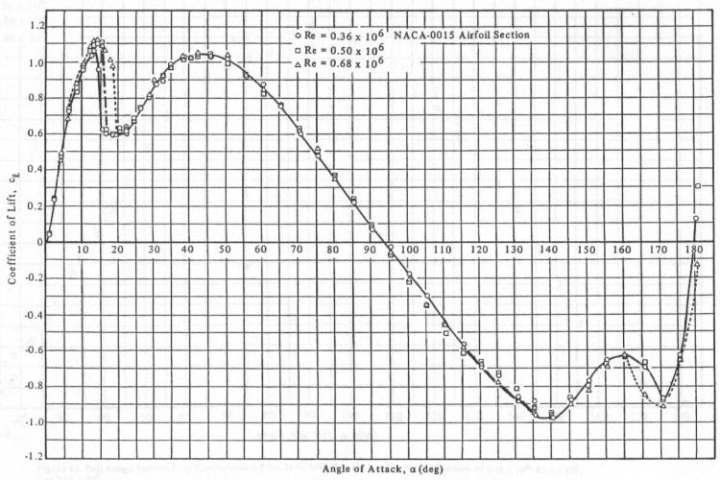

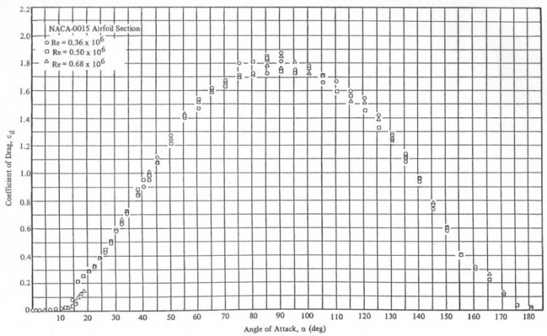

## Calculation of the lift curve

For the wing without mechanization, the lift curve has the following form:

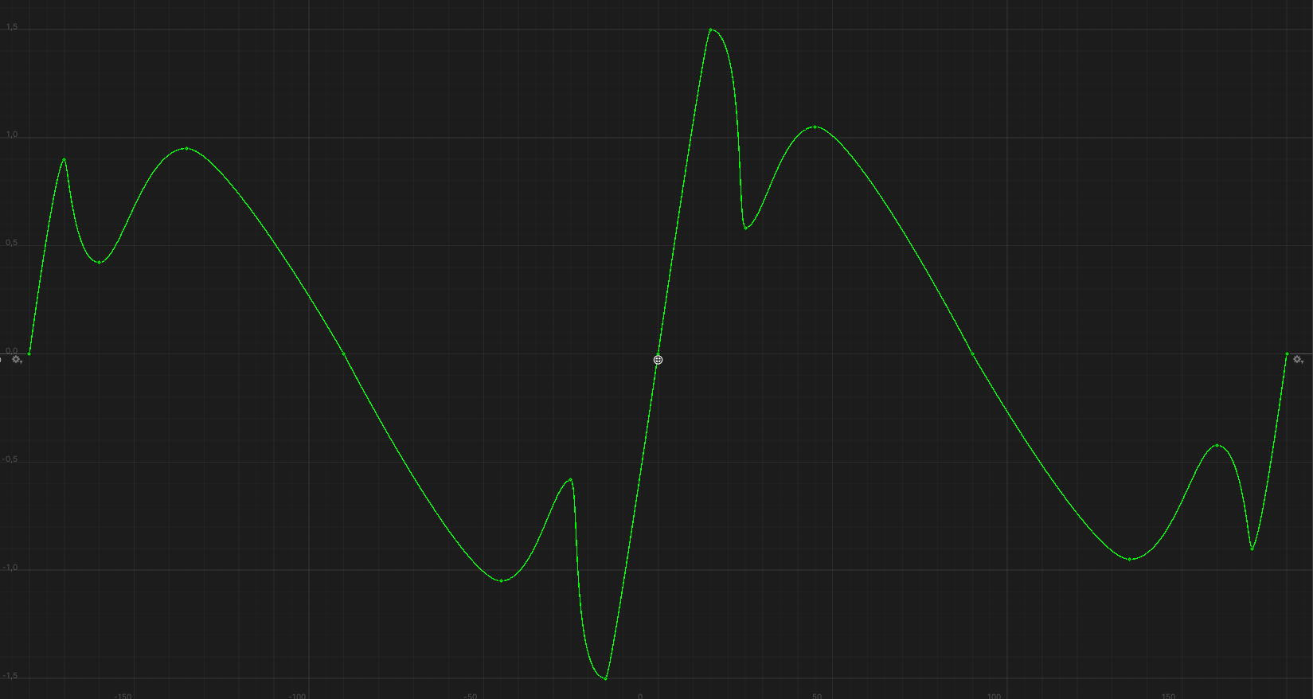

This curve consists of 17 reference points. Each point has a tangent "left" and a tangent "right". Each tangent has its own angle and length. The shape of the entire curve is determined by the coordinates of the reference points on the horizontal axis (angle of attack) and on the vertical axis (coefficient), as well as the angles and lengths of the tangents:

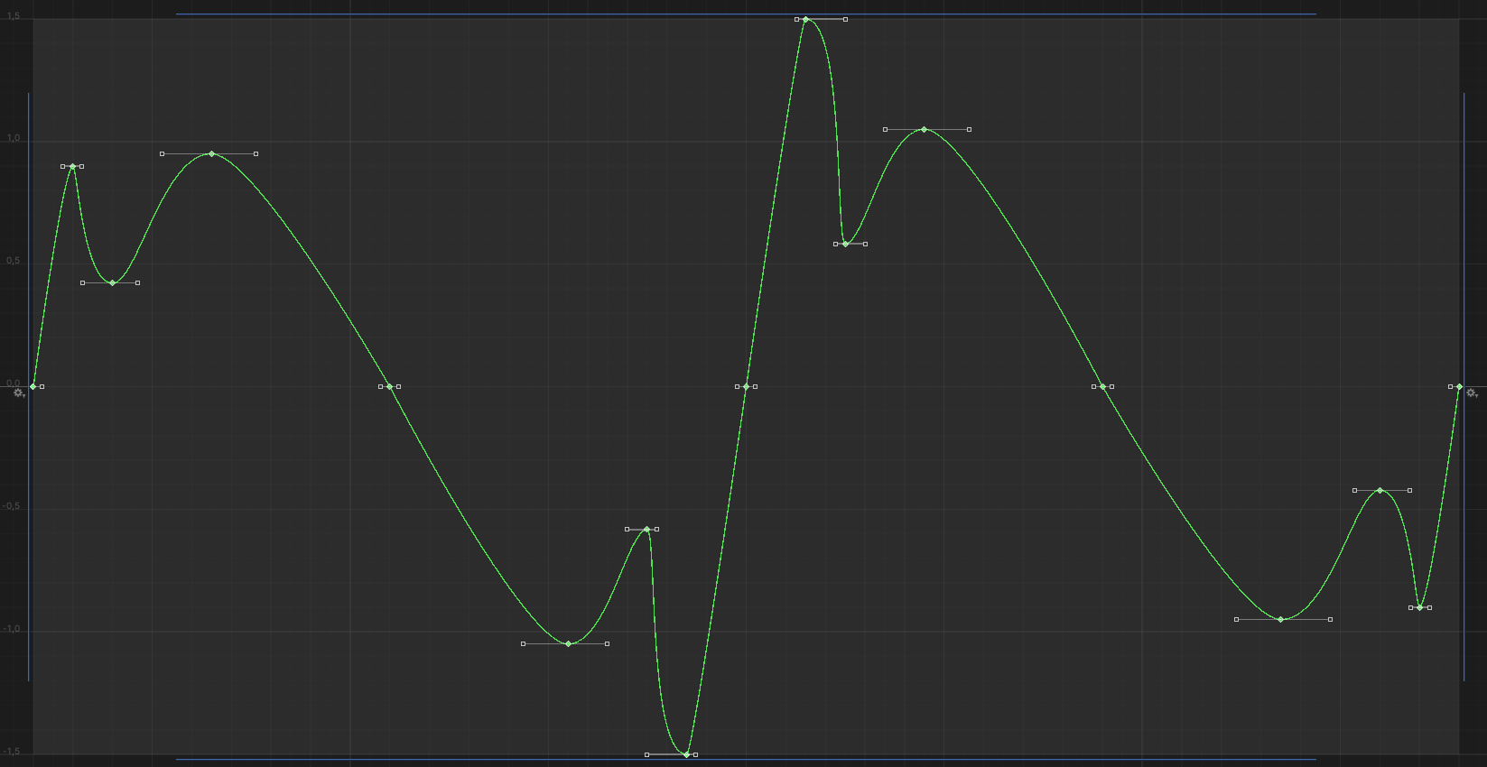

In the area of angles **0°** – **90°**, the reference points are as follows:  
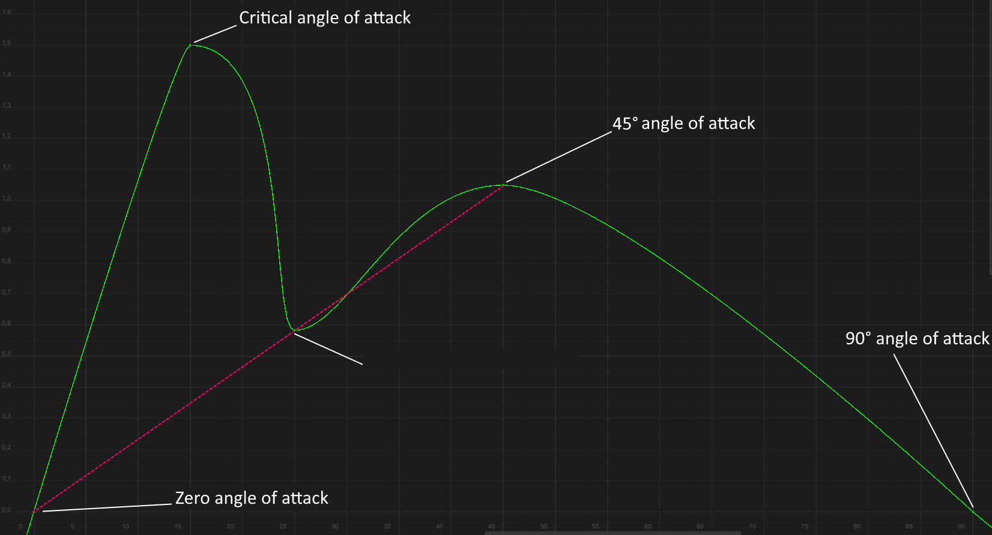

**Zero angle of attack** is at 0° angle of attack in the horizontal axis, in the vertical axis the value of the coefficient can vary from **0** to **0.4** depending on the airfoil.

**Critical angle of attack** onthe horizontal axis is calculated based on the airfoil type and its thickness, and on the vertical axis the coefficient is calculated as the product of the critical angle of attack by the incremental lift.

**Post-critical angle of attack** onthe horizontal axis is calculated as the sum of the critical angle of attack and the post-critical length, and on the vertical axis the coefficient is calculated so that this reference point is on the same line between zero angle of attack and 45° angle of attack. This is indicated in the figure above by the red dashed line.

The value of the **45° angle of attack** coefficient in the vertical axis is **1.05** for all airfoils.

The value of the **90° angle of attack** coefficient in the vertical axis is **0** for all airfoils - when the wing is perpendicular to the oncoming airflow, it generates no lift.

The reference points in the **-90°** – **0°** angle region (negative angles of attack) are calculated in a similar manner, but taking into account the asymmetry factor for asymmetric airfoils.

The reference points in the region of "inverted" angles of attack, i.e. in the regions of **90° – 180°** and **-180° – -90°** are also calculated depending on the airfoil thickness, but this dependence is weakly.

For "inverted 45° angles of attack", i.e. for angles of attack $±135°$ the lift coefficient is fixed and approximately $±0.95$.

For "inverted critical angles", i.e. for angles of attack approximately $±170°$, the lift coefficient is approximately **0.9** and varies slightly with airfoil thickness.

At angles of attack of **180°**, the lift coefficient is four times less than the lift coefficient at zero angle of attack.

### Influence of the control surface to the lift curve

Deflecting the control surface does several things:

1. Increases/decreases the coefficients of zero angle of attack, positive critical angle of attack, and negative critical angle of attack, "raising/lowering" that region of the curve:

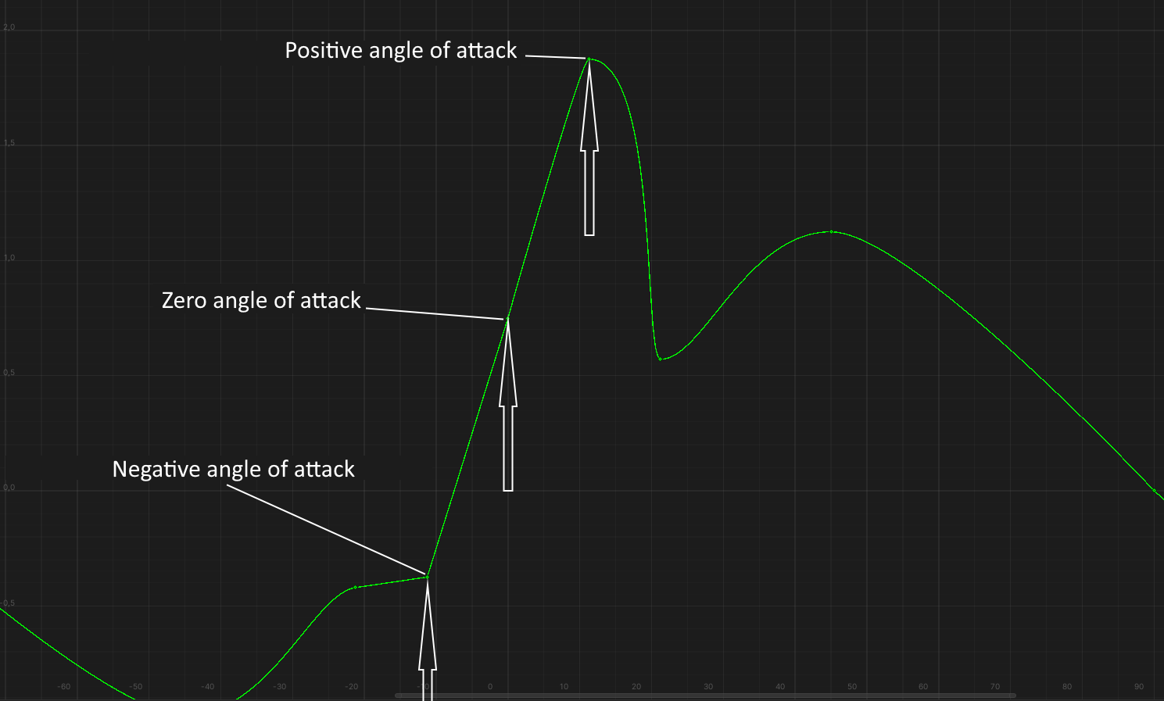

The increasing of the coefficient is calculated as the result of multiplying the following multipliers:

* Angle of deflection of the control surface in degrees;
* The incremental lift force of the wing;
* Control surface size in percent of wing chord / 100;
* Deflection angle efficiency. Equals **1** for deflection angles up to 45°. Decreases from **1** to **0** for deflection angles between 45° and 90°.

*Example. Airfoil NACA 0012, control surface size 25%, deflection angle 15°:*

15° * 0.1 * 25% / 100 * 1 = **0.375**

1. Reduces both the positive critical angle of attack and its coefficient and the negative critical angle of attack and its coefficient. In this area, the curve is "cuts off":

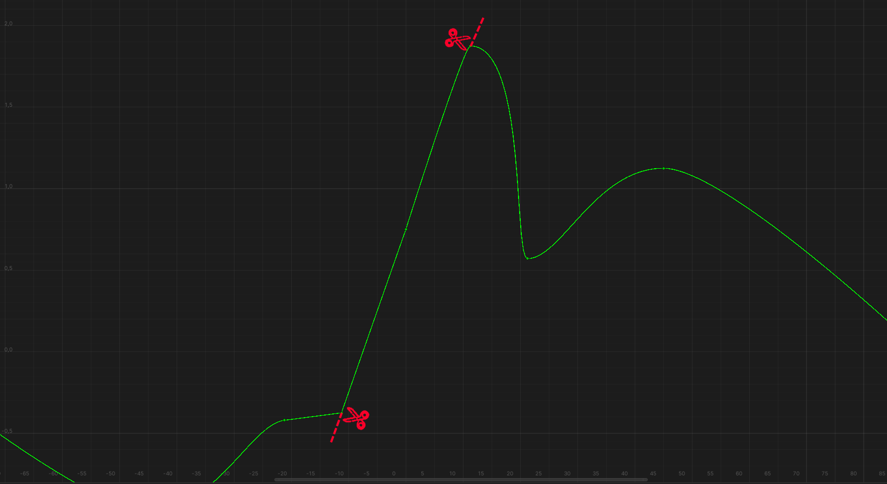

The reduction of the critical angles of attack is calculated as the result of multiplying the following multipliers:

* Control surface deflection angle modulus in degrees;
* Control surface size in percent of wing chord / 100;
* 0.5

*Example. Airfoil NACA 0012, control surface size 25%, deflection angle 15°:*

|15°| * 25% / 100 * 0.5 = **1.875°**

The decrease of the critical coefficient is calculated as the product of the previous value and the wing lift increment:

1.875° * 0.1 = **0.1875**

1. Changes the coefficients of 45° angles of attack, increasing or decreasing them, without changing the angle:

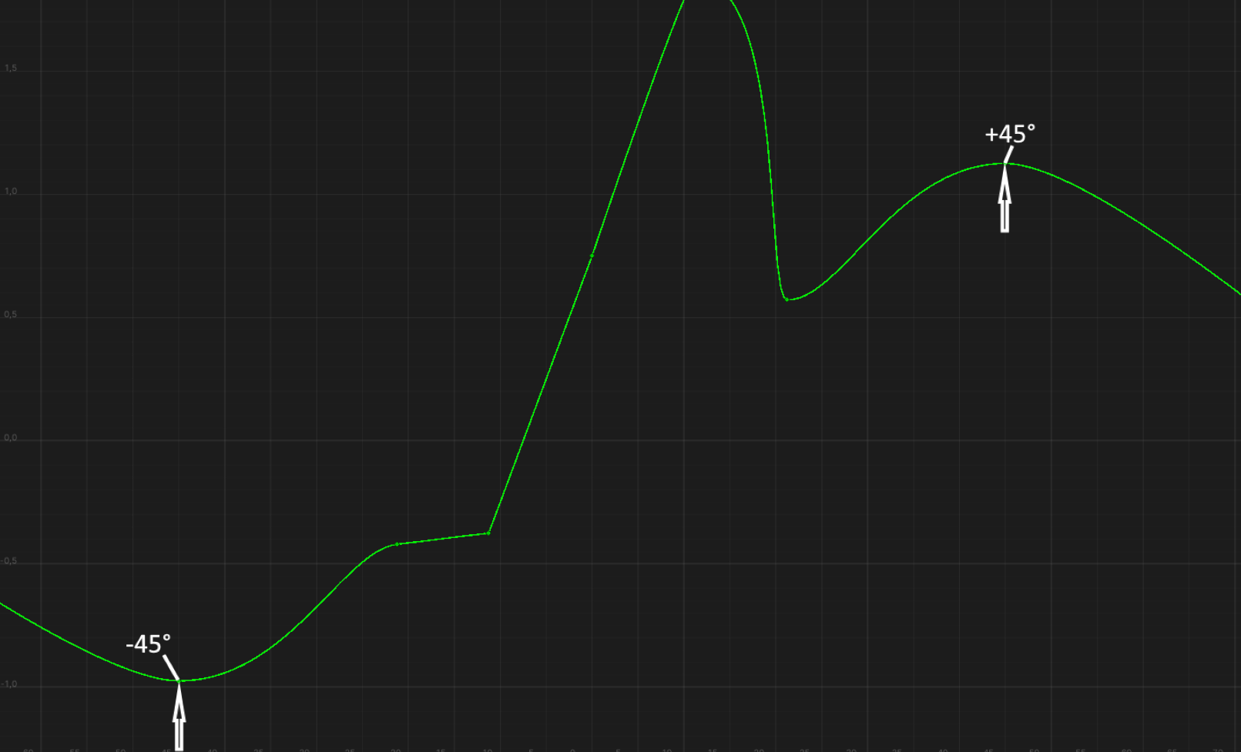

The change of their coefficient is calculated by multiplying the result of the calculation from the first paragraph by 0.1.

*Example. Airfoil NACA 0012, control surface size 25%, deflection angle 15°:*

0.375 * 0.1 = **0.0375**

Above an angle of deflection of 45°, the coefficients at angles of attack of 45° begin to decrease and reach their minimum value at the 90° angle of deflection.

1. There is a calculation of the post-critical angles of attack, which are on the same line between the 45° angles of attack and the point with coordinates (0°, $∆_{k45°}$), where $∆_{k45°}$ is the coefficient increment in 45° angles of attack. This line is indicated by white in the figure below:

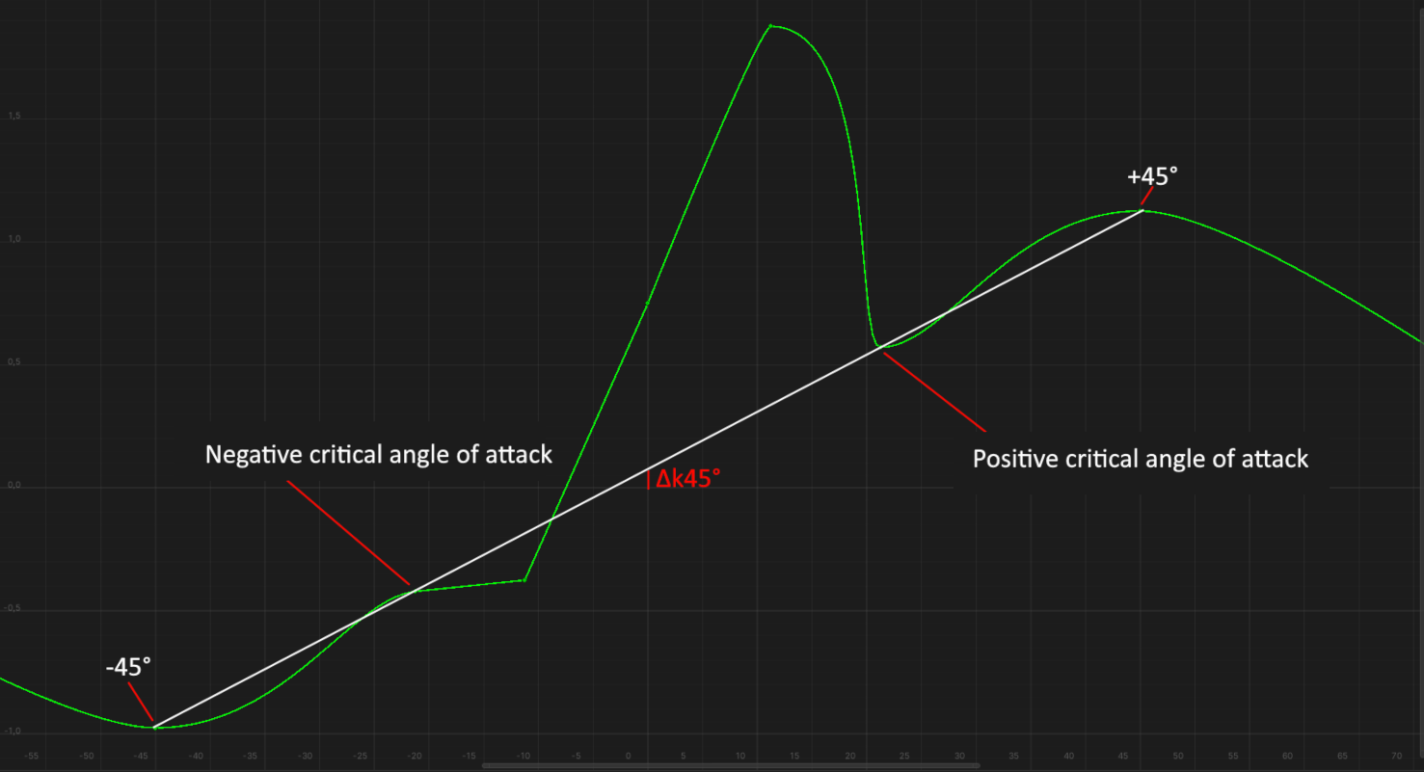

### Effect of deflected leading edge to the lift curve

The deflection of the leading edge changes the following:

1. Increases the positive critical angle of attack with its coefficient and decreases the negative critical angle of attack with its coefficient , as if "lengthening" the curve in the area of positive angles and "cuts off" in the area of negative angles:

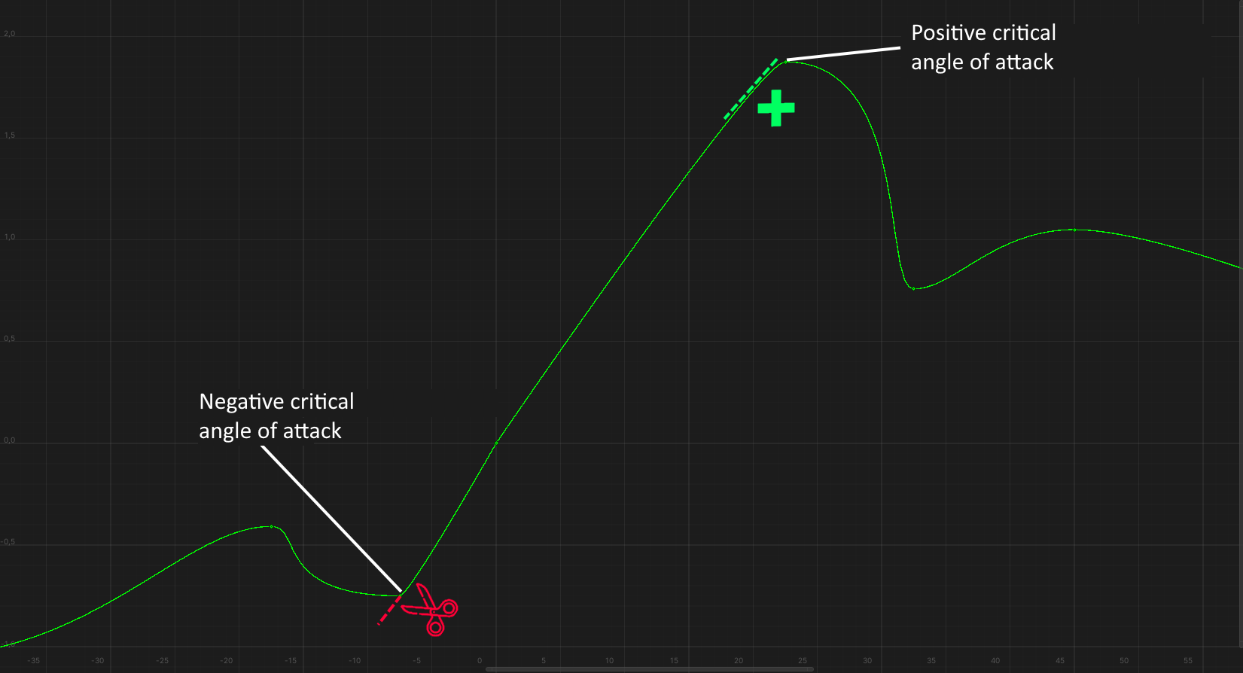

The increase of the positive critical angle of attack and decrease of the negative critical angle of attack is calculated as the product of the following multipliers:

* Angle of deflection of the deflected leading edge in degrees
* Size of deflected leading edge in percent of chord

*Example. Airfoil NACA 0012, deflected leading edge size 40%, deflection angle 30°:*

30° * 40% / 100 =  **12°**

The increasing of the positive critical coefficient is calculated as the product of the following multipliers:

* Increasing of the critical angle of attack
* Lift increment
* 0.5

*Example. Airfoil NACA 0012, deflected leading edge size 40%, deflection angle 30°:*

12° * 0.1 * 0.5 = 0.**6**

The reduction of the negative critical coefficient is calculated as the product of the following multipliers:

* Increase of the critical angle of attack
* Lift increment

*Example. Airfoil NACA 0012, deflected leading edge size 40%, deflection angle 30°:*

12° * 0.1 = **1.2**

Note that as the critical angle of attack and its coefficient increase, the lift curve "breaks" at zero angle of attack. This is due to the **0.5** multiplier in the formula for increasing the coefficient of the positive critical angle of attack. In other words, the lift gain that the leading edge deflection gives you is only 50% compared to the "normal" lift gain of a non-mechanized wing when you increase its angle of attack.

1. Post-critical angles of attack are recalculated, which are still on the same line between the 45° angles of attack. This line is indicated by the red dashed line in the figure below:

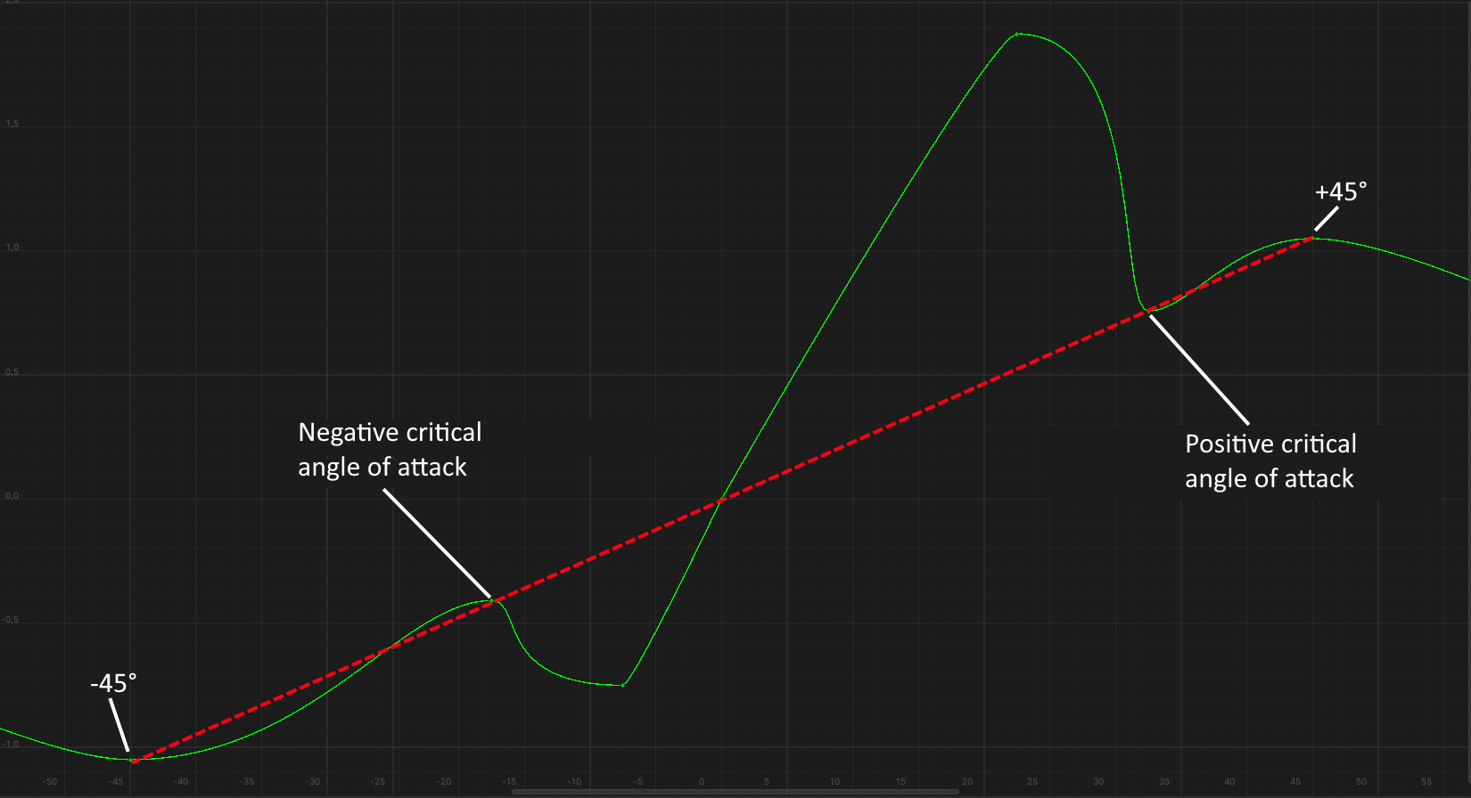

### Effect of LERX to the lift curve

The LERX does 2 things:

1. Increases critical angles of attack and their coefficients.
2. Changes the coefficients of post-critical angles of attack and smooths the curve in that region.

The LERX efficiency varies from **0** to **1**. When the efficiency is **0**, the lift curve does not change in any way. When the efficiency is **1,** the critical angle of attack is increased to the maximum possible for this airfoil and the coefficient of the post-critical angle of attack becomes such that the reference point of the post-critical angle of attack is on the red dashed line between the critical angle of attack and the 45° angle of attack:

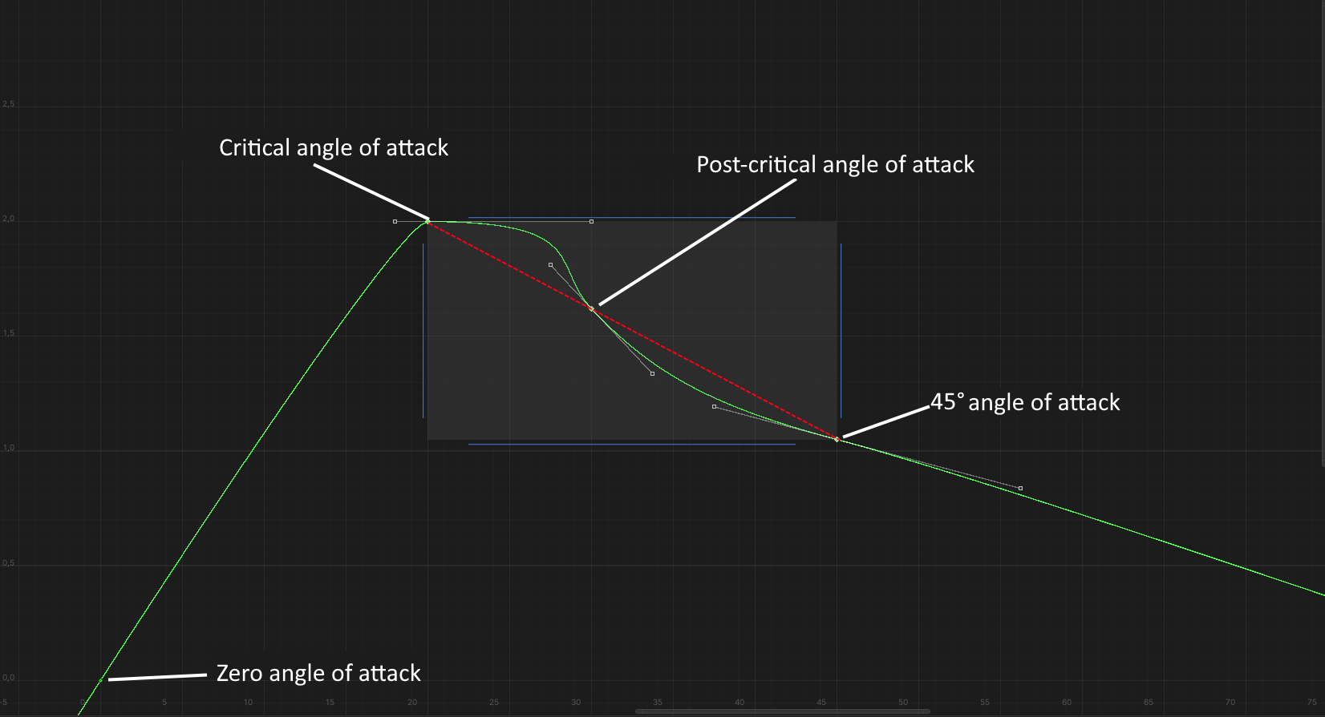

The tangents at these points are calculated in such a way as to make this section of the curve smooth. This smoothness ensures the stability of the aircraft with LERX at post-critical angles of attack.

The increase of the critical angle of attack is calculated as the product of the following multipliers:

* Maximize the critical angle of attack for the LERX airfoil.
* LERX efficiency, ranging from **0** to **1**.

*Example: the LERX consists of a T-10 root airfoil, its efficiency is 1, then the increase of the critical angle of attack is:*

15° * 1 = **15°**

The increase of the the critical coefficient is calculated as the product of the following multipliers:

* Increasing the maximum angle of attack;
* Lift increment.

*Example: the LERX consists of a T-10 root airfoil, its efficiency is 1, and the wing itself consists of a NACA 0012 airfoil, then the increase in the critical angle of attack coefficient is:*

15° * 0.1 = **1.5**

## Calculation of the drag force curve

For a wing without mechanization, the drag force curve is as follows:

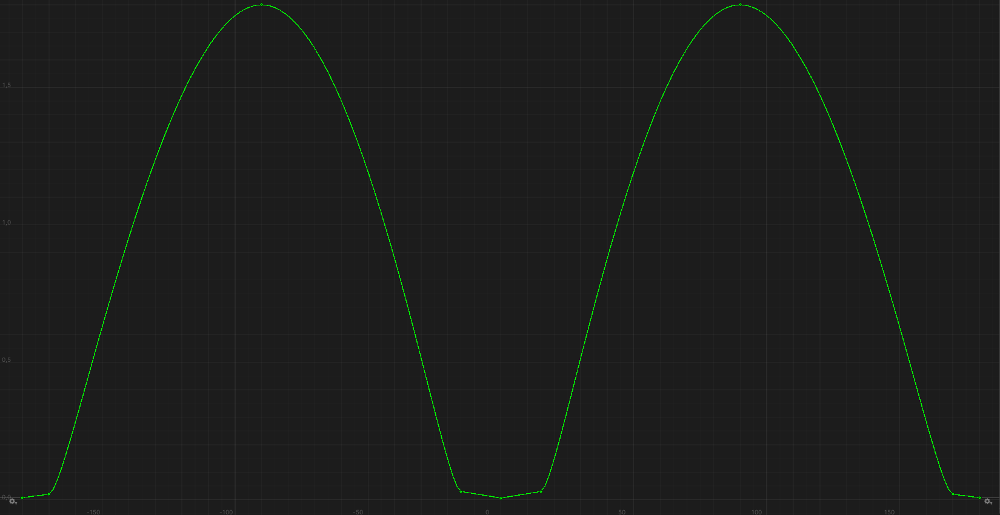

This curve consists of 9 reference points. Like the reference point of the lift curve, each point has tangents of a certain length and angle, which determine the shape of the curve:

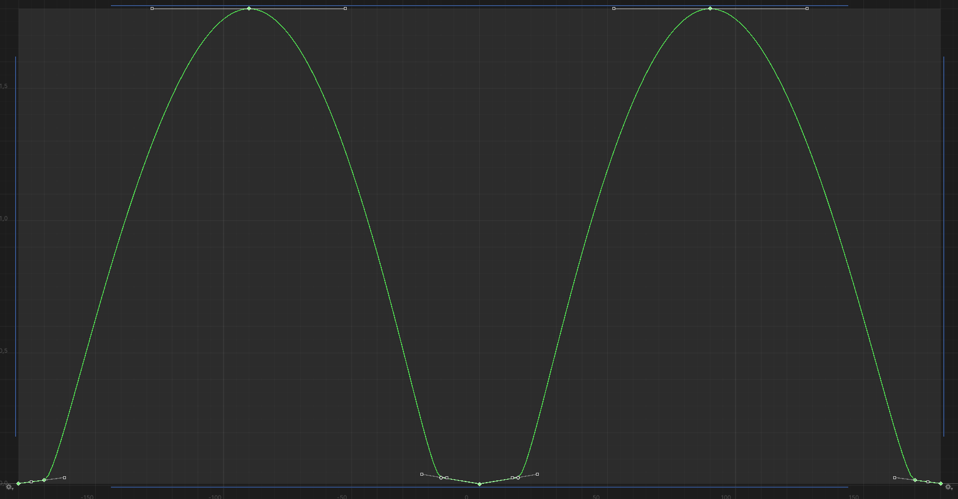

In the -90° – +90° criminal area, the reference points are as follows:  
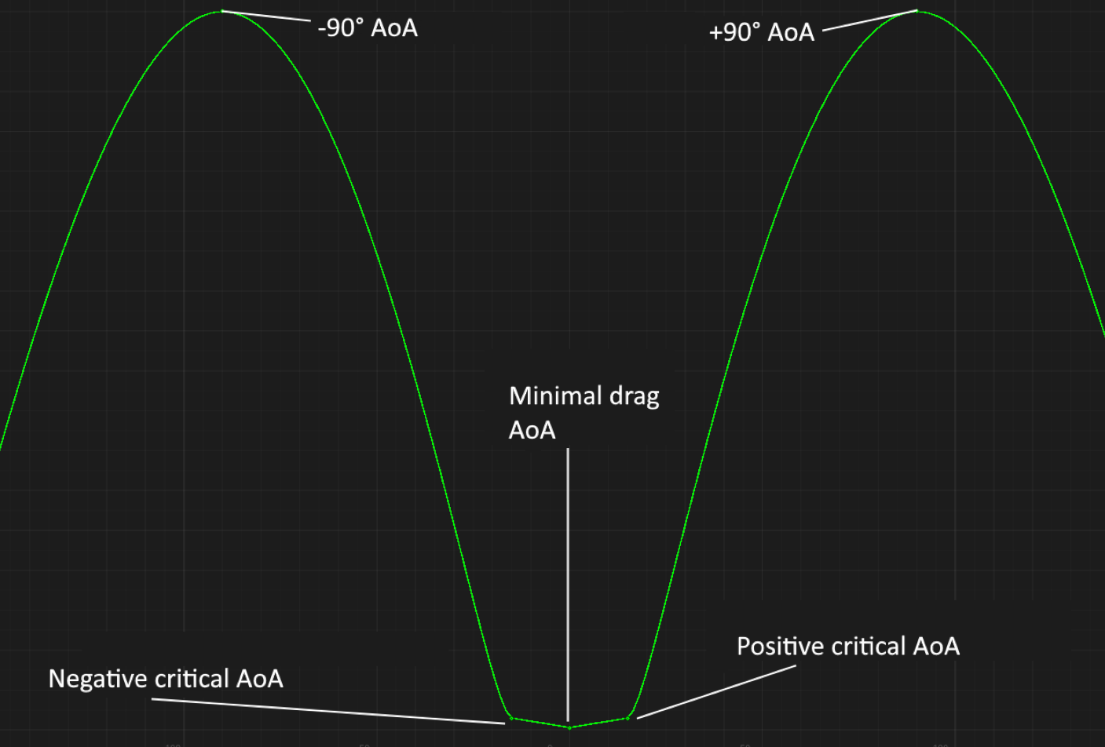

* **Minimal drag angle of attack** depends from the airfoil and may not be equal to 0°. The coefficient also depends from the airfoil.
* **Positive critical angle of attack** is equal to the positive critical angle of attack at the lift curve. The coefficient is calculated as the product of the positive critical angle of attack by the drag increment at the positive angle of attack.
* **Negative critical angle of attack** is equal to the negative critical angle of attack of the lift curve. The coefficient is calculated as the product of the negative critical angle of attack by the drag increment at the negative angle of attack.
* Angles of attack $±90°$ have fixed drag coefficients equal to **1.8**

You can see from the figure above that the drag force curve in the region from negative critical angle of attack to positive critical angle of attack is completely linear. This linearity **only** holds **up to $±15°$**  angles of attack. If the critical angle of attack exceeds $±15°$, then the value of the critical angle of attack coefficient increases by **0.03** for every **5°** of angle of attack regardless from the airfoil type.

*Example. NACA airfoil 0012, critical angle of attack 15°, drag force increment 0.002:*

15° * 0.002 = **0.03**

*If the airfoil thickness is chosen such that the critical angle of attack is 20°, the drag will be calculated as:*

0.03 + 0.03 = 0.**06**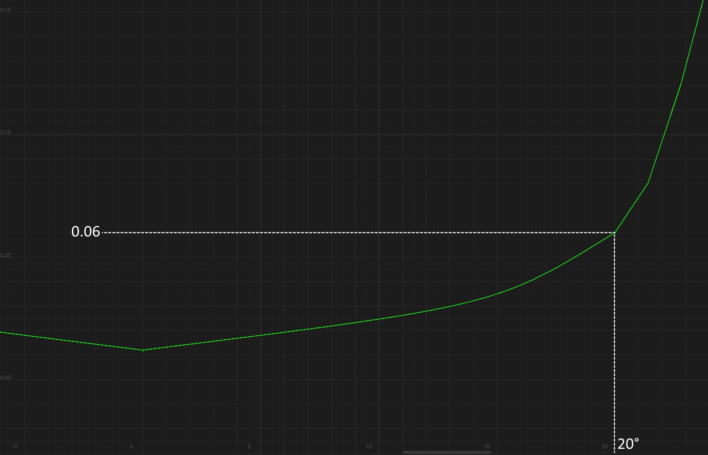

*At a critical angle of attack of 25°, the drag will be calculated as:*

0.03 + 0.03 + 0.03 = 0**.09**

*At a critical angle of attack of 27.5°, the drag will be calculated as:*

0.03 + 0.03 + 0.03 + 0.015 = 0.**105**

As you can see from the image above, when the critical angle of attack is exceeded $±15°$ the drag force curve loses its linearity in this region.

This mechanic of increasing drag by **0.03** for every **5°** degrees of angle of attack changes the curve already after all the changes made by the control surface, deflected leading edge and LERX.

The remaining reference points – inverted critical angles of attack and angles of attack $±180°$:

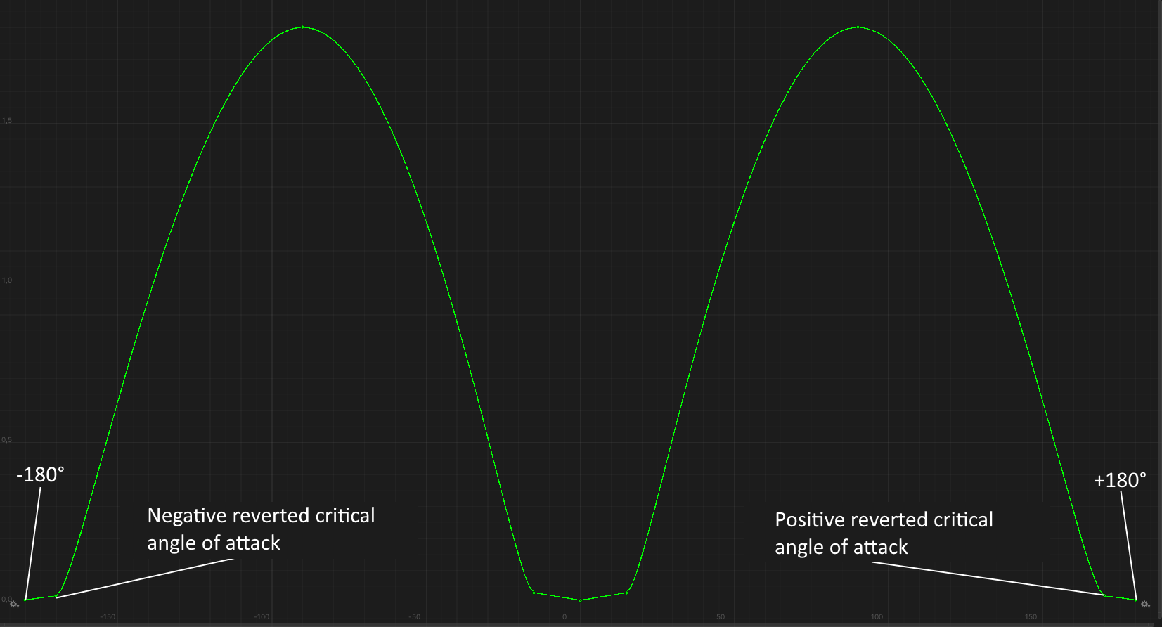

* The drag coefficient at angles of attack $±180°$ is calculated as the **minimal drag coefficient** * **1.25**, i.e. drag at these angles of attack is **25%** higher.
* The angles of **inverted critical angles** of attack are the same as the angles of inverted critical angles of attack of the lift curve. The coefficient at these angles is calculated as the **value of the angle of attack** * **0.002**.

As the critical angles increase, the length of the tangents is selected such that at angles of attack of approximately **50°** the coefficient is **approximately 1.2**, as in the present *NACA 0012* airfoil:

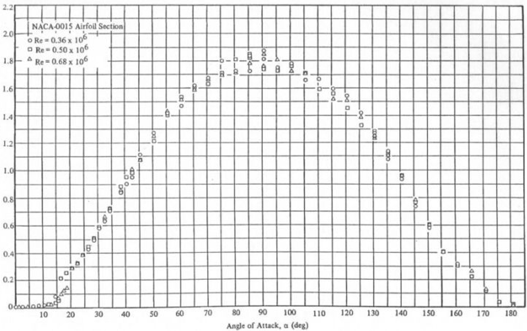

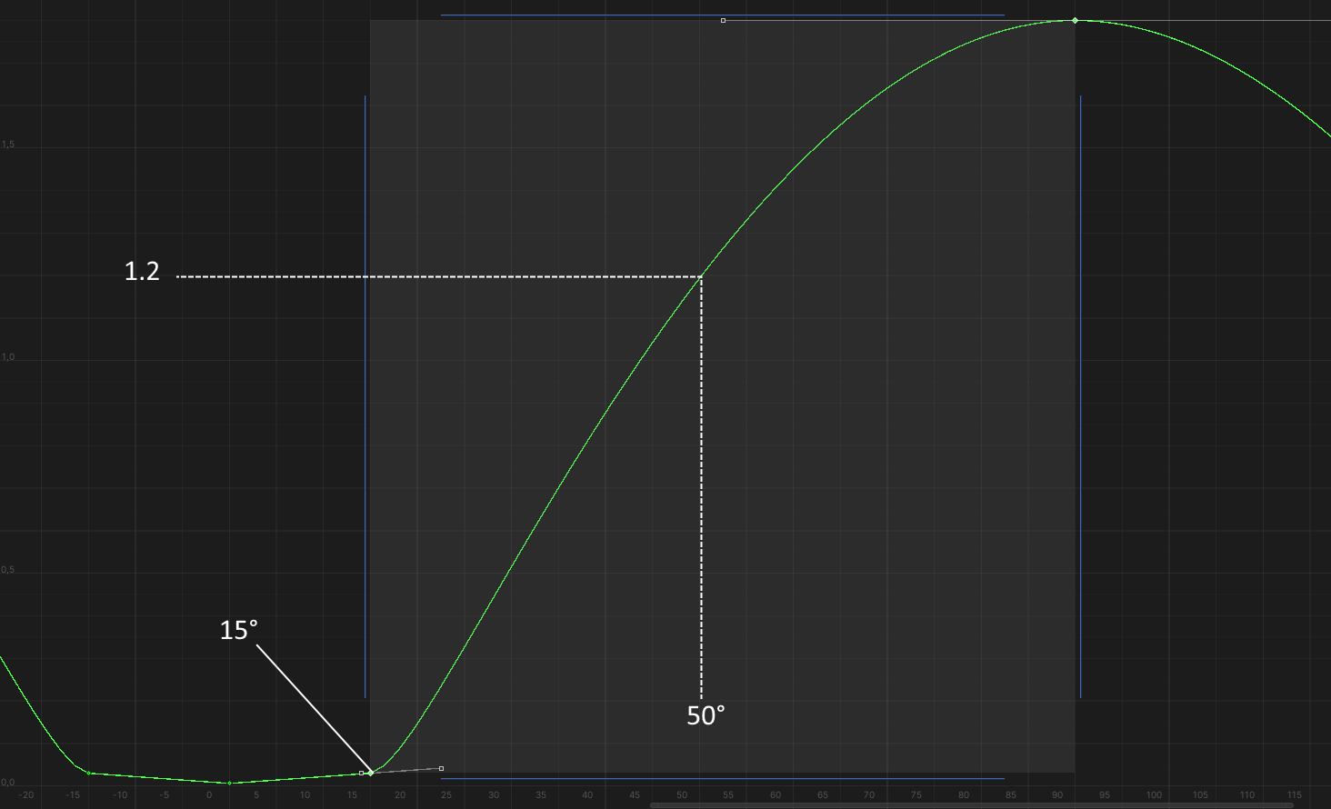

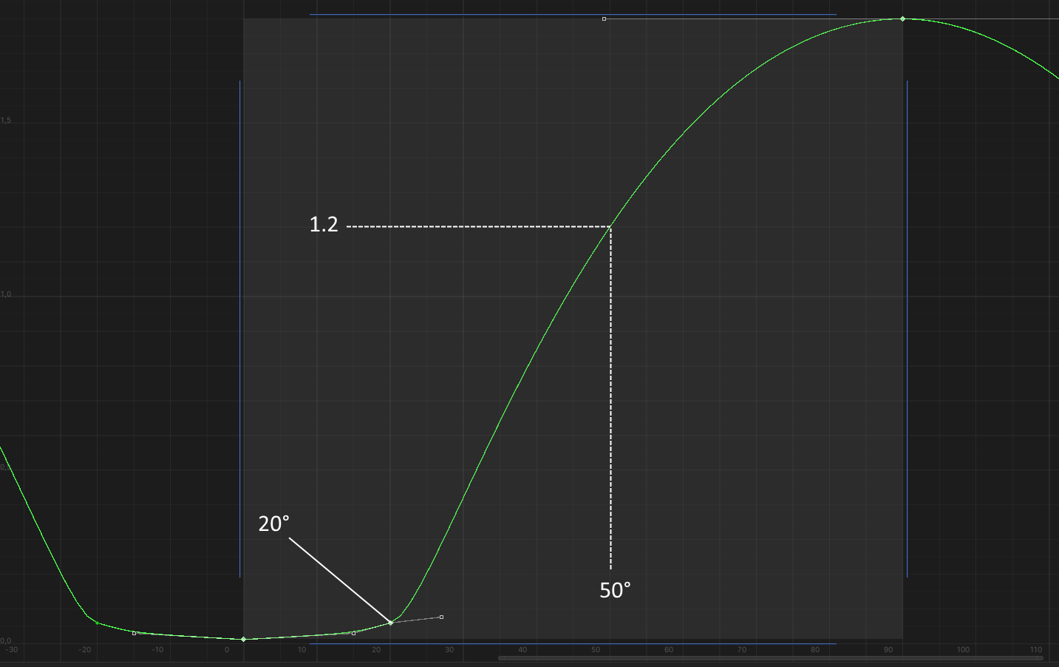

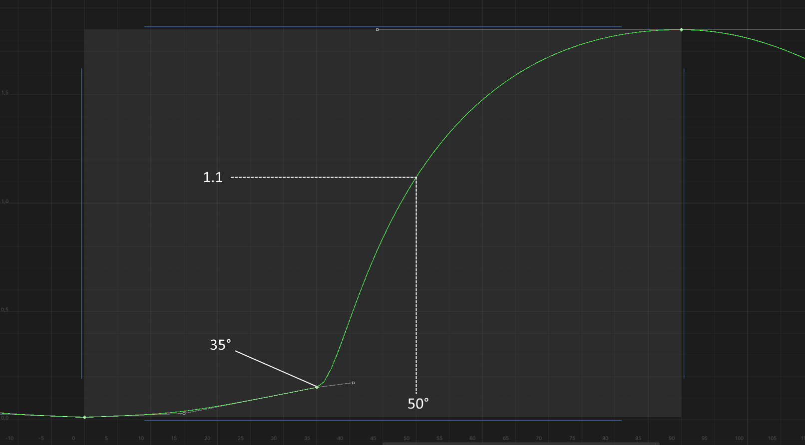

### Influence of the control surface to the drag force curve

The calculation of the effect of control surface deflection on the drag curve has a fundamental difference: while the lift force curve "moves up" linearly depending on the angle of surface deflection (up to 45°), the "upward movement" of the drag curve is nonlinear, because the deflected surface has its own drag curve. It is very similar to the drag curve of a wing without mechanization and without the influence of the LERX, but with the difference that the central reference point always has coordinates (0°, 0).

*Drag force curve of a 12% thick NACA 0012 airfoil:*

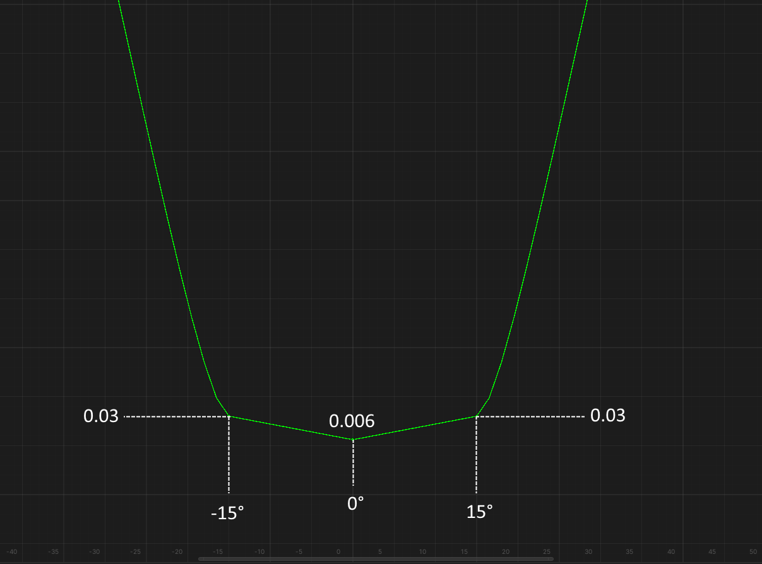

*Curve of drag force of the control surface of NACA 0012 airfoil with 12% thickness. The horizontal axis is the deflection angle. Vertical axis - by how much the wing drag will increase:*

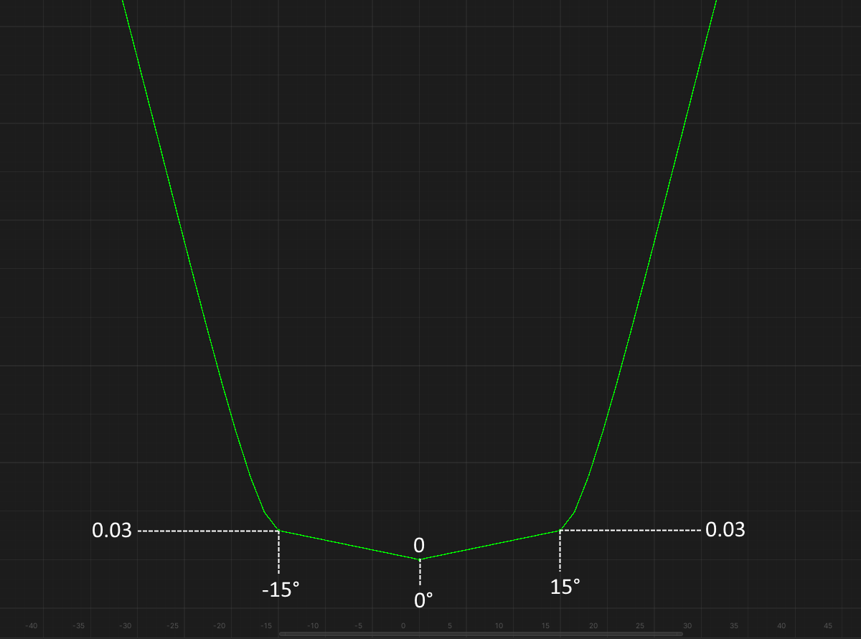

*Drag force curve of NACA 0012 airfoil with 24% thickness:*

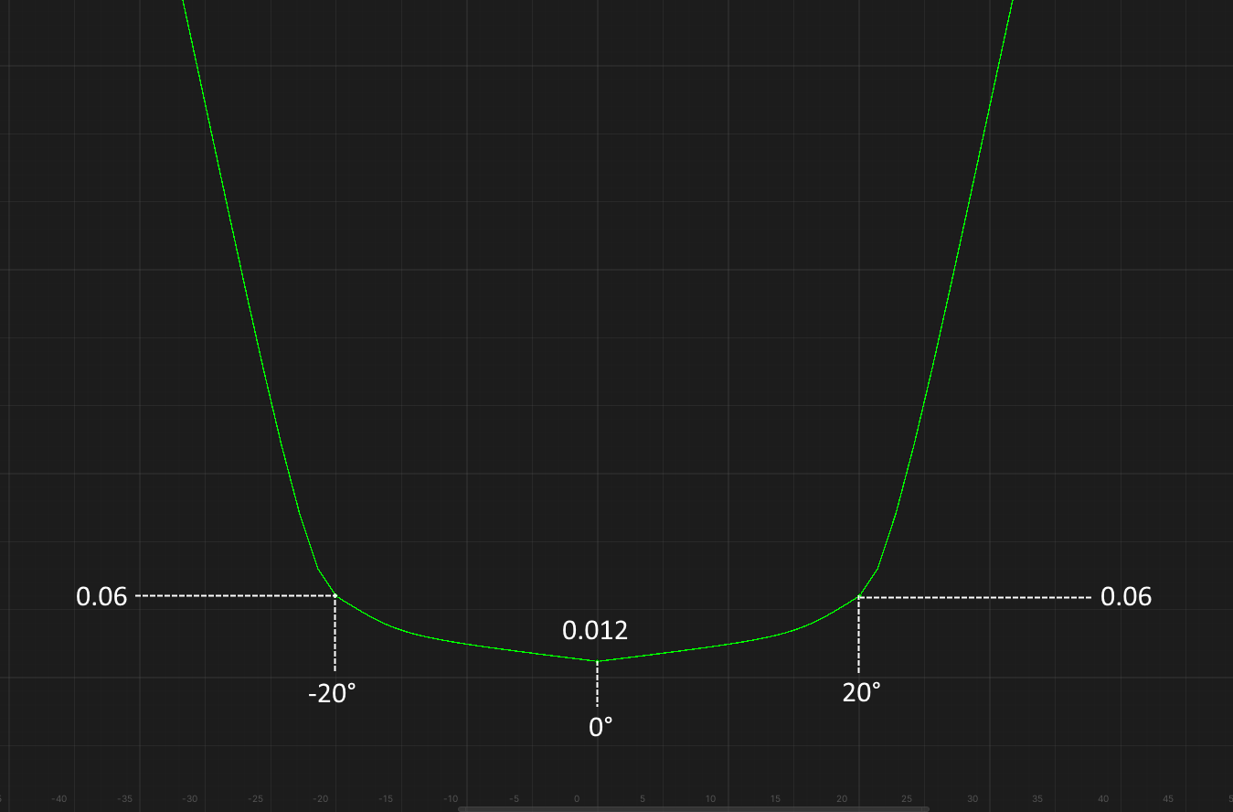

*Drag force curve of the control surface of NACA 0012 airfoil control surface with 24% thickness:*

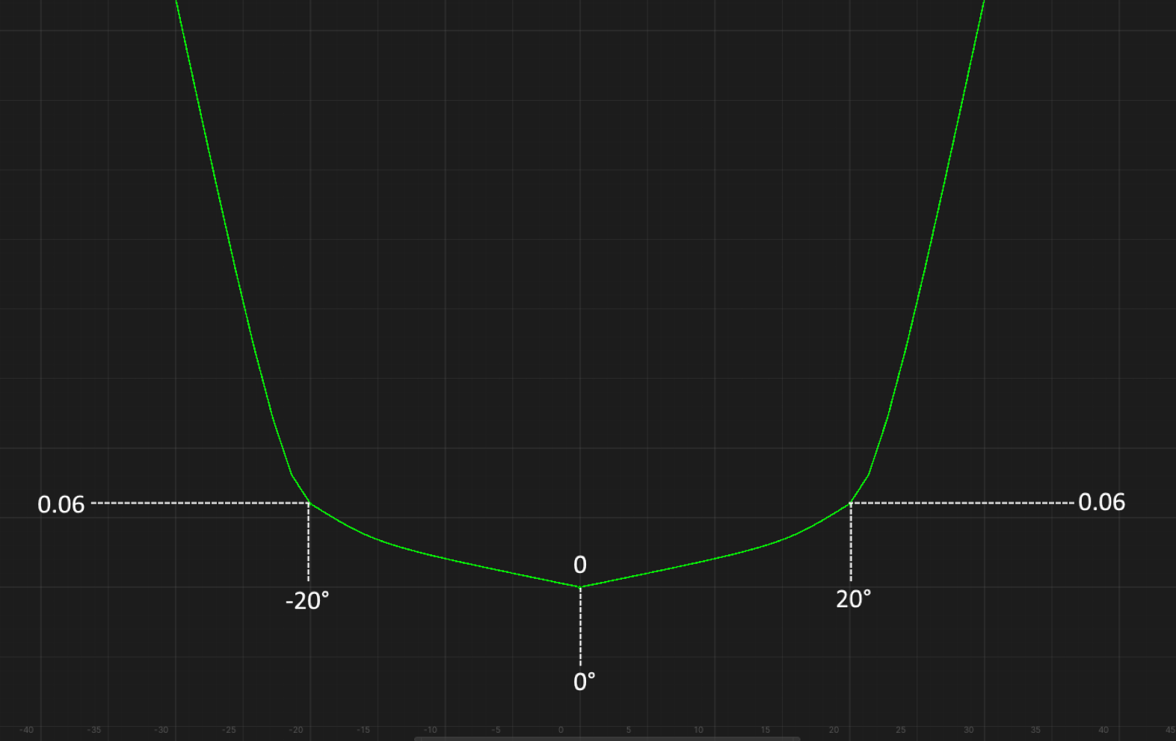

Note that the control surface's own drag curve is affected by the same mechanics of increasing drag by **0.03** for every **5° of** angle of attack.

*Drag force curve of the control surface of the Clark Y airfoil control surface with 24% thickness:*

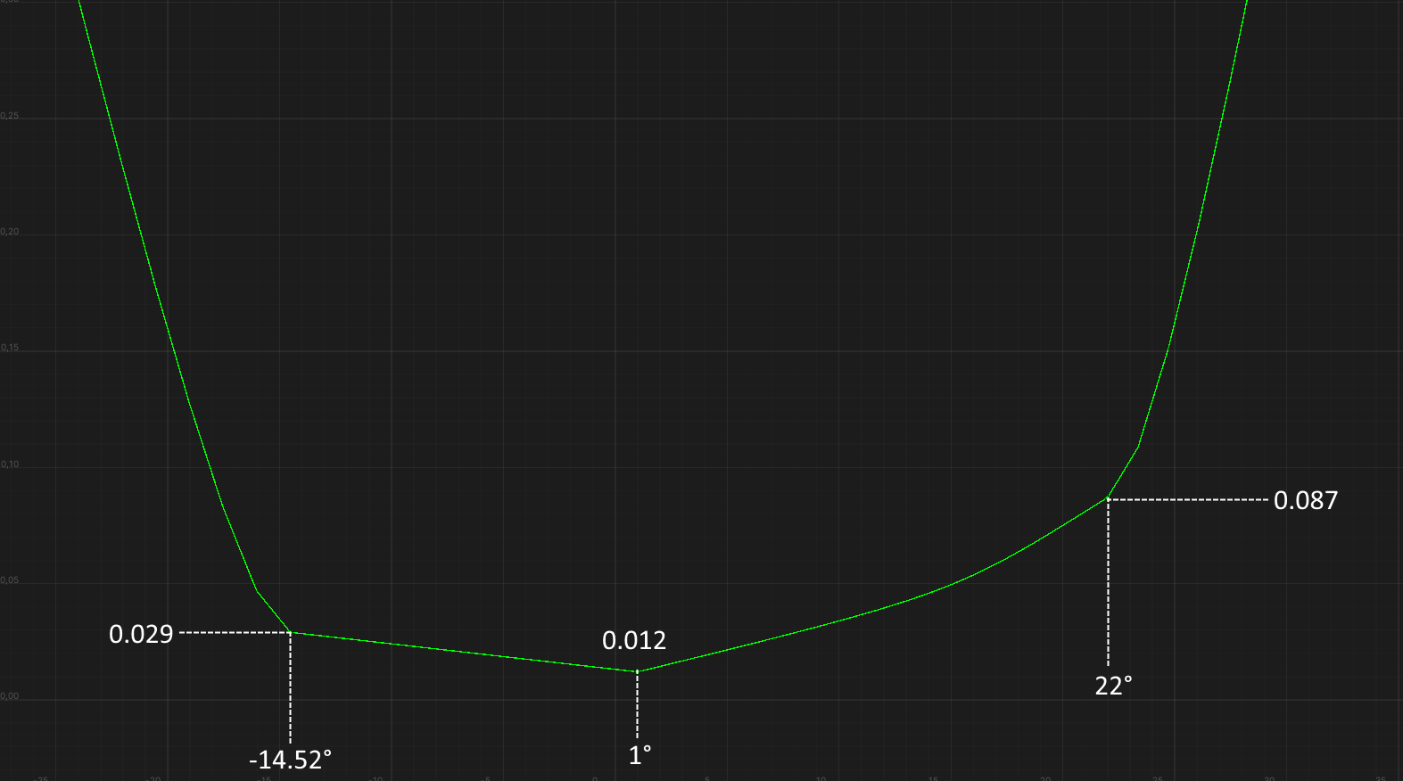

*Drag force curve of the control surface of the Clark Y airfoil control surface with 24% thickness:*

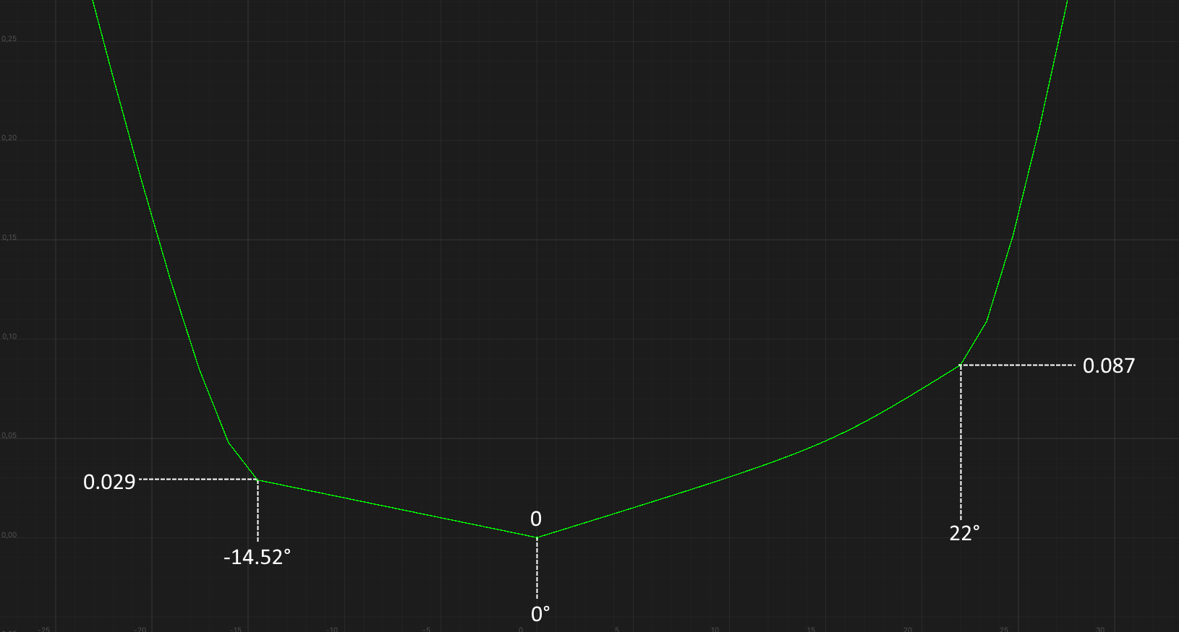

As you can see from the figures above, after a certain deflection angle of the control surface, its drag will start to increase fast. Also, for asymmetrical airfoils, the deflection angle at which the drag increases smoothly depends on the side to which the control surface is deflected.

Let's get to the formulas.

Also, like the lift curve, the deflection of the control surface does several things:

1. Increases the coefficient of critical angles of attack and angle of minimum drag by moving these points up:

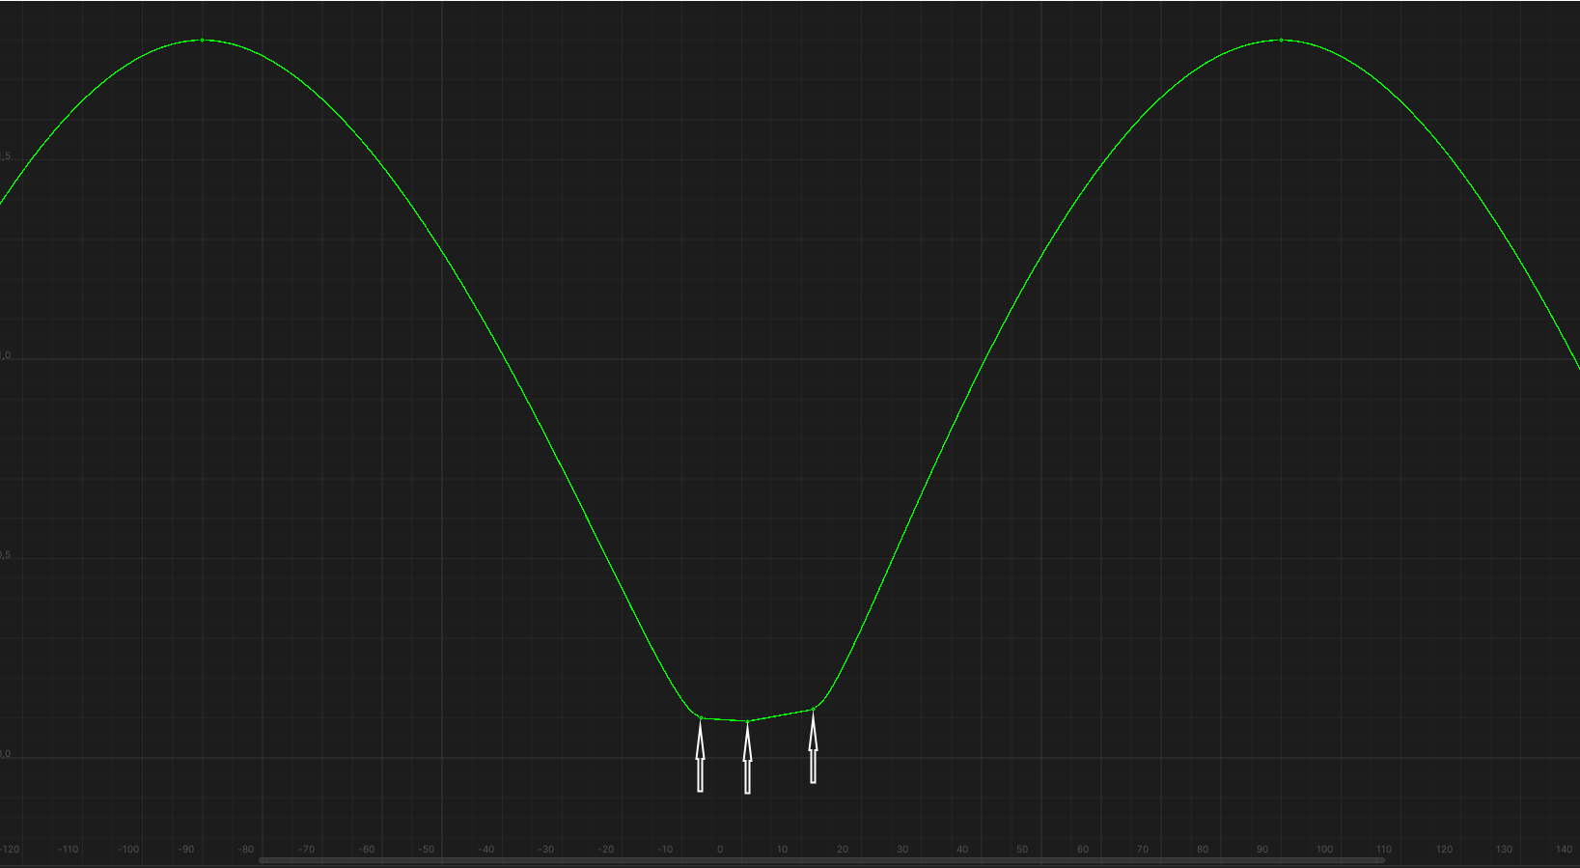

The increase in the coefficient is calculated as the result of multiplying the following multipliers:

* Control surface size in percent of wing chord / 100.
* A coefficient from the own drag curve of the control surface that depends on the deflection angle.

1. Reduction of critical angles of attack and coefficients at these angles. Also, like the lift curve, the drag curve "cuts off" in this region after "moving up":

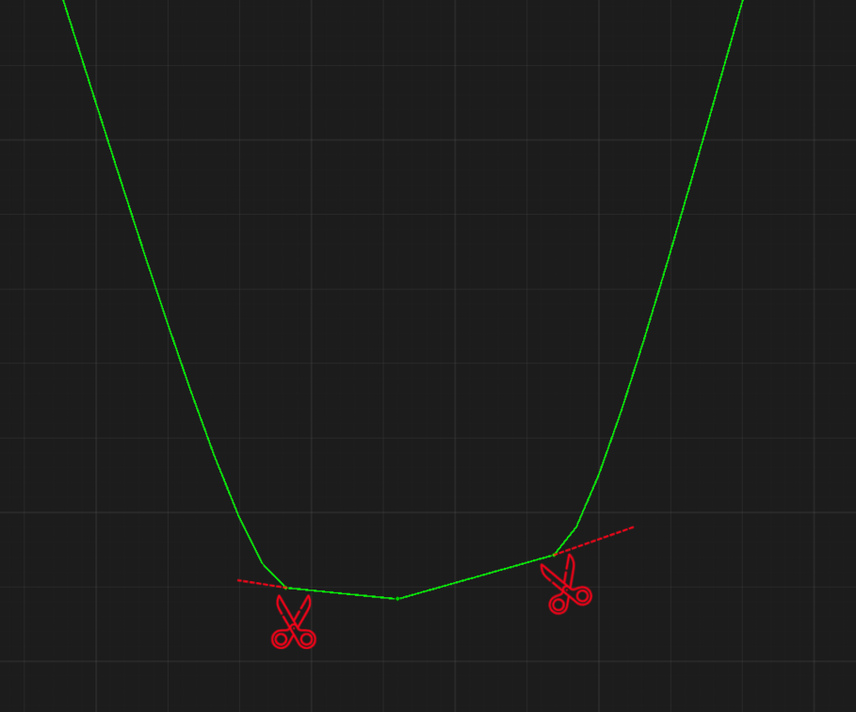

Calculated as the result of multiplying the following multipliers:

* Control surface deflection angle modulus in degrees.
* Control surface size in percent of wing chord / 100.
* 0.5

*Example. Airfoil NACA 0012, control surface size 25%, deflection angle 15°:*

15° * 25% / 100 * 0.5 = **1.875°**

The decrease of the critical coefficient is calculated as the product of the previous value by the drag increment.

*Example. Airfoil NACA 0012, control surface size 25%, deflection angle 15°:*

* 1. 0.002 = **0.00375**

### Effect of deflected leading edge to the drag force curve

Leading edge deflect changes the curve as follows:

1. Increases the positive critical angle of attack and its coefficient, decreases the negative critical angle of attack and its coefficient. As with the lift curve, the curve is "cuts off" in the negative critical angle region and "extended" in the positive critical angle region:

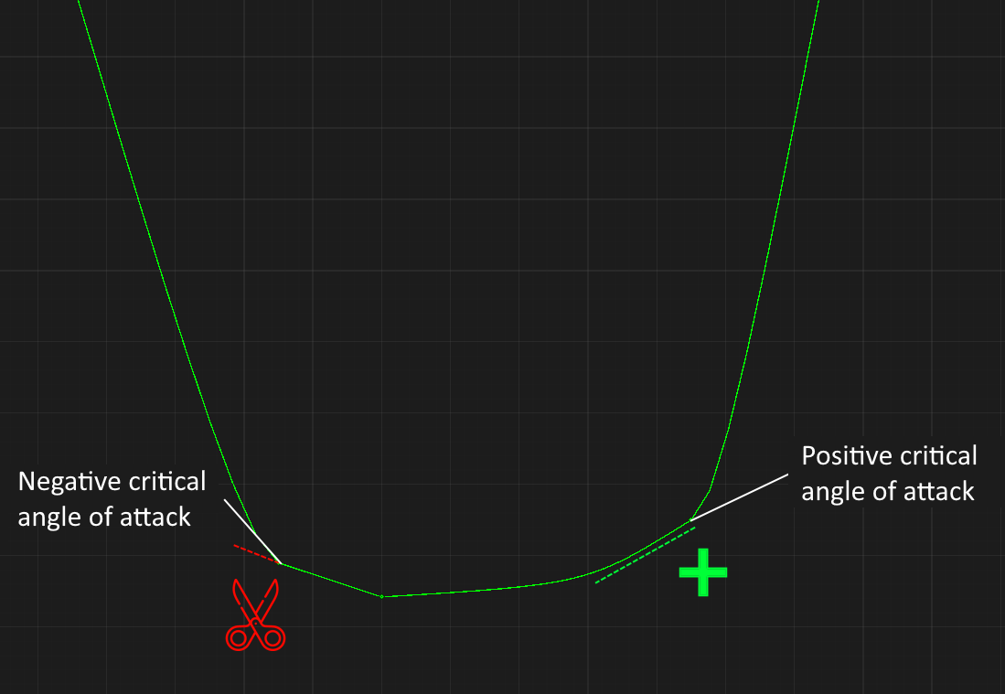

A decrease of the negative critical angle of attack and an increase of the positive critical angle of attack calculates as the product of the following multipliers:

* Leading edge deflection angle
* Size of deflected leading edge in percent chord / 100

*Example. Airfoil NACA 0012, deflected leading edge size 25%, deflection angle 30°:*

30° * 25 / 100 = **7.5°**

Unlike the lift curve, where the coefficient decreases as the critical angle of attack decreases, here it **increases**.

The coefficient increase for a negative critical angle of attack is considered as the product of the previous value by the drag increment at negative angles of attack.

*Example. Airfoil NACA 0012, deflected leading edge size 25%, deflection angle 30°:*

7.5° * 0.002 = **0.015**

So while at 15° *NACA 0012* had a drag **0.03**, at the leading edge deviation in the example above the drag will be 0.03 + 0.015 = **0.045**, which is 50% more!

The increase of the coefficient for positive angle of attack is calculated in a similar way, except that the increase in critical angle is multiplied by the drag increment at positive angles of attack.

*Example. Airfoil NACA 0012, deflected leading edge size 25%, deflection angle 30°:*

7.5° * 0.002 = **0.015**

But in the example above, the positive critical angle became 22.5°, which is greater than 15°, so the drag will already be recalculated taking into account the mechanics of increasing drag by **0.03** for every **5°**. Thus, before recalculation the drag at the angle of attack of 22.5° would be 0.03 + 0.015 = 0**.045**, but after recalculation it will be 0.03 *(at 15°)* + 0.03 *(5°)* + 0.015 *(2.5°)* =  **0.075.**

1. Increases the minimum drag coefficient

Calculated as an increase in the coefficient for a positive angle of attack.

*Example. Clark Y airfoil, deflected leading edge size 25%, deflection angle +30°:*

7.5° * 0.003 = **0.0225**

*Example. Airfoil NACA 0012, deflected leading edge size 25%, deflection angle -30°:*

7.5° * 0.002 = **0.015**

Accordingly, in the first case, the minimum drag coefficient will be 0.006 + 0.0225 = **0.0285** and in the second case 0.006 + 0.015 = **0.021**.

### Effect of LERX to the drag force curve

The effect of LERX changes the curve in the only way it can: it increases the positive and negative critical angle of attack with their coefficients, "extending" the curve both ways in this region:

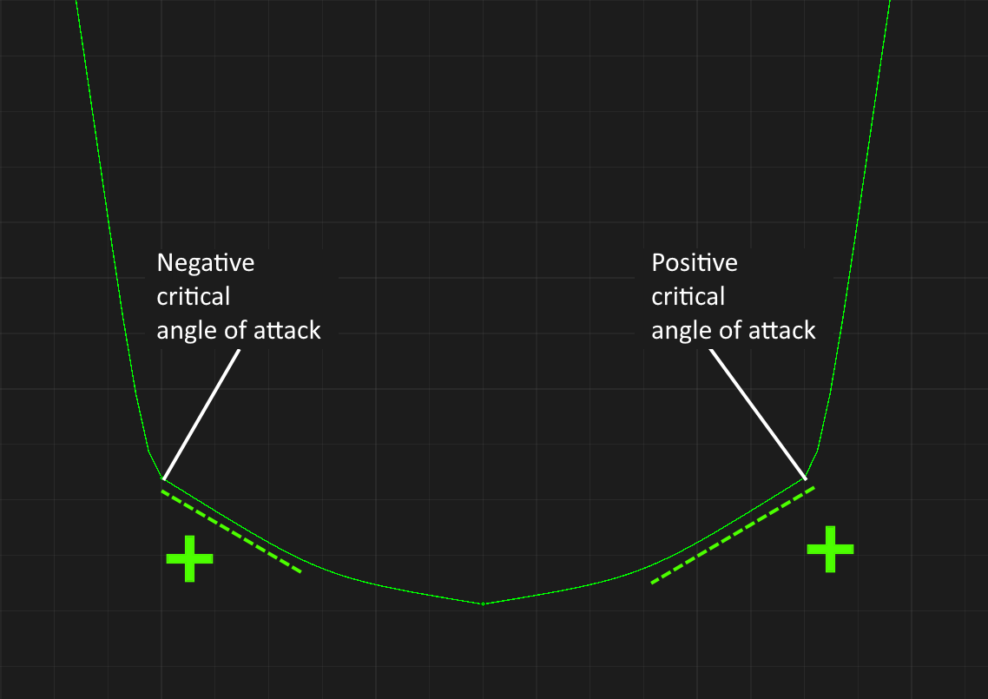

The critical angle increase is calculated as the product of the LERX efficiency, which varies from **0** to **1**, by the maximum critical angle increase for the LERX airfoil.

*Example. T-10 LERX airfoil, its increase in critical angles is 15°, LERX efficiency is 1:*

15° * 1 = **15°**

The coefficient increase for negative critical angle of attack is calculated as the product of the increase critical angle of attack by the drag increment for negative angles of attack.

*Example. NACA 0012 wing airfoil, T-10 LERX airfoil, its increase in critical angles is 15°, LERX efficiency is 1:*

15° * 0.002 = **0.03**

But since the resulting negative critical angle of attack is -30°, the resulting coefficient is calculated with the mechanics of increasing by **0.03** for every **5°**, so the resulting coefficient at the -30° angle would be:

0.03 *(15°)* + 0.03 *(5°)* + 0.03 *(5°)* + 0.03 *(5°)* =  **0.12**

Since the airfoil of *NACA 0012* is symmetrical, the drag at a positive critical angle of attack of 30° will be the same.

# LERX mechanics

The SimpleWing becomes a LERX when its sweep angle exceeds **61°**. A LERX cannot have a control surface or a deflected leading edge. If the wing has them, they will disappear when the sweep exceeds 61°.

The area of the LERX may be different from the wing area:

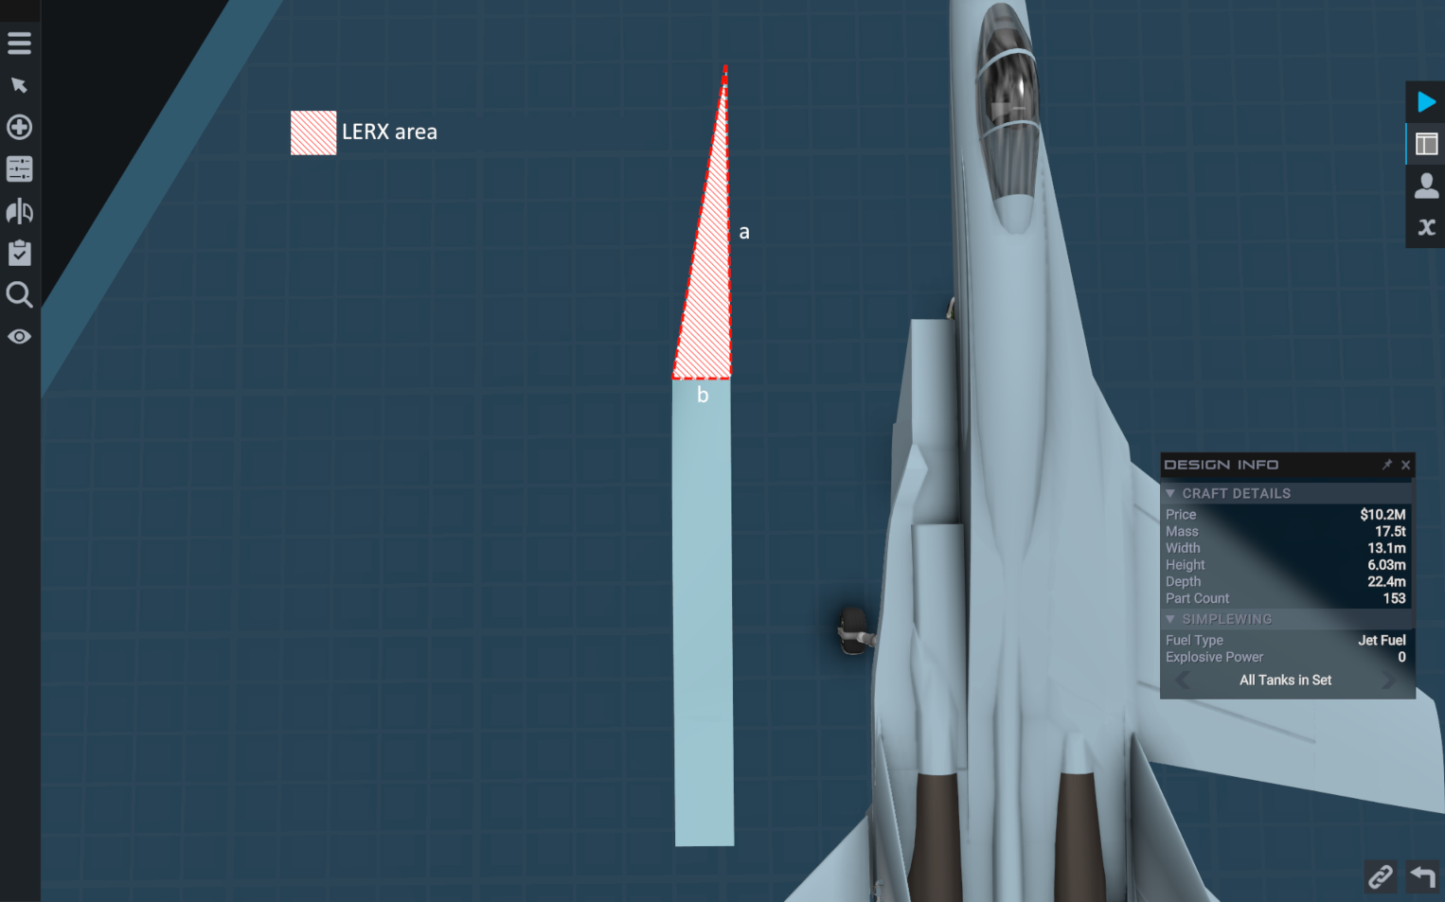

When the LERX consists of only one SimpleWing part, its area is calculated as the area of a triangle using the formula **a * b / 2**.

The LERX may consist of several SimpleWing parts:

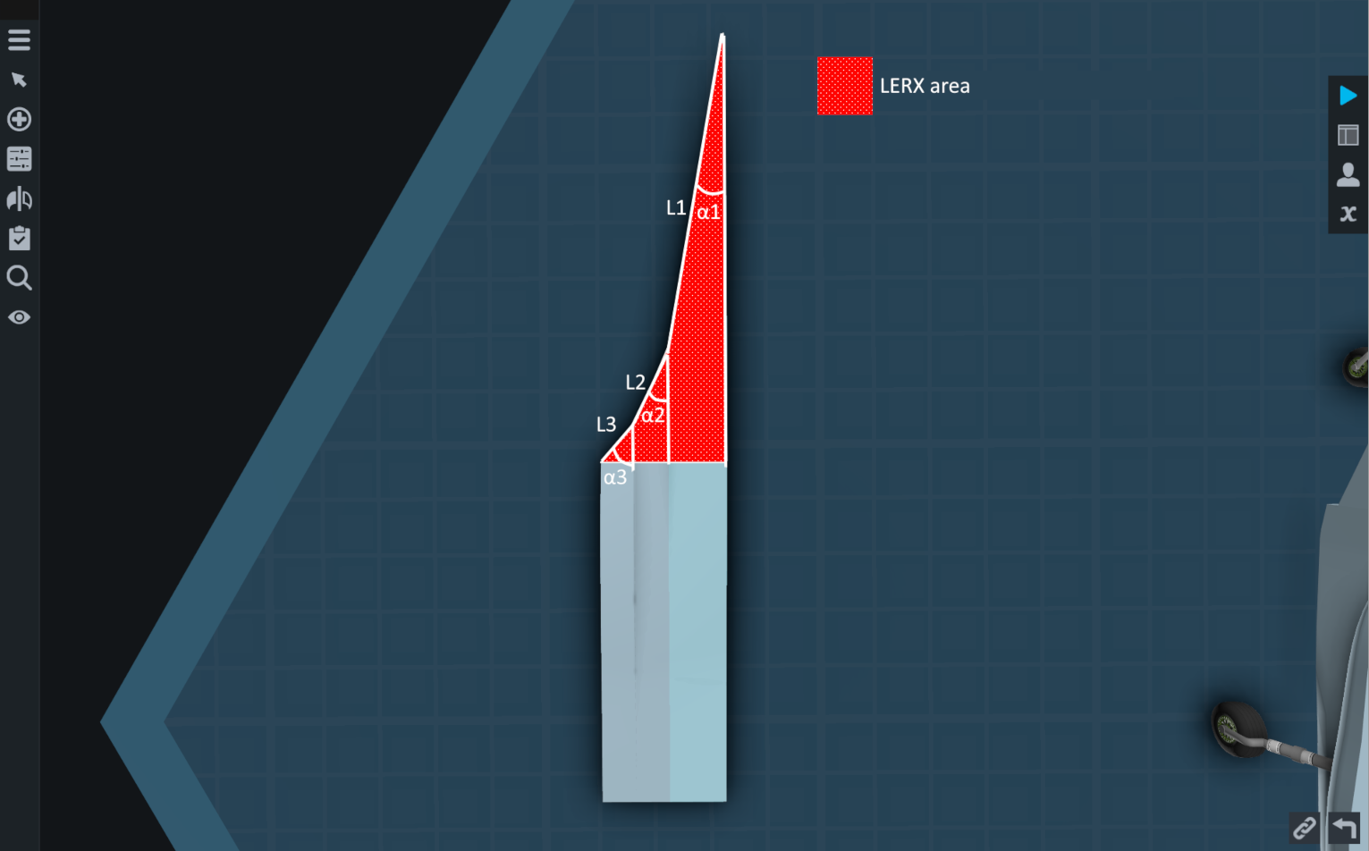

Then the area will be calculated by the formula

$$\frac{{\left(L1+L2+L3\right)}^{2}*sin\left(2*\frac{α1+α3+α3}{3}\right)}{4}$$

This is the formula for calculating the area of a triangle through its hypotenuse and acute angle. Here, the hypotenuse is the sum of the leading edge lengths and the angle is the arithmetic mean of the sweep angle.

LERX's are searched from tip to the root. That is, if a composite LERX, as in the image above, consists of three parts, then LERX L3 knows about both L2 and L1. The LERX L2 knows only about L1. At the same time, L1 knows nothing about either L2 or L3.

The LERX changes the lift curve and drag curve **of only those wings that are attached to the end point of the** LERX by their **root point:**

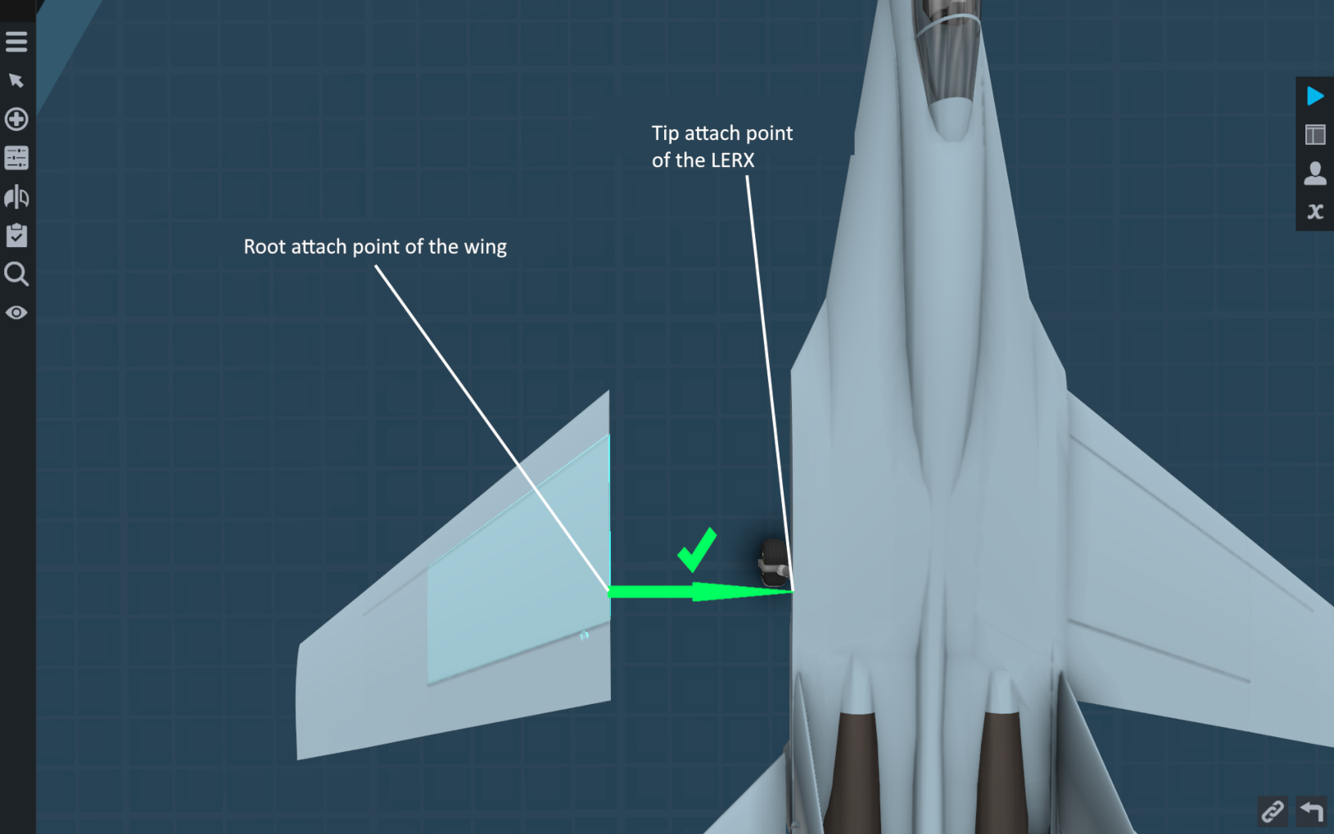

At the same time, in order for the LERX to have an effect on the "far" wings of the compound wing, they too must be attached correctly, with their root point to the tip point of the "near wing":

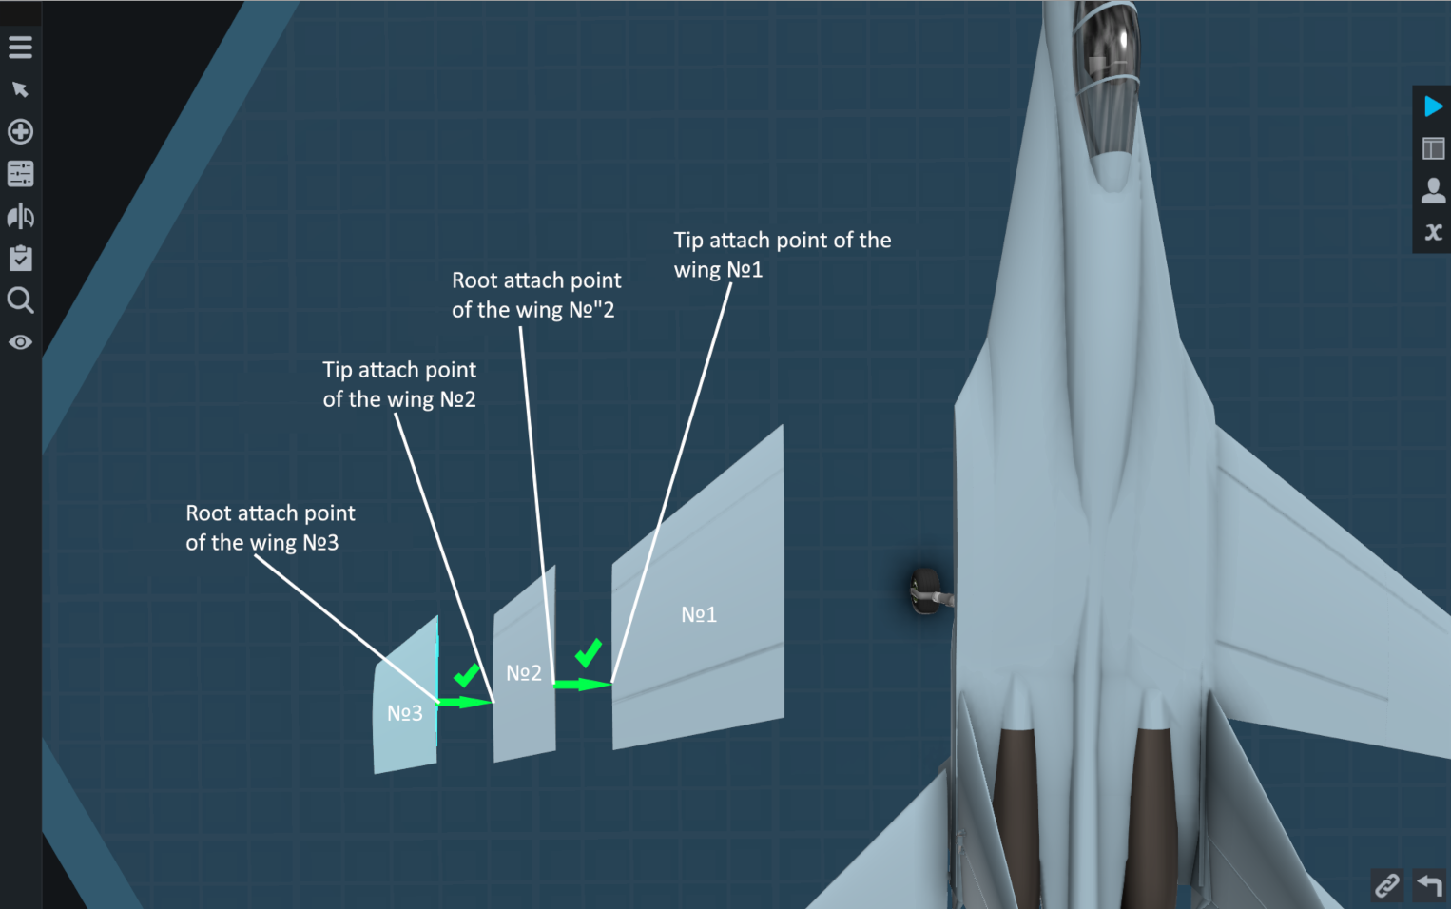

From Section 9.1.3. Effect of LERX to the lift curve, you learned that the LERX efficiency varies from **0** to **1**. This efficiency is the **total LERX efficiency**.

**The total LERX efficiency** is the product of several multipliers that can also take values from **0** to **1**. These multipliers are:

* Effectiveness of LERX from the angle of attack. In other words, vortex generation. This multiplier is always 0 at subcritical angles of attack. That is, until the critical angles are overcome, no vortex is generated. At the angle of attack **(critical angle of attack + 4°)** this multiplier takes the value **1.** I.e. for 4 degrees of angle of attack the generated vortex gains its full strength. If the LERX airfoil has a **LERX asymmetry factor**, this multiplier is multiplied by it at negative angles of attack – at negative angles of attack the vortex will be generated worse. When using a composite LERX, where each LERX has its own angle of attack efficiency, the value of this multiplier will be calculated by the arithmetic mean.

*Example: the LERX consists of NACA airfoil 0012, has critical angles of attack $±12°$, then this multiplier will be equal to* ***1*** *at angles of attack $±16°$*

*Example: the LERX consists of T-10 root airfoil, has critical angles of attack* ***+12°****,* ***-6°****, then this multiplier will be equal to* ***1*** *at angle of attack* ***+16°*** *and equal to* ***0.5*** *at angle of attack* ***-10°***.

*Example: the LERX consists of a T-10 wing airfoil, has critical angles of attack* ***+12°****,* ***-3°****, then this multiplier will be equal to* ***1*** *at angles of attack* ***+16°*** *and equal to* ***0.25*** *at angle of attack* ***-7°.***

* The ratio of the area of the LERX to the area of the wing attached to it. If this ratio is equal to **0.25**, then this multiplier will be equal to **1**. That is, for the LERX to be able to completely cover the wing attached to it by the vortex, the LERX must be 4 times smaller in area than the wing. This multiplier cannot be less than **0** and cannot be greater than **1** - there is no sense in too large area of the LERX.
* Coefficient of horizontal coverage of the wing by the LERX. If the entire length of the wing is in the green shaded area, the coefficient is **1**. If only half of the wing length is in the green shaded area, then this coefficient is **0.5**. If only a quarter of the wing length is in this area, then **0.25**, etc.

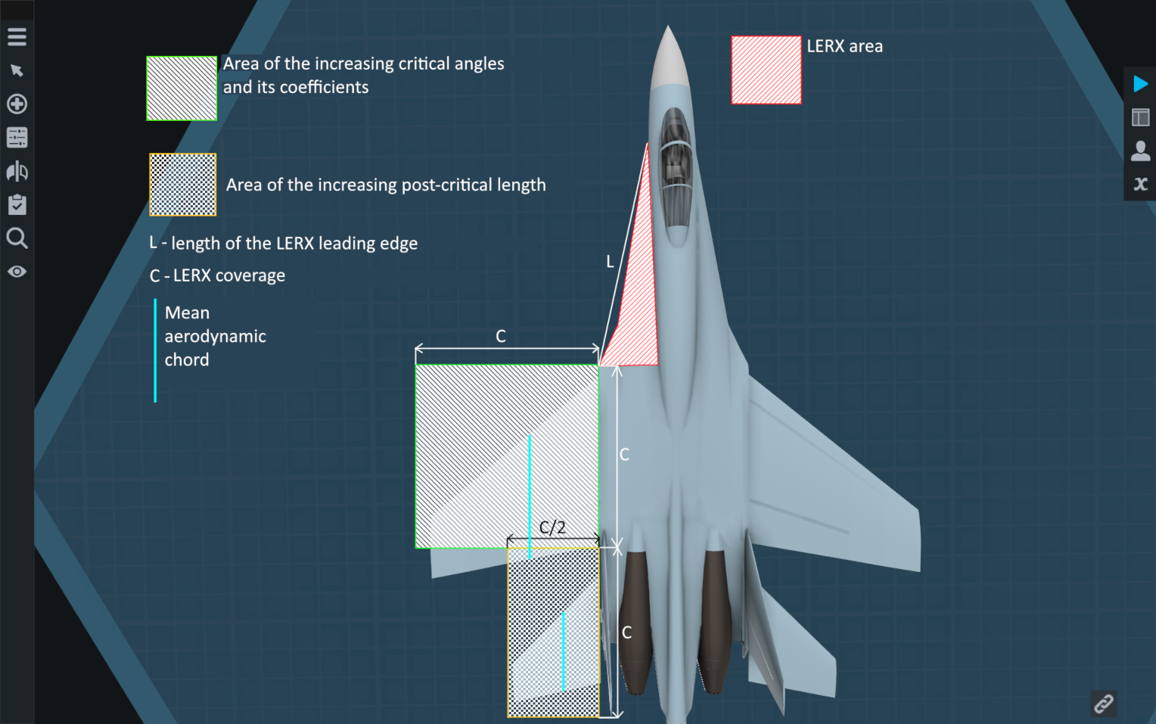

* Coefficient of coverage of the **MAC** by the root surge. If the entire **length of the MAC** is in the green zone, this coefficient is equal to **1**. If the **MAC** is not in the green shaded zone, this coefficient is **0** and because of this the **total LERX efficiency** will also be **0**.

However, if the **MAC** is not in the green shaded area, but is in the orange shaded area, then the mechanics of increasing the post-critical length come into play. The post-critical length increases by the same amount by which the critical angle of attack of the wing would increase. At the same time, the post-critical length increases permanently, i.e. it does not depend on the effectiveness of the LERX from the angle of attack. At the same time, it increases equally for both positive and negative angle of attack, i.e. it does not depend on the LERX asymmetry coefficient. You can see from the image above that the orange shaded area is half as wide as the green shaded area. The length of the orange shaded area is the same as the green shaded area.

I introduced this mechanic to ensure that aircraft with neutral or negative static stability can always "get off" from high angles of attack. Before this mechanic was introduced, the SimpleFlanker could climb to high angles of attack, but when attempting to descend from them, it would "lose its balance" and tilt backwards. This happened because the stabilizers at maximum deflection of their leading edge up there was a flow separation and they sharply lost their lift, while the wing because of the deflected leading edge flow separation did not occur. This mechanics increases the post-critical angles of attack, because of this decrease in lift of stabilizers is not so sharp and it allows SimpleFlanker to get off at high angles of attack.

# Effect of sweep to lift and drag forces

The coefficient $mathbfC_{mathbfy}$ in the lift calculation formula is the product of the coefficient of the lift curve at the current angle of attack and the cosine of the wing sweep, taking into account the slip angle:

$C_{y}$**= $C_{y lift curve}*cos(sweep angle+angle of slip)$**

In this $cos(sweep angle+angle of slip)$ cannot be less than **0.5**. Thus, the cosine value will decrease from **1** at no sweep to **0.5** at **60°** sweep. If the sweep is further increased, there will be no decrease in the cosine value.

The value of the $C_{x}$ is calculated almost exactly the same way, but with the difference that the drag reduction occurs only at subcritical angles of attack, and at **90°** angles of attack the cosine value will be equal to **1.** In the case of a **60°** sweep wing, the cosine value will be **0.5** at subcritical angles of attack and will increase linearly from **0.5** at the critical angle of attack to **1** at **90°** angle of attack.

The deflected surface also has its own sweep:

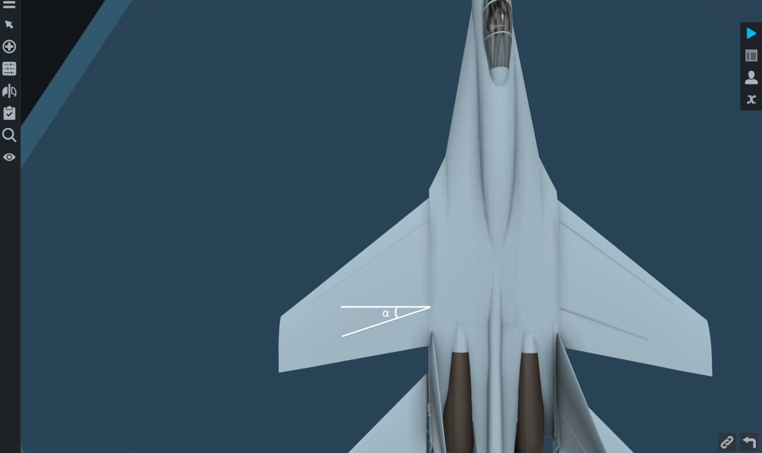

The slip angle is also considered for it, but the cosine can take the value **0** - when this angle is 90°, the control surface has no effect on either the lift or drag curve. In other words, as the angle **α** in the image above increases, the effectiveness of the control surface decreases.

# Movement of the aerodynamic forces center (AFC)

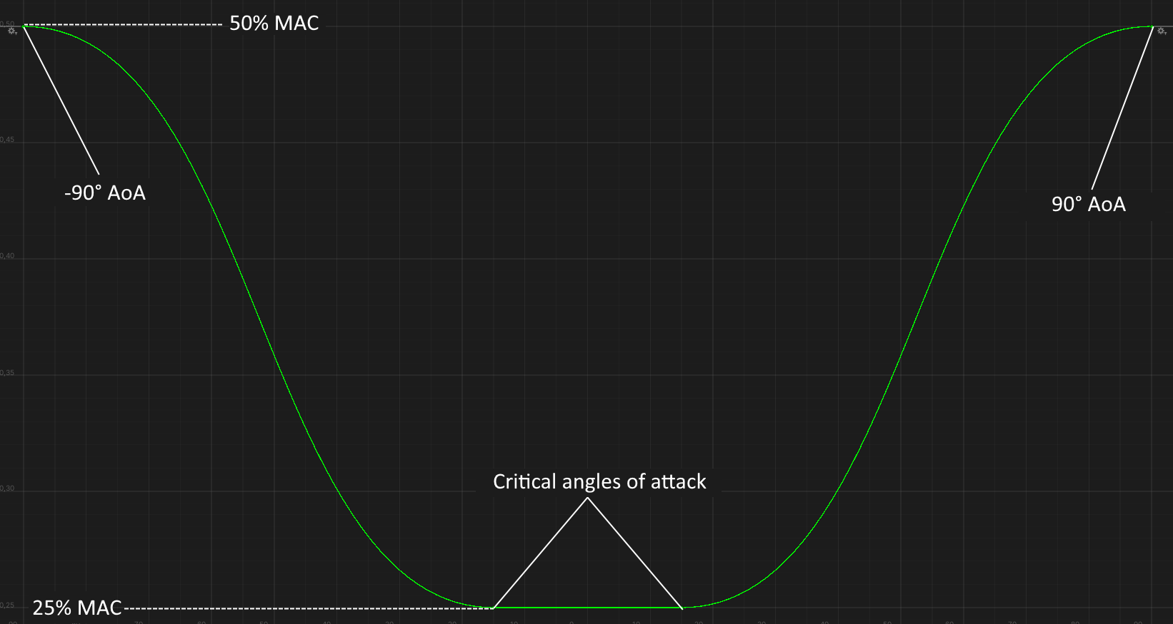

The image above shows a plot of **AFC** moving as a function of angle of attack. At subcritical angles of attack, the **AFC** is at **25%** of the **MAC**. Once the negative or positive angle of attack is exceeded, the **AFC** moves from **25%** ofthe **MAC** to **50%** of the **MAC**.

When the critical Mach number is exceeded, the **AFC** also moves from **25%** of the **MAC** to **50%** of the **MAC** in **0.1** Mach. I.e. at Mach **1** the **AFC** will be at **25%** ofthe **MAC**, and at Mach **1.1 it** will move back to **50%** ofthe **MAC**. At the same time, the movement of along the **MAC** when exceeding the critical angle of attack, added to the movement along the **MAC** when exceeding the critical Mach number cannot exceed **50%**.

# SimpleWingData

**SimpleWingData** - window that displays various information on the highlighted SimpleWing. It is disabled by default. It is enabled either through Mod Settings or by pressing Left Ctrl + 1:

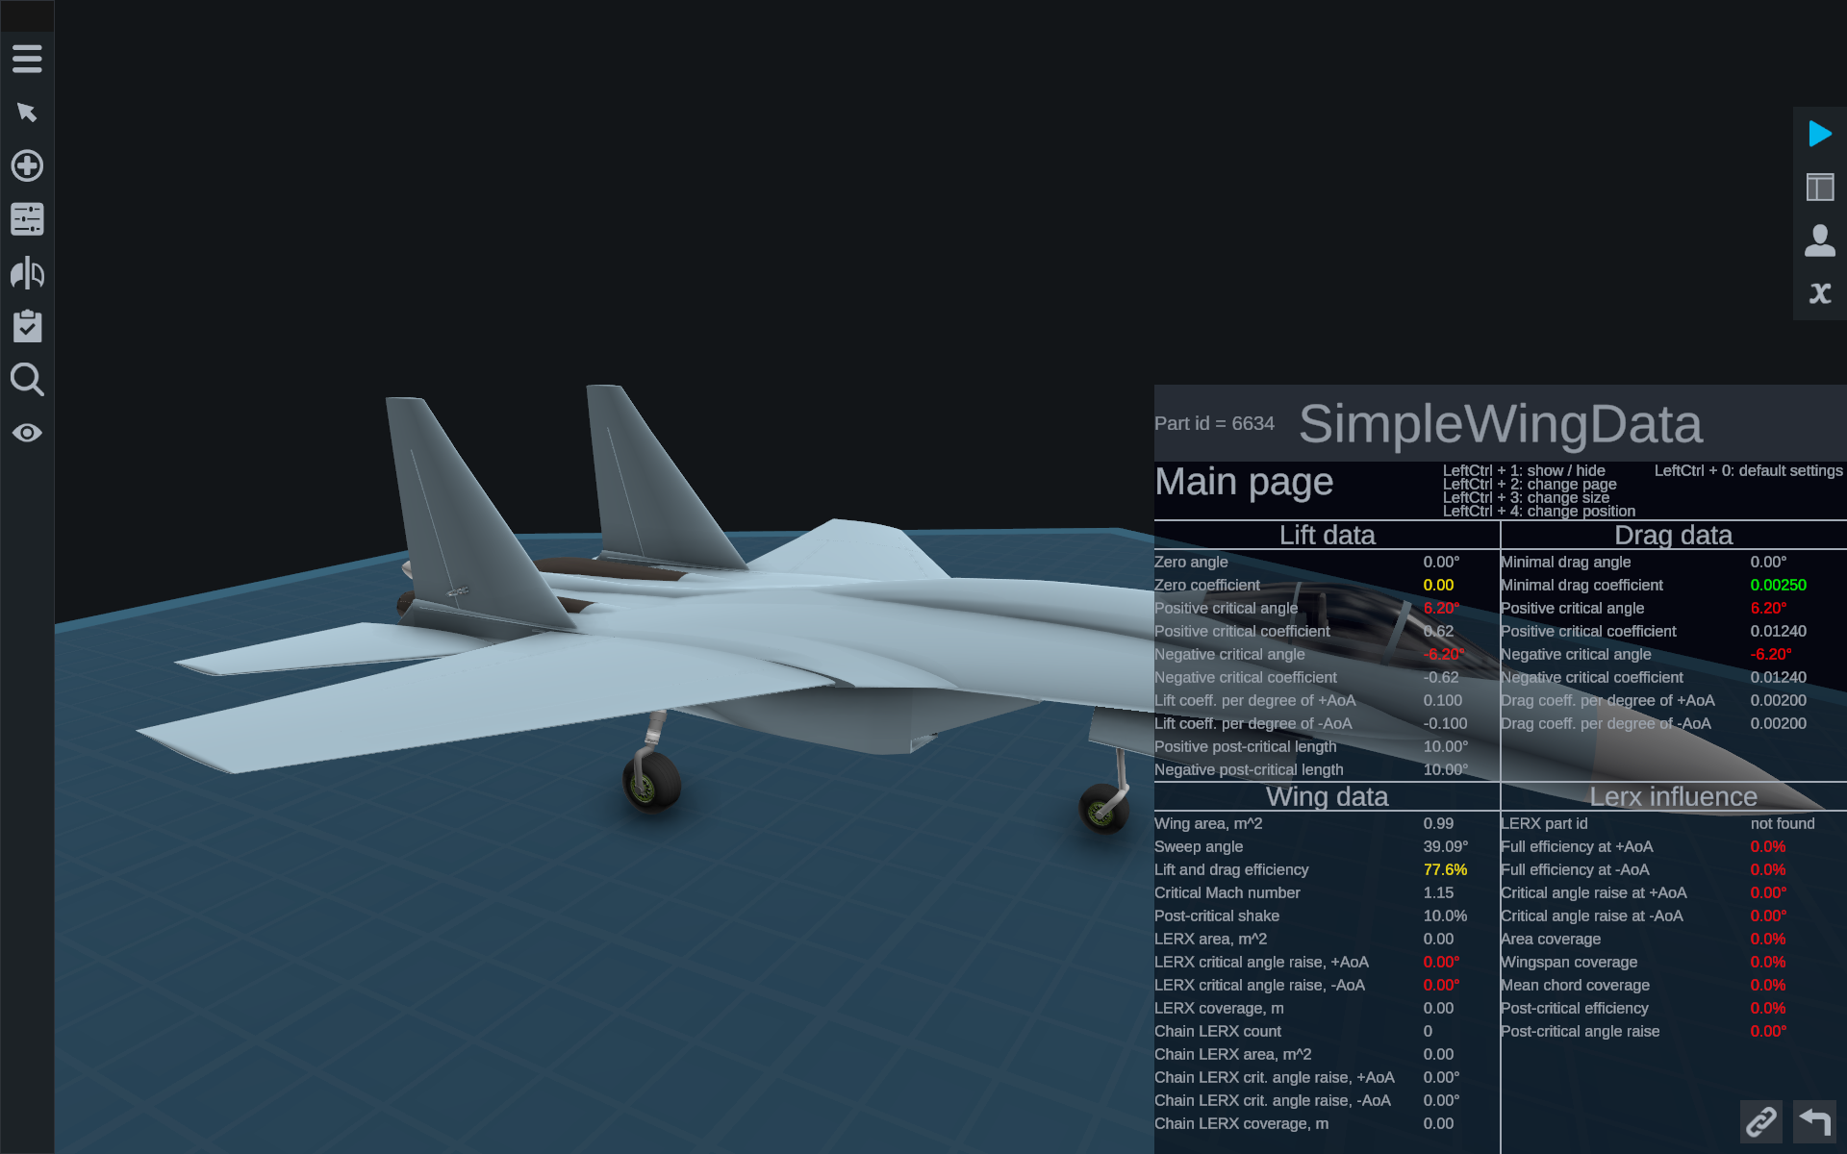

The data in this window is updated at the moment when you open the Part Properties of the selected part:

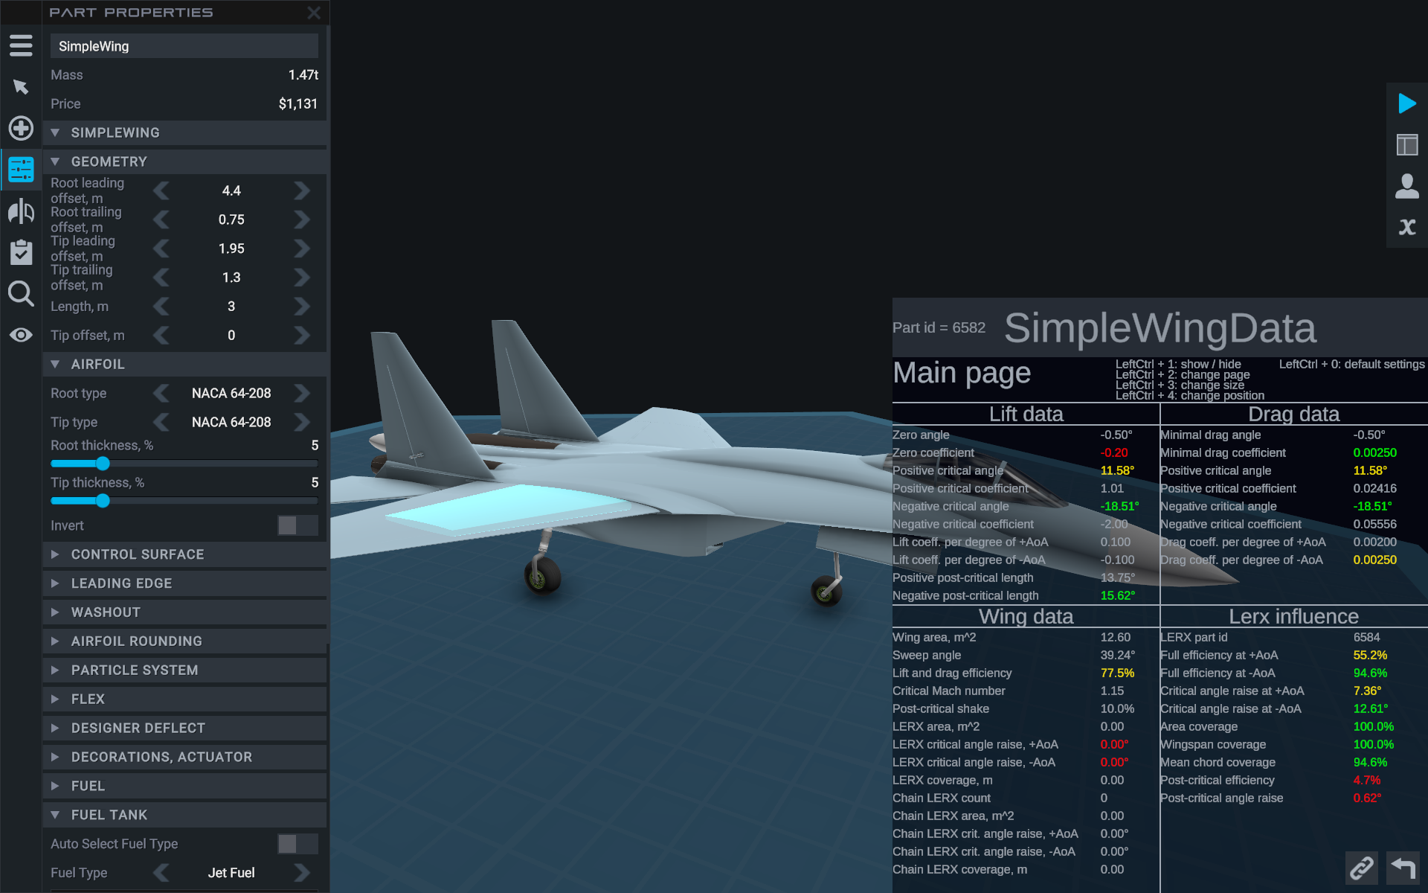

You can realize that the data in this window has been updated by the change of **Part id** in the upper left part ofthe window. **If this does not happen**, try to change some characteristic of the selected wing. For example, switch the **Invert** toggle twice. After that the window will be updated.

At the top of the window, you can see hints on how to modify this window:

* Left Ctrl + 1 – hides/shows the window.
* Left Ctrl + 2 – changes the page.
* Left Ctrl + 3 – increases the size. When the window exceeds a certain size, the size is reset to the minimum size and you can increase it again.
* Left Ctrl + 4 – changes the window position. There are five positions in total: left-top, right-top, left-bottom, right-bottom, center.
* Left Ctrl + 0 – returns all window settings to default state, but the window remains visible.

## Main Page

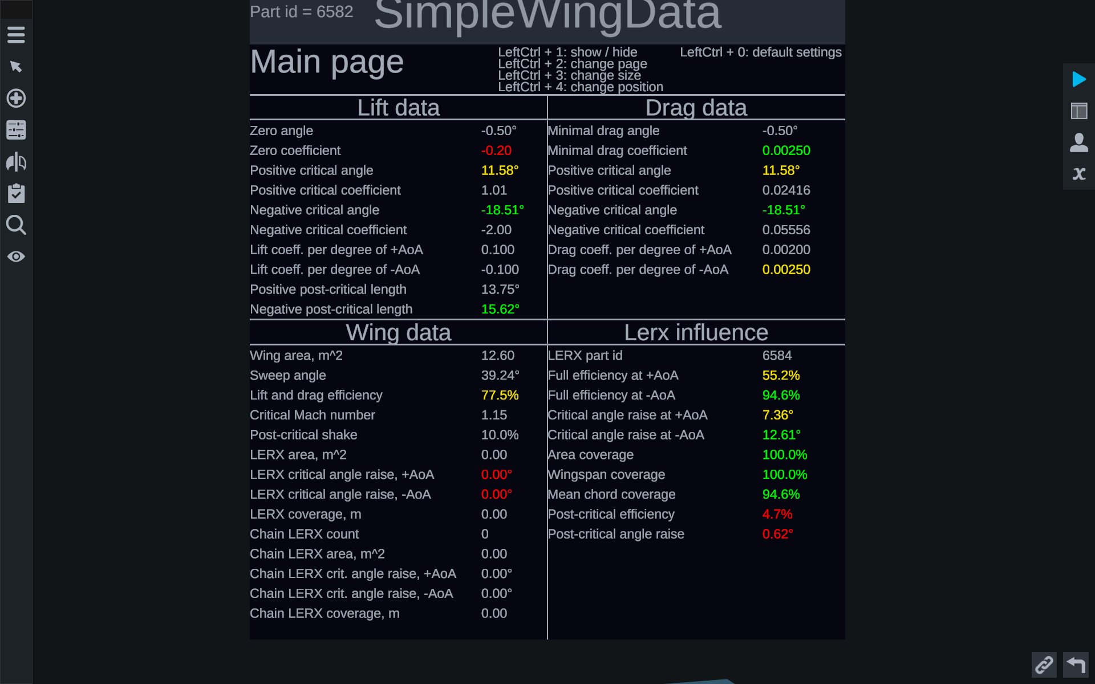

On the Main page you can see 4 sections:

* Lift data – characteristics of the lift curve.
* Drag data – characteristics of the drag force curve.
* Wing data – wing characteristics.
* Lerx influence – information on the influence of the LERX of the selected wing.

### Lift data

**Zero angle** – zero angle of attack.

**Zero coefficient** – lift coefficient at zero angle of attack.

Note that when using the washout property, the **Zero angle** value will change, but the **Zero coefficient** value will not. This is because these two properties show the coordinates of the center reference point of the wing lift curve, not the actual lift coefficient at zero angle of attack.

**Positive critical angle** – positive critical angle of attack.

**Positive critical coefficient** – lift coefficient at positive critical angle of attack.

**Negative critical angle** – negative critical angle of attack.

**Negative critical coefficient** – lift coefficient at negative critical angle of attack.

**Lift coeff. Per degree of + AoA** –lift increment at positive angle of attack.

**Lift coeff. Per degree of -AoA** –lift increment at negative angle of attack.

When deflecting in the deflected leading edge in designer, you can see that the lift increment at positive and at negative angle of attack can have different values due to the break of the lift curve at zero angle of attack.

**Positive post-critical length** –post-critical length at positive angle of attack.

**Negative post-critical length** –post-critical length at negative angle of attack.

### Drag data

**Minimal drag angle** – zero angle of attack.

**Minimal drag coefficient** – lift coefficient at zero angle of attack.

Also, as in the neighboring Lift data section, when using the washout property, the **Minimal drag angle** value will change, but the **Minimal drag coefficient** value will not. This is because these two properties show the coordinates of the center reference point of the drag curve of the wing.

**Positive critical angle** – positive critical angle of attack.

**Positive critical coefficient** – drag force coefficient at positive critical angle of attack.

**Negative critical angle** – Negative critical angle of attack.

**Negative critical coefficient** – drag force coefficient at negative critical angle of attack.

**Lift coeff. Per degree of +** **AoA** – drag increment at positive angle of attack.

**Lift coeff. Per degree of -AoA** – drag increment at negative angle of attack.

### Wing data

**Wing area, m^2** – wing area in square meters.

**Sweep angle** – sweepangle in degrees.

**Lift and drag efficiency** – Lift and dragefficiency factor in percent. Cannot be less than **50%**.

**Critical Mach** **number** – Critical Mach number.

**Post-critical shake** – post-critical shake factor in percent.

The lower properties show how a given wing **may affect other wings** when that wing is a LERX.

**LERX area, m^2** – area of the LERX in square meters.

**LERX critical angle** **raise, +AoA** – maximum possible critical angle raise at positive angles of attack for this wing if this wing is a LERX.

**LERX critical angle** **raise, -AoA** – maximum possible critical angle raise at negative angles of attack for this wing if this wing is a LERX.

**LERX coverage** – the length of the LERX coverage.

**Chain LERX count** – the number of SimpleWing parts in the composite LERX.

**Chain LERX area, m^2** – area of the composite LERX.

**Chain LERX crit. angle raise, +AoA** – maximum possible increase of the critical angle of attack at positive angles of attack for a composite LERX**.**

**Chain LERX crit. angle raise, -AoA** – maximum possible increase of the critical angle of attack at negative angles of attack for a composite LERX**.**

**Chain LERX coverage, m** – the length of the composite LERX coverage.

### Lerx influence

This section shows the effect of **the other SimpleWing part**, which is the LERX, to this wing.

**LERX part id** – the identifier of the SimpleWing part that is the LERX for this wing.

**Full efficiency at +** AoA – full efficiency of the LERX for this wing at positive angles of attack.

**Full efficiency at -AoA** – full efficiency of the LERX for a given wing at negative angles of attack.

**Critical angle raise at +** **AoA** – raising the positive critical angle of attack by LERX.

**Critical angle** **raise at -AoA** – raising the negative critical angle of attack by LERX.

**Area coverage** – coverage factor of this wing by area in percent.

**Wingspan coverage** – coverage factor of a given wing length in percent.

**Mean chord coverage** – coverage ratio of the **MAC** of a this wing in percent.

**Post-critical efficiency** – coverage coefficient of the **MAC** of a this wing in the region of increase of the post-critical length in percent.

**Post-critical angle raise** – raising the post-critical length by LERX for a this wing.

## Lift & Drag page

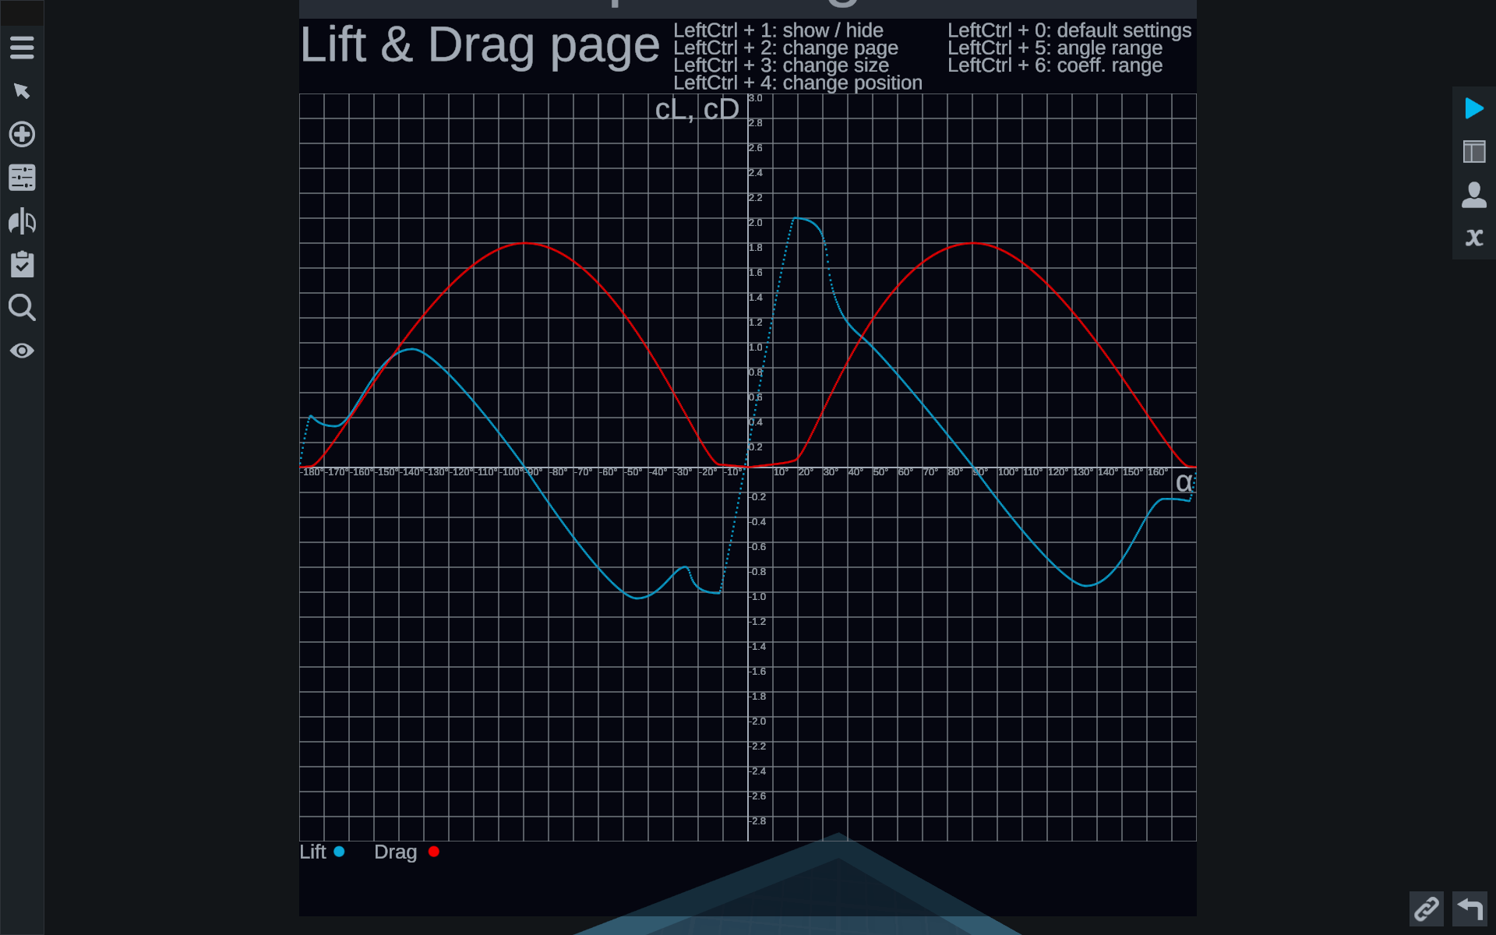

There are new hints on this page:

* Left Ctrl + 5 – reduce the range of angles of attack (horizontal axis).
* Left Ctrl + 6 – reduce the range of coefficients (vertical axis).

Decreasing the axis range works in a cycle - after decreasing a certain minimum value, the axis range will become maximum again.

Here you can see both the wing lift curve (light blue line) and the drag force (red line).

## α & Thickness

This page shows the dependence of critical angle of attack from airfoil thickness for different airfoils.

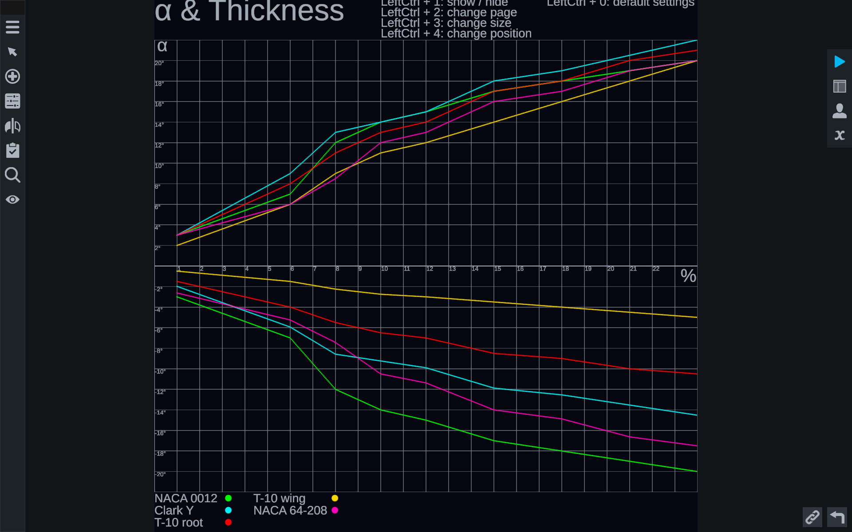

The vertical axis measures the critical angles of attack from -22° to +22°, the horizontal axis measures the airfoil thickness as a percentage from 1% to 24%.

## Polar page

This page presents the wing polar - the relationship between lift curve and drag curve:  
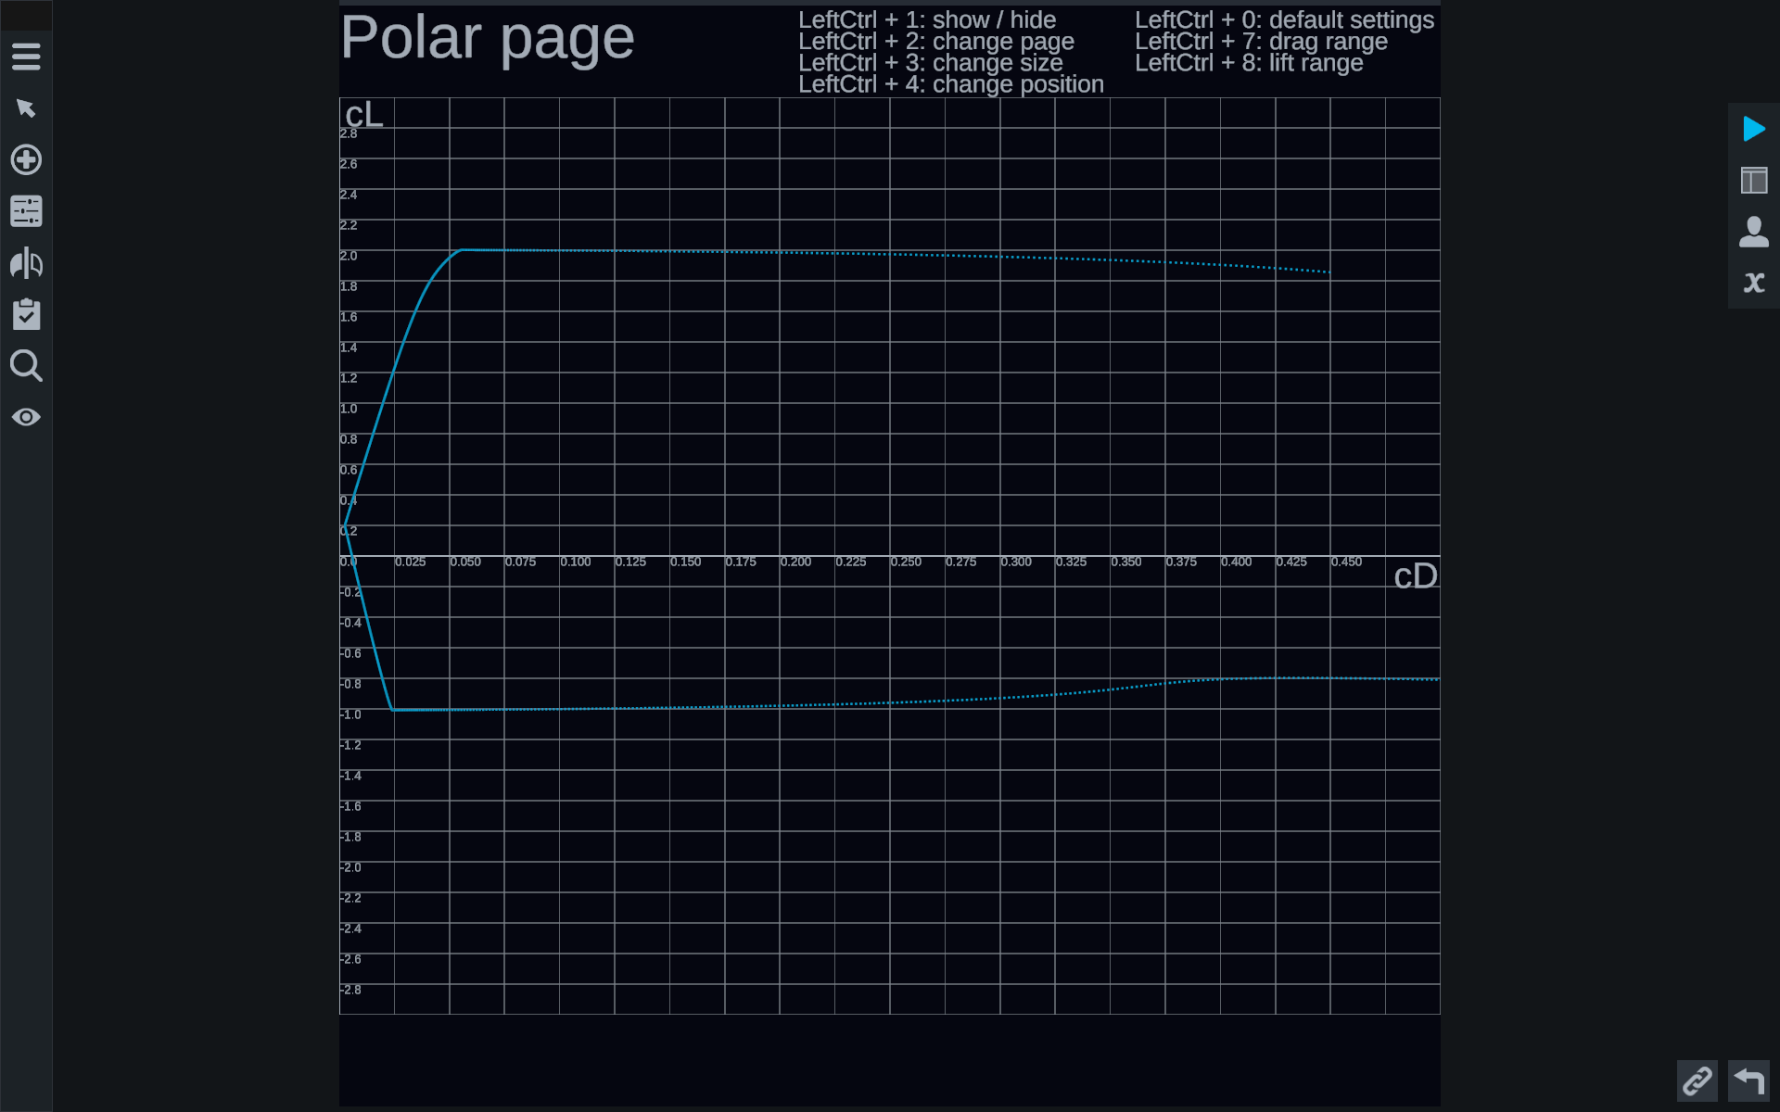

In the image above, drag coefficients are measured on the horizontal axis and lift coefficients are measured on the vertical axis. The graph itself is a function of

$$C_{y}=F\left(C_{x}\right)$$

There are some new advanced settings here:

* Left Ctrl + 7 - changes the range of coefficients on the horizontal axis.
* Left Ctrl + 8 - changes the range of coefficients on the vertical axis.

Also, like the Lift & Drag page, on this page, changing ranges works in a loop.

By default, the graph is drawn for a range of -60°...60° angles of attack. The range of angles of attack can be changed in the mod settings.

# Mod settings

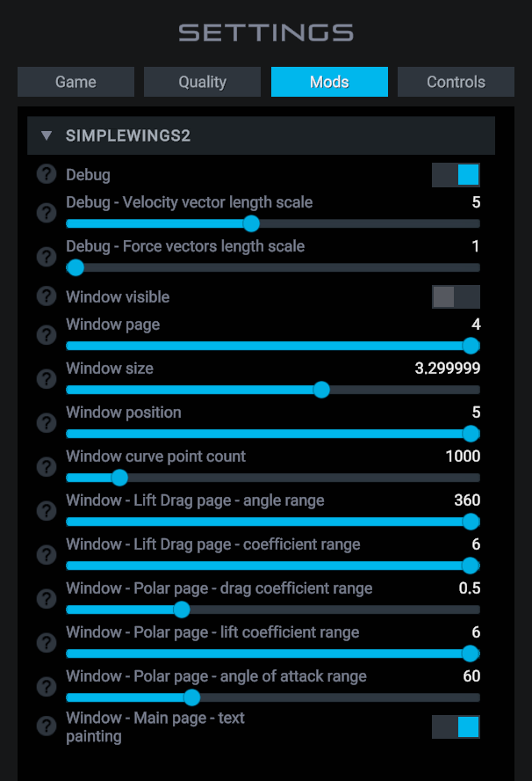

**Debug** – enables display of force vectors during flight:

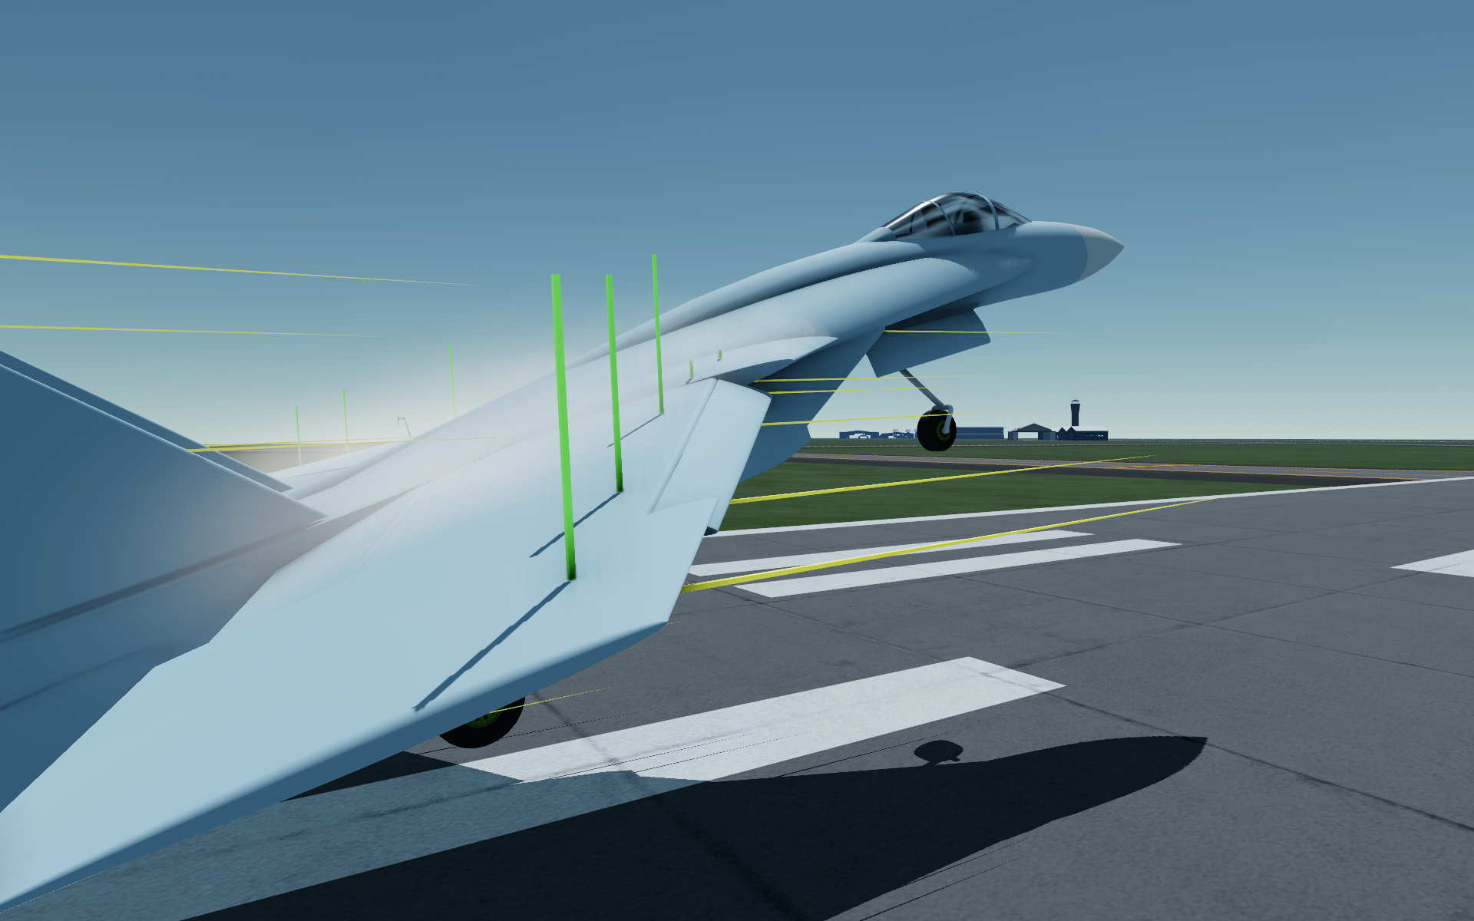

**Debug - Velocity vector length scale** – force vectors length scale. **Debug - Force vectors length** scale – velocity vector length scale (yellow).

**Window visible** – enables/disables displaying of SimpleWingData window in the designer.

**Window page** – SimpleWingData page. 1 - Main page, 2 - Lift & Drag, 3 - α & Thickness, 4 - Polar page.

**Window size** – the size of the SimpleWingData window.

**Window position** – SimpleWingData window position. 1 - upper right, 2 - upper left, 3 - lower left, 4 - lower right, 5 - center.

**Window curve point count** – number of points for drawing curves in the SimpleWingData window. For the changes to take effect, you need to reload the game.

**Window - Lift Drag page - angle range** – angle ofattack range (horizontal axis) on the Lift & Drag page.

**Window - Lift Drag page** – coefficient range (vertical axis) on the Lift & Drag page.

**Window - Polar page** - **drag coefficient range** – range of coefficients along the horizontal axis on the Polar page.

**Window - Polar page - lift coefficient range** – vertical axis coefficient range on the Polar page.

**Window** - **Polar page - angle of attack range** – angle of attack range for drawing the polar curve on the Polar page.

**Window - Main page** - **text painting** – text highlighting in red, yellow and green on the Main page.

# Building recommendations

Connect the wings so that the root attachment point is connected to the tip attachment point. If you do not observe this, the wing bend and LERX mechanics may not work correctly.

# Table of aerodynamic characteristics of different airfoils

|  |  |  |  |  |  |
| --- | --- | --- | --- | --- | --- |
|  | **NACA 0012** | **Clark Y** | **T-10 root** | **T-10 wing** | **NACA 64-208** |
| **Lifting force** | | | | | |
| Lift coefficient at zero angle of attack | 0 | 0.4 | 0.1 | 0.15 | 0.2 |
| Lift increment | 0.1 | 0.0733 | 0.085 | 0.1 | 0.1 |
| Asymmetry coefficient | - | 0.66 | 0.5 | 0.25 | 0.875 |
| Post-critical length | 10° | 10° | 15° | 5° | 15° |
| Post-critical shake | 10% | 10% | 12.5% | 20% | 10% |
| Critical coefficients | 0.1  1.0  0.25 | 0.1  1.0  0.25 | 0.1  1.0  0.25 | 0.3  0.25  0.75 | 0.1  1.0  0.25 |
| **Drag force** | | | | | |
| Minimal drag angle of attack | 0° | +1° | 0° | +1.5° | 0° |
| Minimum drag coefficient | 0.006 | 0.006 | 0.005 | 0.005 | 0.006 |
| Drag increment | 0.002  0.002 | 0.003  0.002 | 0.00225  0.002 | 0.002  0.002 | 0.0025  0.002 |
| Critical Mach number for 1% airfoil | 1 | 1 | 1.25 | 1.5 | 1 |
| **Effectiveness of root surge** | | | | | |
| Asymmetry coefficient | - | - | 0.5 | 0.25 | - |
| Coverage coefficient | 0.5 | 0.5 | 0.75 | 1.0 | 0.5 |
| Increasing the critical angle | 5° | 5° | 15° | 10° | 5° |

# SimpleWing properties description

Abbreviations used in property names:

**CoSu** or **CS** - Control Surface

**LeEd** or **LE** - Leading Edge

**TrVo** - Trail Vortex.

**LxVo** - Lerx Vortex.

**WiVo** - Wing Vortex.

## Geometry section

**Root leading offset, m** – offset of the lead point of the wing root in meters. Minimum possible value: 0. Name of xml-property – rootLeadingOffset.

**Root trailing offset, m** – offset of the trail point of the wing root in meters. Minimum possible value: 0. Name of xml-property – rootTrailingOffset.

**Tip leading offset, m** – offset of the lead point of the wing tipin meters. Minimum possible value: 0. Name of xml-property – tipLeadingOffset.

**Tip trailing offset, m** – offset of the trail point of the wing tip in meters. Minimum possible value: 0. Name of xml-property – tipTrailingOffset.

**Length, m** – length of the wing in meters. Minimum possible value: 0. The name of xml-property – length.

**Tip offset, m** – offset of wing **tip** in meters. The name of xml-property – tipOffset.

## Airfoil section

**Root type** – type of root airfoil. Possible values: NACA 0012, Clark Y, T-10 root, T-10 wing, NACA 64-208. The xml property name – airfoilRootType.

**Tip type** – type of end airfoil. Possible values: NACA 0012, Clark Y, T-10 root, T-10 wing, NACA 64-208. The xml property name – airfoilTipType.

**Root thickness, %** – relative thickness ofthe root airfoil in percent. Minimum possible value: 1. Maximum possible value: 24. The xml property name is airfoilRootThickness.

**Tip thickness, %** – relative thickness ofthe tip airfoil in percent. Minimum possible value: 1. Maximum possible value: 24. Name of xml-property – airfoilTipThickness.

**Invert** – airfoil inversion. The name of the xml-property – isAirfoilInverted. Changes airfoil inversion only when hidden property autoAirfoilInvertEnabled is false.

## Control Surface section

**Percentage, minimal = 7%** – the size of the control surface in percentage. Increases the weight of the wing. Minimum possible value: 7. Maximum possible value: 45. The xml property name – CoSu_percentage.

**Deflection angle, °** – deflectionangle of the control surface in degrees. Minimum possible value: 0. Maximum possible value: 90. The xml property name – CoSu_deflectionAngle.

**Rotation speed, °/s** – rotation speed of the control surface in degrees per second. Minimum possible value: 0. Name of xml-property – CoSu_rotationSpeed.

**Spacing, %** – gap between the control surface and the wing in percent. Does not affect the physics of the wing. Minimum possible value: 0. Maximum possible value: 45 - CoSu_percentage. Name of xml-property – CoSu_spacing.

**Border rounded** – rounding of the front edge of the control surface. The xml property name – CoSu_isBorderRounded.

## Leading Edge section

**Percentage, %** – the size of the deflected leading edge in percent. Increases the weight of the wing. Maximum possible value: 40. Name of xml-property – LeEd_percentage.

**Deflection angle, °** – maximum deflectionangle of the leading edge in degrees. In flight the leading edge is controlled automatically. Minimum possible value: 0. Maximum possible value: 30. The xml property name – LeEd_deflectionAngle.

**Rotation speed, °/s** – rotation speed of the leading edge in degrees per second. Minimum possible value: 0. Name of xml-property – LeEd_rotationSpeed.

**Sensitivity, °/AoA** – sensitivity of leading edge deflection, in degrees per angle of attack. If the value is 1, the deflection angle will be equal to the angle of attack. If the value is 0.5, it will be equal to half the angle of attack. If the value is 2, it will be twice the angle of attack. Minimum possible value: 0. The xml property name –LeEd_angleOfAttackSensitivity.

**Spacing, %** – the gap between the deflected wingtip and the wing in percent. Does not affect the physics of the wing. Minimum possible value: 0. Maximum possible value: 40 - LeEd_percentage. The xml property name – LeEd_spacing.

**Full deflect** **Activation Group** – full deflection of the leading edge when activating the specified activation group. The xml property name – LeEd_fullDeflectActivationGroup.

**Border rounded** – rounding ofthe leading edge. The xml property name – LeEd_isBorderRounded.

LeEd_isAttachedToRoot – hidden property. If true, the deflection angle of the wing leading edge becomes equal to the deflection angle of the wing leading edge of another root SimpleWing to which your wing is attached. Can be useful if your wing is made up of multiple SimpleWing parts that have washout. If you don't use this setting, the angle of deflection of the leading edge will be different on them due to the different angle of attack.

## Washout section

**Washout angle, °** – angle of aerodynamic twist of the wing in degrees. Minimum possible value: -15. Maximum possible value: +15. Name of xml-property – washoutAngle.

**Relative point** – relative point of aerodynamic twist. If the value is 0, the end airfoil rotates relative to the front point. With value 1 the rotation is relative to the rear point. Minimum possible value: 0. Maximum possible value: 1. Does not affect the physics of the wing. The xml property name – washoutRelativePoint.

## Airfoil Rounding Section

**Rounded** – rounding of the wing tip. Does not affect the physics of the wing. The name of xml-property – isAirfoilRounded.

**Length** – scale of wing tip rounding length. Minimum possible value: 0. Does not affect the wing physics. The xml property name – airfoilRoundingLength.

## Particle System section, Trail vortex

**Trail vortex** – if enabled, trail vortex bundle wing tip becomes visible. The name of xml-property – TrVo_enabled.

**TrVo_forOtherSideEnabled** – hidden property. If false, then the trail vortex becomes invisible at negative angle of attack for non-inverted airfoil and at positive angle of attack for inverted airfoil.

**TrVo_inWorldSpaceEnabled** – hidden property. If true, the trail vortex simulation takes place in global space, and if false, it takes place in local space. Simulation in global space creates a more realistic trajectory of the trail vortex, but the trail vortex can 'break' at high angular velocity at roll. For example, on the SimpleFlanker simulation of the left and right wing trail vortex in local space.

**TrVo_sizeMultiplier** – hidden property. Trail vortex size multiplier, its thickness. Minimum possible value: 0.

**TrVo_lengthMultiplier** – hidden property. Trail vortex length multiplier. Minimum possible value: 0.

**TrVo_speedMultiplier** – hidden property. Trail vortex speed multiplier. Minimum possible value: 0.

**TrVo_emissionMultiplier** – hidden property. The coefficient of the number of created particles of the trail vortex. Minimum possible value: 0.

**TrVo_randomAngleMultiplier** – hidden property. The coefficient of the random angle of the trail vortex. The default random angle is 10 degrees. Minimum possible value: 0.

**TrVo_randomLengthMultiplier** – hidden property. Random length multiplier of the trail vortex. Minimum possible value: 0.

**TrVo_maxParticles** – hidden property. Maximum number of trail vortex particles. This setting may need to be increased after increasing TrVo_emissionMultiplier, because the number of created particles may exceed the maximum. Minimum possible value: 0.

**TrVo_opacityMultiplier** – hidden property. The transparency factor of the trail vortex. You may need to lower this value when the number of trail vortex particles is so high that the trail vortex starts to "glow". Minimum possible value: 0. Maximum possible value: 1.

**TrVo_growStartVisibilityAOA** – hidden property. The angle of attack (both positive and negative) when the trail vortex starts to appear. Default value: 7.5. Minimum possible value: 0. Maximum possible value: 90.

**TrVo_growEndVisibilityAOA –** hidden property. The angle of attack (both positive and negative) when the trail vortex becomes maximally visible. Default value: 15. Minimum possible value: 0. Maximum possible value: 90.

**TrVo_fadeStartVisibilityAOA –** hidden property. The angle of attack (both positive and negative) when the trail vortex starts to fade out. Default value: 20. Minimum possible value: 0. Maximum possible value: 90.

**TrVo_fadeEndVisibilityAOA –** hidden property. The angle of attack (both positive and negative) when the trail vortex becomes invisible. Default value: 45. Minimum possible value: 0. Maximum possible value: 90.

**TrVo_minVisibilitySpeed** – hidden property. The speed in meters per second at which the trail vortex starts to appear. Default value: 27.7 (100 km/h). Minimum possible value: 0.

**TrVo_maxVisibilitySpeed** – hidden property. The speed in meters per second at which the trail vortex becomes maximally visible. Default value: 41.55 (150 km/h). Minimum possible value: 0.

## Particle System section, LERX vortex

**LERX vortex** – if enabled and wing leading edge sweep angle is greater than 61° , LERX vortex becomes visible. The xml property name – LxVo_enabled.

**LxVo_forOtherSideEnabled** – hidden property. If false, the LERX vortex becomes invisible at negative angle of attack for non-inverted airfoil and positive angle of attack for inverted airfoil.

**LxVo_inWorldSpaceEnabled** – hidden property. If true, the LERX vortex is simulated in global space, if false, it is simulated in local space. As in the case with the TrVo_inWorldSpaceEnabled property, simulation in global space makes the vortex trajectory more realistic, but at high angular velocities on roll the vortex may break. On the test SimpleFlanker the simulation takes place in local space.

**LxVo_sizeMultiplier** – hidden property. The coefficient of the LERX vortex size, its thickness. Minimum possible value: 0.

**LxVo_randomSizeMultiplier** – hidden property. Coefficient of random size of LERX vortex. Default value: 0.25. At this value the size of vortex particles along its length will vary from (1 - 0.25 ) to (1 + 0.25), i.e. from 0.75 to 1.25. The minimum possible value is 0.

**LxVo_lengthMultiplier** – hidden property. Coefficient of random length of LERX vortex. Minimum possible value: 0.

**LxVo_speedMultiplier** – hidden property. Speed coefficient of LERX vortex particles. Minimum possible value: 0.

**LxVo_emissionMultiplier** – hidden property. The coefficient of the number of created LERX vortex particles. Minimum possible value: 0.

**LxVo_randomAngleMultiplier** – hidden property. Random angle coefficient of the LERX vortex. If the value is 1, the random angle will be 5°. Minimum possible value: 0.

**LxVo_angleOfAttackSensitivity** – hidden property. Sensitivity of the LERX vortex deflection to the angle of attack. With a value of 1, the vortex will deflect by 1 degree at 1 degree of angle of attack. At a value of 2, the vortex will deflect by 2 degrees at 1 degree of angle of attack. Minimum possible value: 0.

**LxVo_angleOfSlipSensitivity** – hidden property. Sensitivity of LERX vortex deviation to slip angle. If the value is 1, the vortex will deflect by 1 degree at 1 degree of slip angle. At a value of 2, the vortex will deflect by 2 degrees at 1 degree of slip angle. Minimum possible value: 0.

**LxVo_maxAngleOfAttack** – hidden property. Maximum angle of deflection of the LERX vortex by the angle of attack. Minimum possible value: 0. Maximum possible value: 60.

**LxVo_maxAngleOfSlip** – hidden property. Maximum angle of LERX vortex deviation by angle of slip. Minimum possible value: 0. Maximum possible value: 60.

**LxVo_maxParticles** – hidden property. Maximum number of LERX vortex particles. This setting will need to be increased after increasing LxVo_emissionMultiplier, because the number of created particles may exceed the maximum. Minimum possible value: 0.

**LxVo_opacityMultiplier** – hidden property. The transparency factor of the LERX vortex. You may need to lower this value when the number of LERX vortex particles is so high that the LERX vortex starts to "glow". Minimum possible value: 0. Maximum possible value: 1.

**LxVo _growStartVisibilityAOA** – hidden property. The angle of attack (both positive and negative) when the LERX vortex starts to appear. Default value: 15. Minimum possible value: 0. Maximum possible value: 90.

**LxVo _growEndVisibilityAOA** –hidden property. The angle of attack (both positive and negative) when the LERX vortex becomes maximally visible. Default value: 20. Minimum possible value: 0. Maximum possible value: 90.

**LxVo _fadeStartVisibilityAOA** –hidden property. The angle of attack (both positive and negative) when the LERX vortex starts to fade out. Default value: 25. Minimum possible value: 0. Maximum possible value: 90.

**LxVo _fadeEndVisibilityAOA** –hidden property. The angle of attack (both positive and negative) when the LERX vortex becomes invisible. Default value: 60. Minimum possible value: 0. Maximum possible value: 90.

**LxVo_minVisibilitySpeed** – hidden property. The speed in meters per second at which the LERX vortex starts to manifest. Default value: 27.7 (100 km/h). Minimum possible value: 0.

**LxVo_maxVisibilitySpeed** – hidden property. The speed in meters per second at which the LERX vortex becomes maximally visible. Default value: 41.55 (150 km/h). Minimum possible value: 0.

## Particle System section, Wing vortex

**Wing vortex** – if enabled, wing vortex becomes visible. Name of xml-property - WiVo_enabled.

**WiVo_forOtherSideEnabled** – hidden property. If false, the wing vortex becomes invisible at negative angle of attack for non-inverted airfoil and at positive angle of attack for inverted airfoil.

**WiVo_sizeMultiplier** – hidden property. Wing vortex size multiplier. Minimum possible value: 0.

**WiVo_lengthMultiplier** – hidden property. Wing vortex length multiplier. Minimum possible value: 0.

**WiVo_speedMultiplier** – hidden property. Wing vortex speed multiplier. Minimum possible value: 0.

**WiVo_emissionMultiplier** – hidden property. The coefficient of the number of created wing vortex particles. Minimum possible value: 0.

**WiVo_maxParticles** – hidden property. Maximum number of wing vortex particles. This setting will need to be increased after increasing WiVo_emissionMultiplier, because the number of created particles may exceed the maximum. Minimum possible value: 0.

**WiVo_opacityMultiplier** – hidden property. Wing vortex opacity multiplier. You may need to lower this value when the amount of created wing vortex particles is so high that the wing vortex starts to "glow". Minimum possible value: 0. Maximum possible value: 1.

**WiVo_growStartVisibilityAOA** – hidden property. The angle of attack (both positive and negative) when the wing vortex starts to appear. Default value: 15. Minimum possible value: 0. Maximum possible value: 90.

**WiVo_growEndVisibilityAOA** –hidden property. The angle of attack (both positive and negative) when the wing vortex becomes maximally visible. Default value: 20. Minimum possible value: 0. Maximum possible value: 90.

**WiVo_fadeStartVisibilityAOA** –hidden property. The angle of attack (both positive and negative) when the wing vortex starts to fade out. Default value: 25. Minimum possible value: 0. Maximum possible value: 90.

**WiVo_fadeEndVisibilityAOA** –hidden property. The angle of attack (both positive and negative) when the wing vortex becomes invisible. Default value: 90. Minimum possible value: 0. Maximum possible value: 90.

**WiVo_minVisibilitySpeed** – hidden property. The speed in meters per second at which the wing vortex starts to appear. Default value: 27.7 (100 km/h). Minimum possible value: 0.

**WiVo_maxVisibilitySpeed** – hidden property. The speed in meters per second at which the LERX vortex becomes maximally visible. Default value: 41.55 (150 km/h). Minimum possible value: 0.

## Flex section

**Wing flex** - enable wing flex. Wing flex has no effect on stock parts attached to this wing. The xml property name – wingFlexEnabled.

**wingFlexRigidityMultiplier** – hidden property. Coefficient of wing rigidity. As this coefficient increases, the wing will flex less.

## Designer deflect section

**Leading edge deflect, °** - angle of deflection of the leading edge in degrees in the designer. Allows you to evaluate changes in aerodynamic characteristics, which are displayed in the SimpleWingData window. The xml property name – designerDeflectLeadingEdge.

**Control surface deflect, °** - angle of deflection of the control surface in degrees in the designer. Allows you to evaluate changes in aerodynamic characteristics, which are displayed in the SimpleWingData window. The xml property name is designerDeflectControlSurface.

## Hidden section Additional Offsets

This section is only available for editing through the Tinker Panel.

The properties in this section change the wing geometry only when the tipOffset property is 0.

These properties only change the appearance of the wing and do not affect weight, do not affect fuel capacity, and do not affect aerodynamics.

additionalRootLeadingOffset - additional offset of the front point of the wing root in meters. Minimum possible value: 0.1.

additionalRootTrailingOffset - additional offset of the trail point of the wing root in meters. Minimum possible value: 0.1.

additionalTipLeadingOffset - additional offset of the front point of the wing tip in meters. Minimum possible value: 0.1.

additionalTipTrailingOffset - additional offset of the trail point of the wing tip in meters. Minimum possible value: 0.1.

additionalRootLeadingRelativePercentage - relative point of additional offset as a percentage of the root chord length. Minimum possible value: 0. Maximum possible value: 50.

additionalRootTrailingRelativePercentage - relative point of additional offset as a percentage of the root chord length. Minimum possible value: 0. Maximum possible value: 50.

additionalTipLeadingRelativePercentage - relative point of additional offset as a percentage of the tip chord length. Minimum possible value: 0. Maximum possible value: 50.

additionalTipTrailingRelativePercentage - relative point of additional offset as a percentage of the tip chord length. Minimum possible value: 0. Maximum possible value: 50.

These properties can be applied when you want to do something like this:  
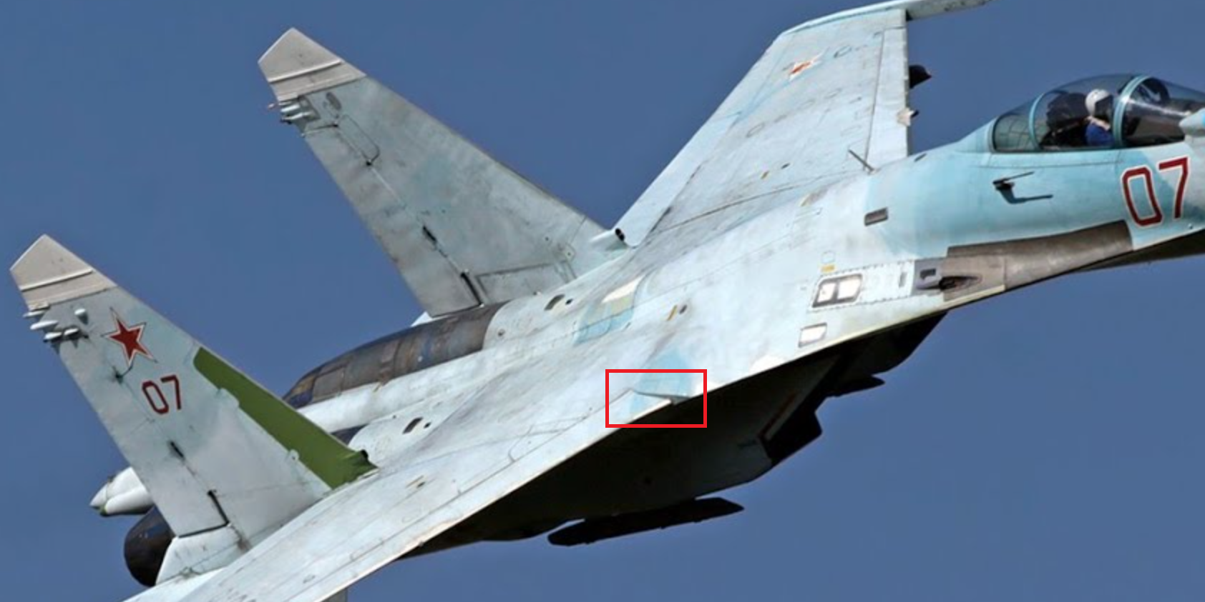

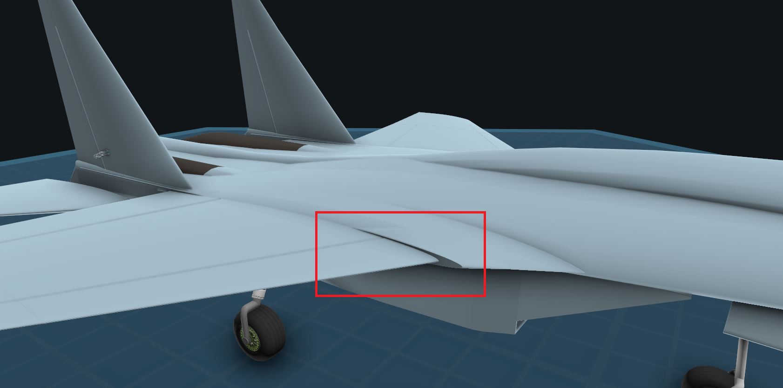

These properties allow you to "pull" the lead or trail points of the wing relative to a specific chord point without "breaking" the rest of the wing, so it continues to mate smoothly with other parts of the SimpleWing.

## Decorations section, Actuator

**Actuator enabled** – enables the actuator of the control surface. The xml property name – actuatorEnabled.

**Inverted** – inverting the actuator. The xml property name isActuatorInverted. Changes airfoil inversion only when hidden property autoAirfoilInvertEnabled is false.

**Scale** - actuator scale. Minimum possible value: 0.001. The xml property name – actuatorScale.

**Length position** – position of the actuator along the length of the wing. Minimum possible value: 0. Maximum possible value: 100. The xml property name – actuatorLengthPosition.

**Chord position** – position of the actuator along the wing chord. Minimum possible value: 0. Maximum possible value: 100. The xml property name – actuatorChordPosition.

**Up offset** – actuator offset relative to the wing surface. The xml property name – actuatorUpOffset.

**Back lug offset** – distance between cylinder back lugand cylinder back cover. Minimum possible value: 1. The xml property name – actuatorBackLugOffset.

**Shell length** – the length of the cylinder. Minimum possible value: 0. The xml property name – actuatorShellLength.

**Front lug initial offset** – initial length of cylinder rod. Minimum possible value: 1. xml property name – actuatorFrontLugInitialOffset.

**Initial rotation, °** – initialrotation of the cylinder in degrees. Minimum possible value: -90. Maximum possible value: 100. The xml property name is actuatorInitialRotation.

**Back mount initial rotation, °** – back mount actuator initial rotation in degrees. Minimum possible value: -90. Maximum possible value: 100. The xml property name – actuatorBackMountInitialRotation.

**Front mount initial rotation, °** – front mount actuator initial rotation in degrees. Minimum possible value: -90. Maximum possible value: 100. The xml property name – actuatorFrontMountInitialRotation.

**Back mount length** – the length of the actuator's back mount. Minimum possible value: 0. The xml property name – actuatorBackMountLength.

**Front mount length** – the length of the front mount of the actuator. Minimum possible value: 0. The xml property name – actuatorFrontMountLength.

**Back mount visible** – visibility of the backmount of the actuator. The xml property name – isActuatorBackMountVisible.

**Front mount visible** – visibility of the front mount of the actuator. The xml property name – isActuatorFrontMountVisible.

**Cables visible** – visibility of the actuator cables. The xml property name –isActuatorCablesVisible.

## Fuel section

**Fuel amount, %** – the amount of fuel filled in percent. Increasing the percentage of control surface and deflected wingtip decreases the maximum possible fuel amount. Minimum possible value: 0. Maximum possible value: 100. The xml property name – fuelAmount.

## Other hidden properties

**wingPhysicsEnabled** – if false, the wing does not create aerodynamic forces and the Debug mode does not display force vectors. Default value is true. You may need to disable it when excessive lift force in a certain part of the wing makes it unnecessarily unstable. On SimpleFlanker, physics is disabled for the two SimpleWing parts that are closest to the center of the fuselage.

**wingDestructibilityEnabled** –if false, the wing is not destroyed by over-G. In fact, SimpleWing is not destroyed by over-G itself, but by the excessive bending force that breaks the wing at the root attachment point. The break calculation is such that a wing with 25% control surface and 15% leading edge will break around 12-14g. Increasing the percentage of deflected leading edge and control surface reduces the breaking over-G. A wing with 45% control surface and 40% deflected leading edge has 30% less breaking over-G than a wing with no mechanization. Defaults to true.

**transformRelativeRootEnabled** –if true, when the length or tipOffset properties are changed, the wing geometry changes relative to the root, but the wing root itself remains fixed.

**lerxSearchSphereRadius** – radius of the search sphere of the LERX. The search is performed relative to the root attachment point. Minimum possible value: 0.

**lerxPartId** – you can manually set a specific SimpleWing identifier that will be the LERX for your wing, but the LERX must still be inside the search sphere with radius lerxSearchSphereRadius. You can see the SimpleWing part id in the SimpleWingData window in the Part id field at the top of the window by clicking on the SimpleWing part and opening its properties. By default, this property is **auto**. The specific identifier is set as follows:



**autoAirfoilInvertEnabled** – automatic airfoil inversion depending on left/right position of your wing relative to the cockpit. Default is true.

# Known errors

1. When the game loads, the control surfaces will be huge:

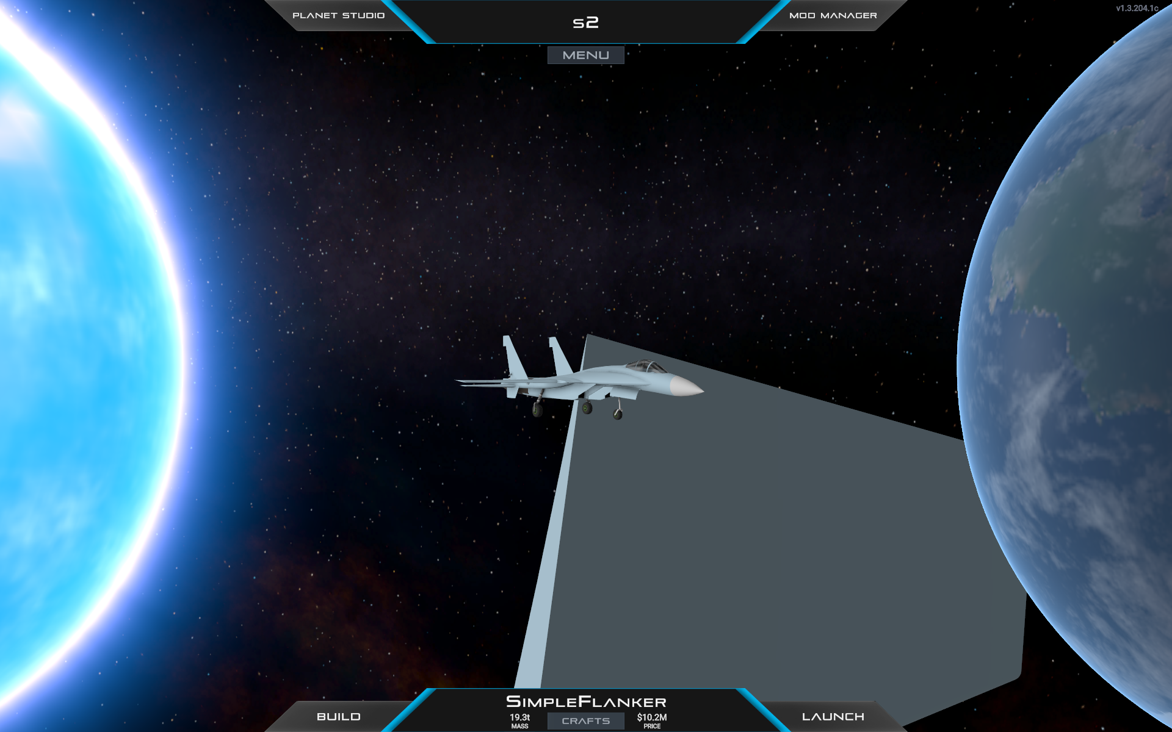

1. When using wing bend after spawning you will see errors like this in the console:

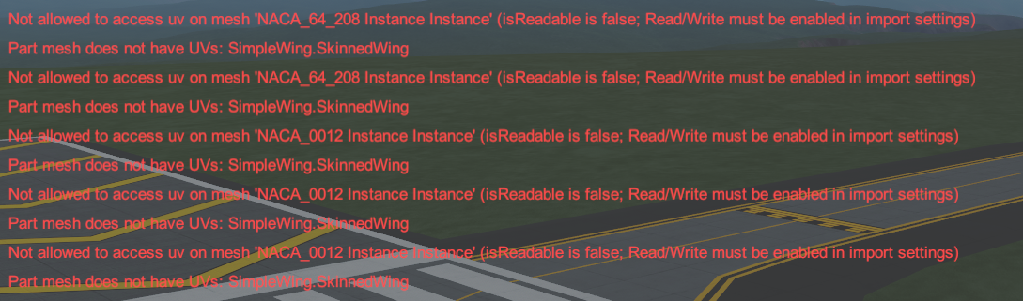

These errors are not critical and do not affect gameplay.

# Source code

The source code for this mod is available on my GitHub: <https://github.com/IvanTyurin96/SimpleWings2>

**/Assets/Scripts/Craft/Parts/Modifiers/SimpleWingData.cs –** class with properties that the player sees in Designer when opening the properties of a selected SimpleWing part.

**/Assets/Scripts/Craft/Parts/Modifiers/SimpleWingScript.cs –** class that executes SimpleWing code in the designer and during flight.

**/Assets/Scripts/Aerodynamics –** this folder contains static classes that build various curves. These classes are "accessed" by **SimpleWingScript.cs** during flight.

**/Assets/Scripts/UI/SimpleWingDataController.cs –** theclass is responsible for controlling the SimpleWingData window in the game.

# Conclusion

Thank you for reading this manual. I hope it helped you to better understand the mechanics of the SimpleWings2 mod.

Enjoy!

*The manual was written by Ivan Tyurin, also known as MOPCKOE_DNISHE, for the English-speaking community of Juno: New Origins.*

*Russia, Tula, June 13, 2025*